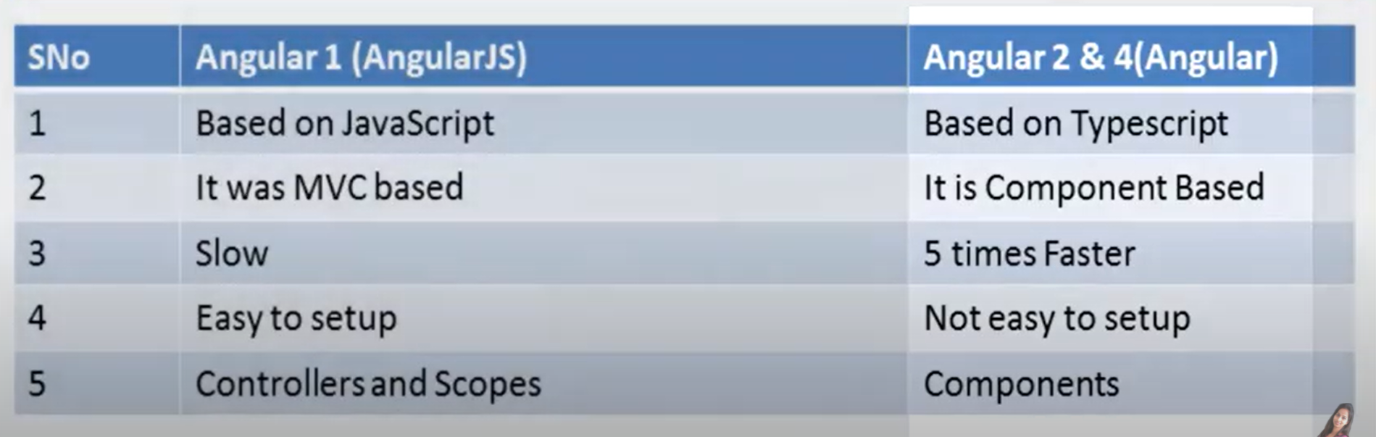

Typescript is superset of JAVA script.



It gives the concept of classes fat arrow function inheritance and let keyword.

We can do angular setup in two ways manual and builtin in manual user will not get functionality like testing bundling and production build.

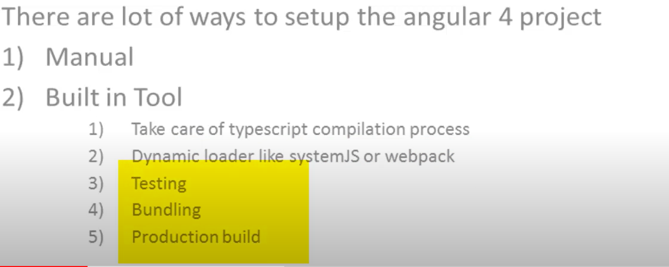

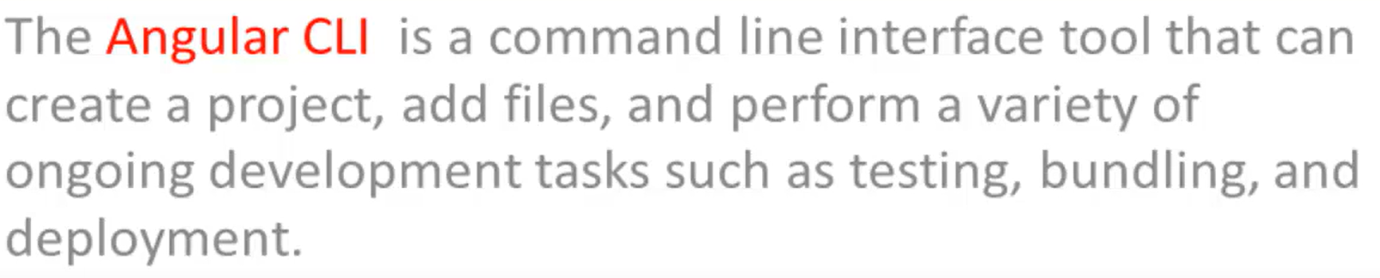

Before using angular CLI node and npm should be installed .

Download Nodejs and install node js then chk using node -v command. In same way chk for npm as well npm -v

Angular install command :



We can use ng version to check weather angular got installed correctly or not.

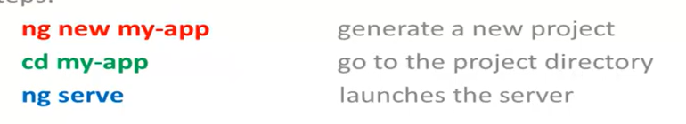



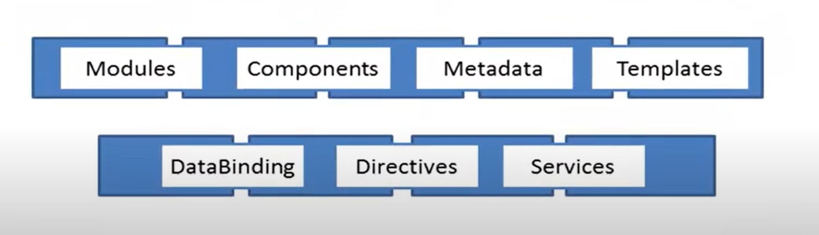

Module is a mechanism to group component , directives ,pipes and services.

Every angular have at least one module is called root module.

.ts stands for type script and in typescript each file is a module and all object belong to the file and all object defined in the file are belong to the module.

Using Import we can access public object from other module.

Component : it encapsulate the template , data and the behavior of a view.





We attach matadata with the help of decorators.

Databinding : It coordinates part of template with parts of component.

{} is type script class and DOM is template.

Angular transforms the DOM according to the instructions given by directive.

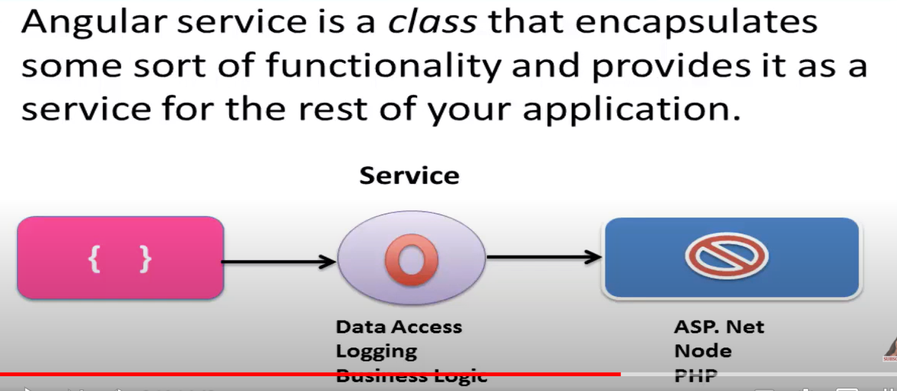

We built typescript class and make them as component using metadata. Each component has separate view with the help of template.

Template and component communicate through property binding and event binding.

If we want to attached some special behavior to template we can use directive along with metadata.

Component is just a logic if we have actual data we use service that makes actual call to server to get data from server and then component will inject that service.

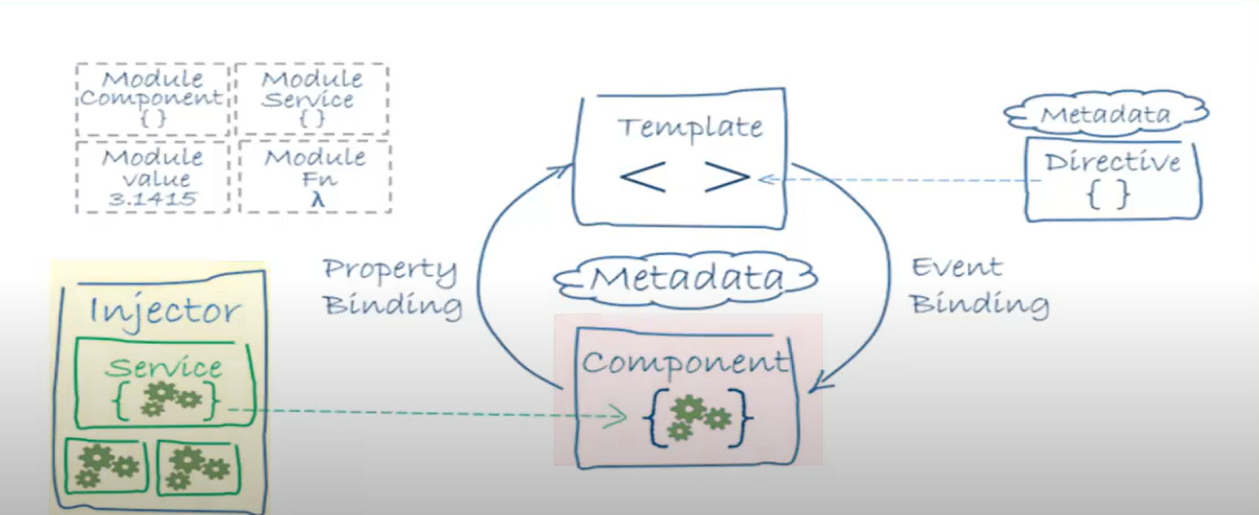

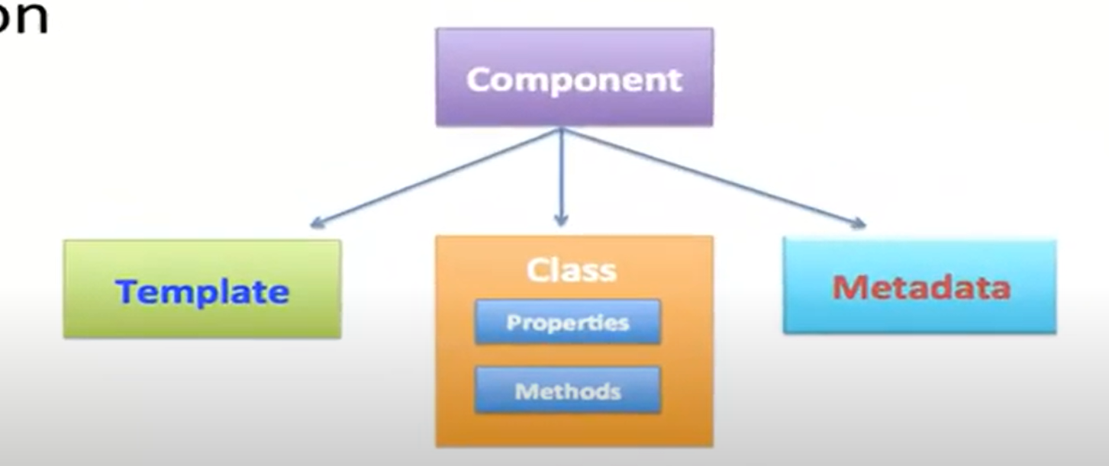

Templet defines view and created with the help of HTML.Metadeta is defined using help of decorators.

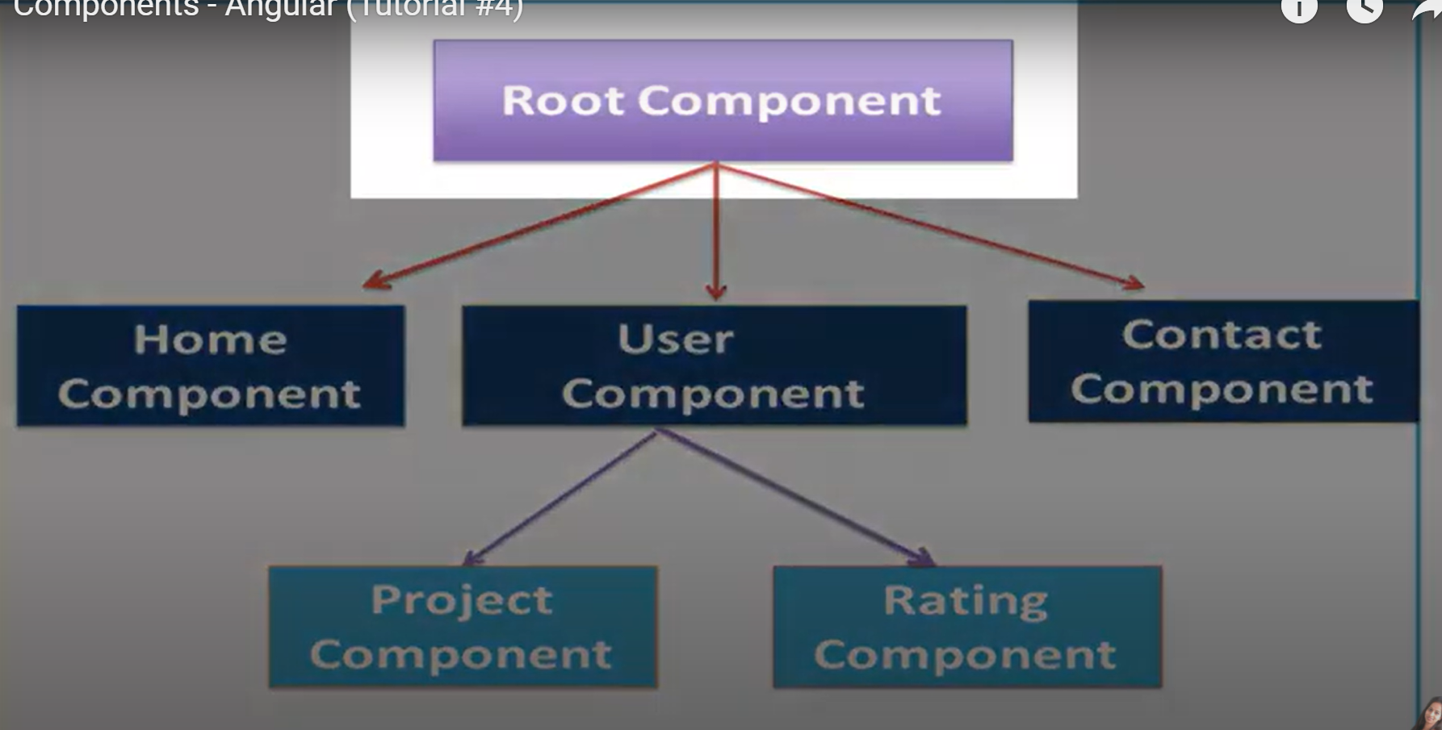

App.component.ts is our root component.

Creating component :

1 : Create class same as in java. We should append export keyword to mark it as public so that we can use this class in another file as well.

Class is just type script calass to make it as angular component we will attach meta data with the help of decorator @Compnant (It is decorator) and import @componanrt as well it is inside angular core

Component : selector means with this name we will call this component.then template because each component have associated template

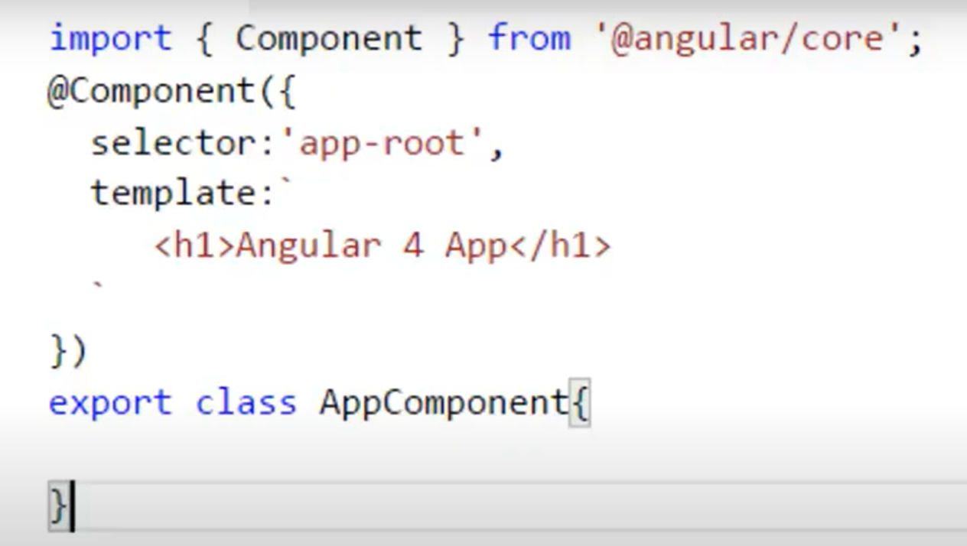

Once we have created a component we must attach it to a angular module.for that we will do in angular.module.ts file this calss is marked with decorator is @NgModule

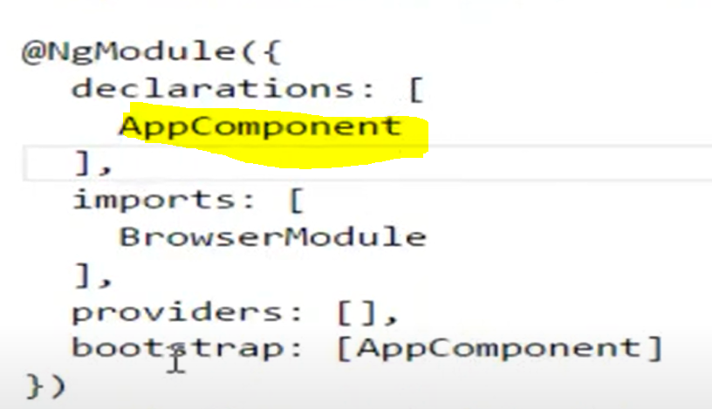

Inside the declarations we have mentioned the component and that component is going to be called from index file or other file. And we should import dependency as well. And component should be declared as export to visibility of component to module.

If you are calling any component from HTML that component should be added in bootsratp of ngModule.

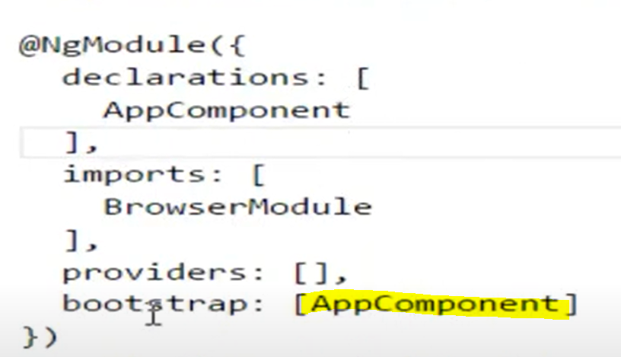

Calling from HTML

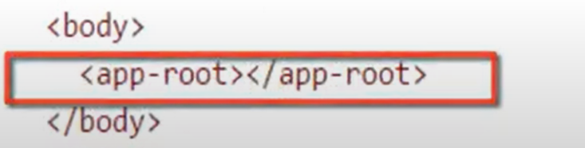

After this we can use ng serve and then we can see changes in index file.

Views can be defined with template or template URL .

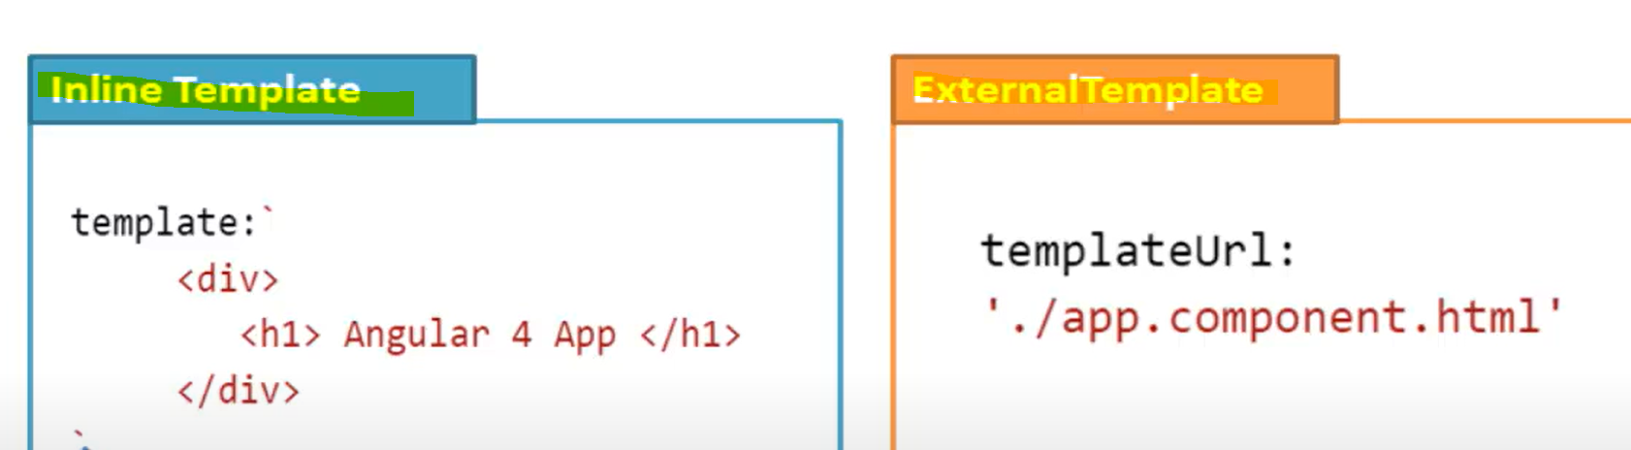

We can write inline template with single and double quotes as well. For doing it in multiple line we use Back tick syntax ``

Data binding allows communication between component and view.

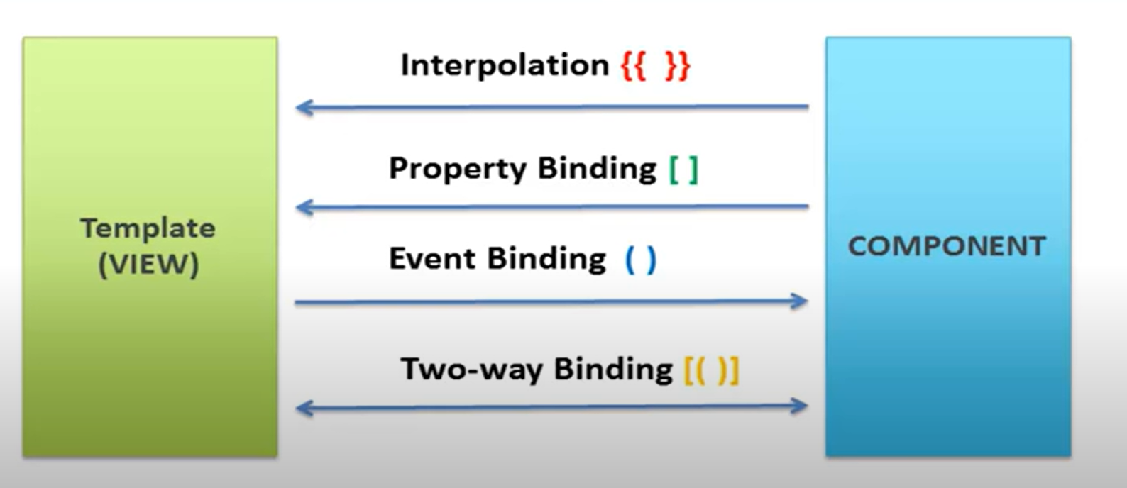

Creating component using CLI

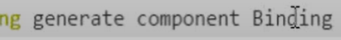



Means it will not have testing files. – -is means don’t create CSS file is is stands for internal stack.if we are using CLI then this binding component will get created inside declarations automatically.

Interpolation provide binding from component to view it is one way.

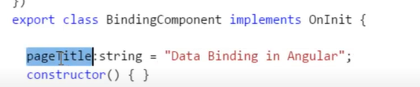

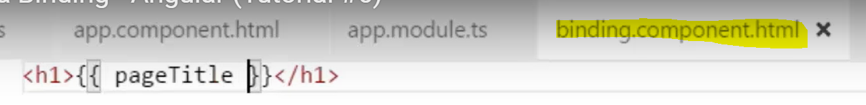

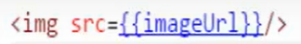



Property Binding : allows us to bind property of view element to the value of the template expression.

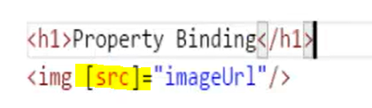

Interpolation requires expression to return a string if we want to set non string value then we can use property binding.like for Boolean use property binding.



It will not work as varble is Boolean.

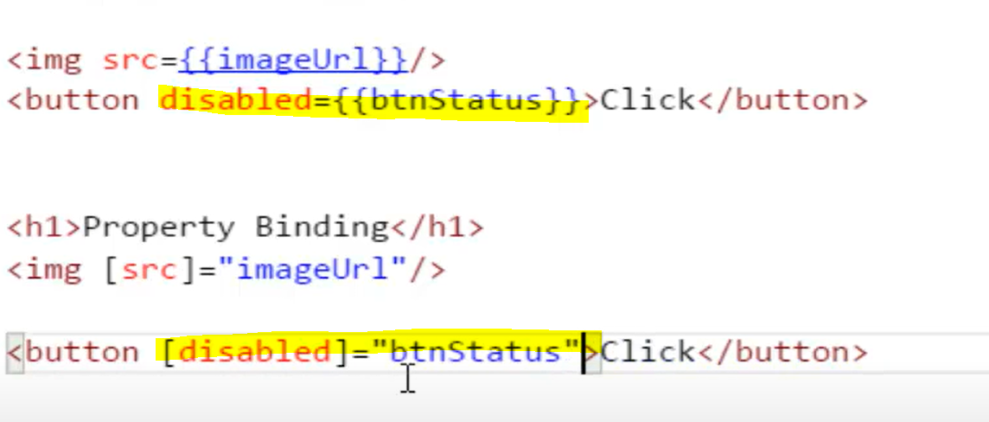

Event binding : from view to component like user is doing events like clicking buttion n all.



This function defined in component.

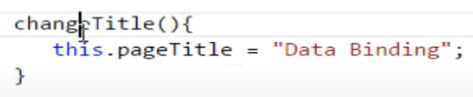

If we want variable to be in sync, then we use two way binding. Usually we can use in input boxes.

Imposr form module for input box which will be declared in app.module.ts file also include module name inside imposrts as well in same file.

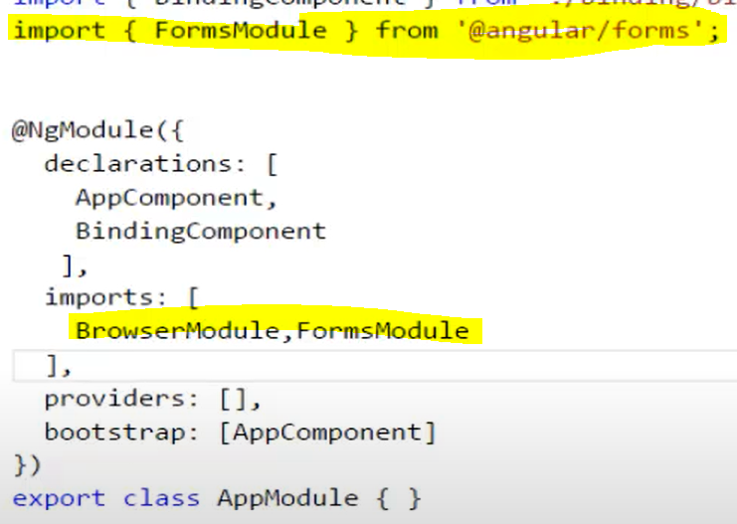

Inside HTML file of component



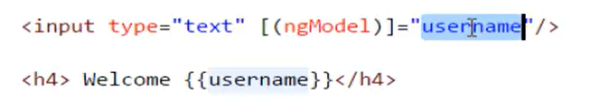

Any change in input box will get reflected in h4

Directive :



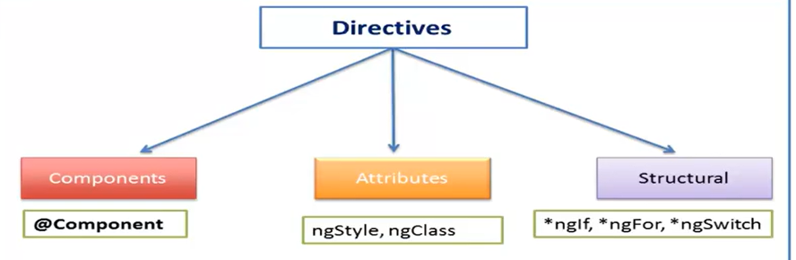

Componant derective :

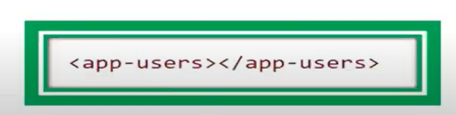

Attributes : 

Bootstrap Using CDN (Content delivery network ): Include CSS file and js file using link.

Isko appcomponant.html me add karenge.

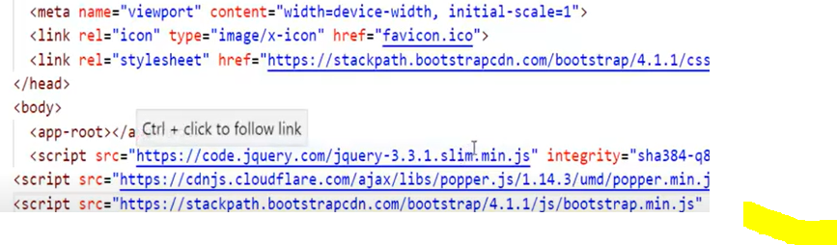

We can do in this way as well



Then npm install bootstrap@3 for version 3

Inside **angular-cli.json** file we will add bootstrap to load bootsrap in project.we can add global CSS or JS inside this file.

If we install any package through npm then that goes into node_modules folders.

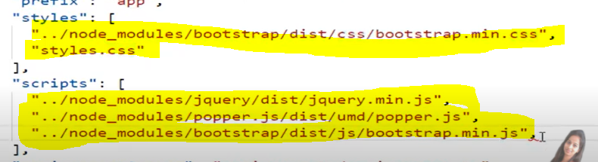

If we make any changes in angular CLI file then we have to restat server.

ngFor:



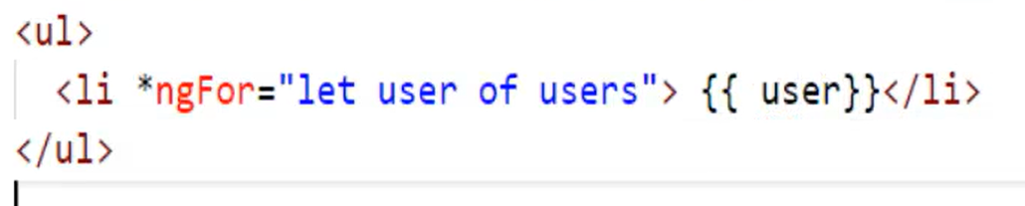for Customized object :

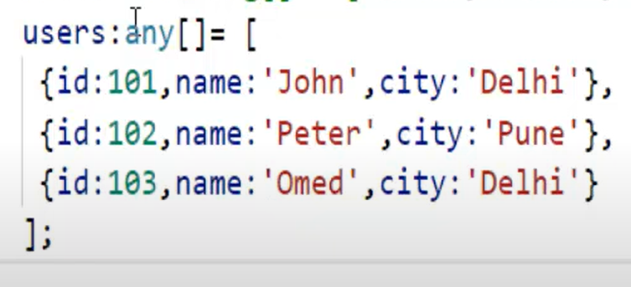

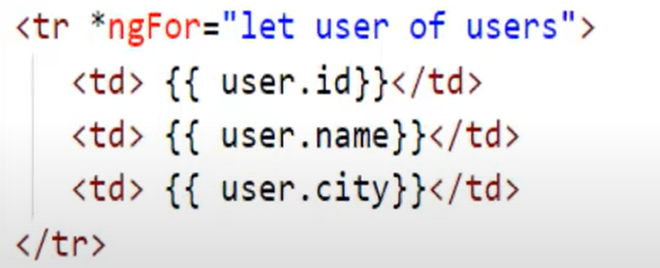

We have added index in this.

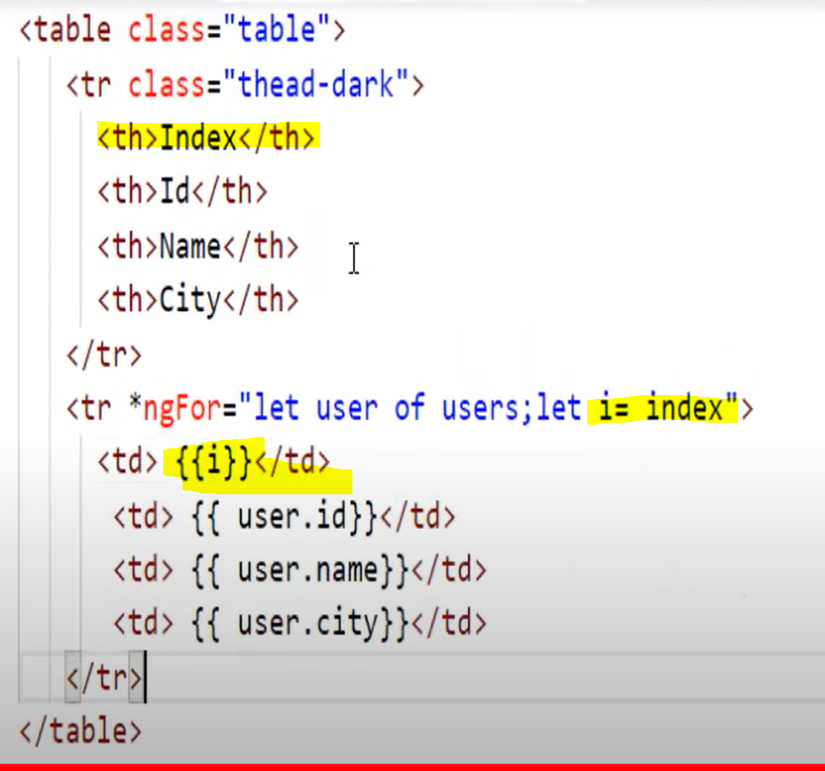

Ng if :

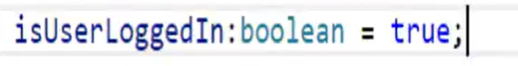

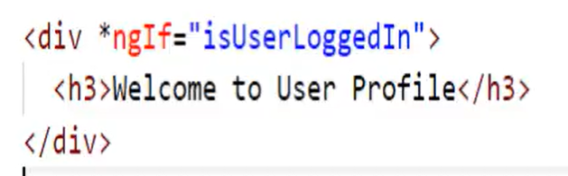

Ngtemplate is angular element for rendering the template.

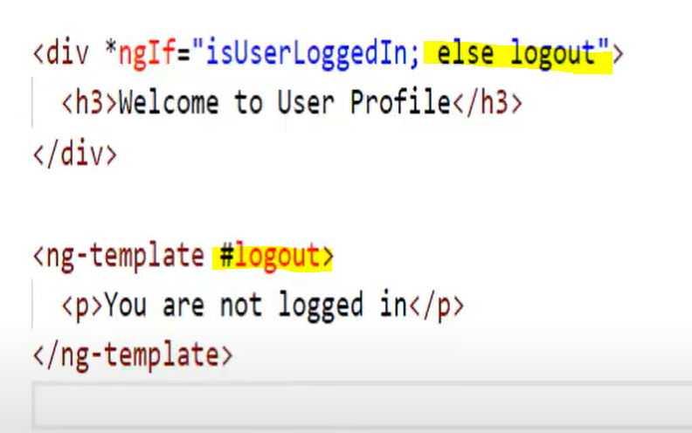

Ng-Switch :-

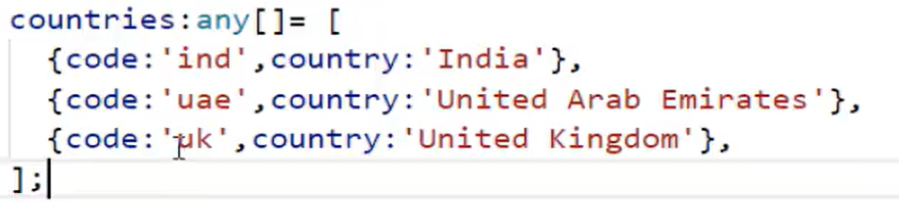

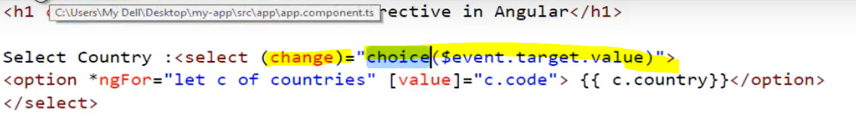

We are showing result based on selection of country.

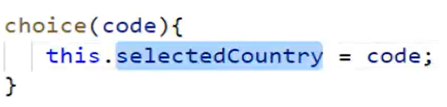

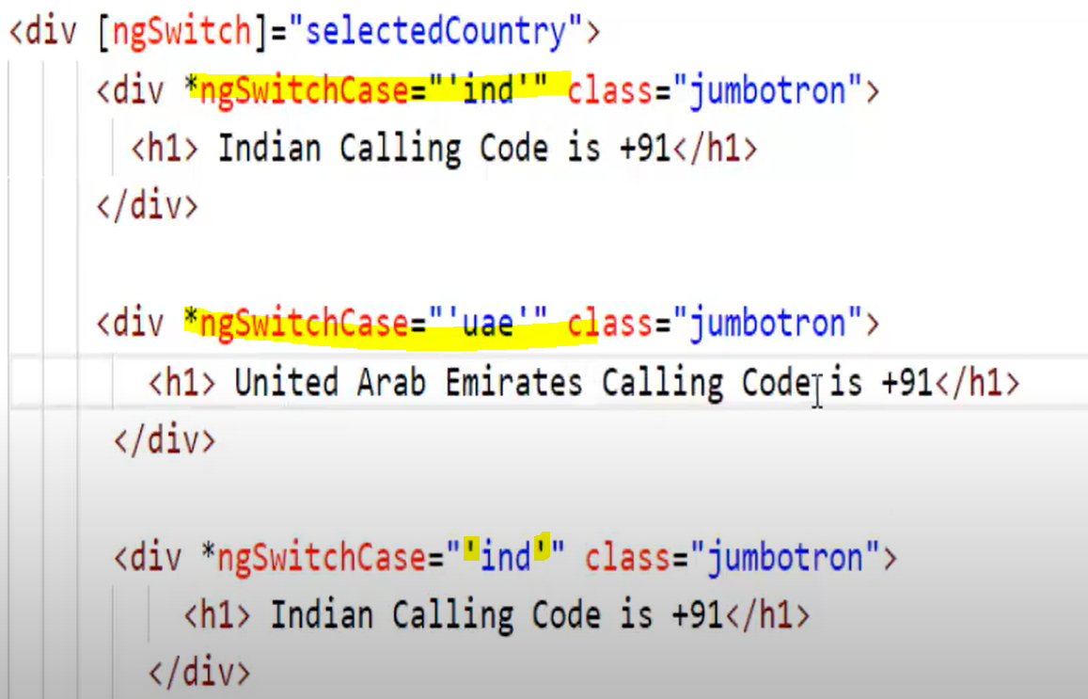

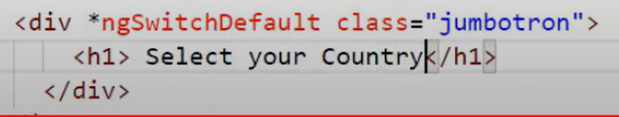

Nested Componanats :

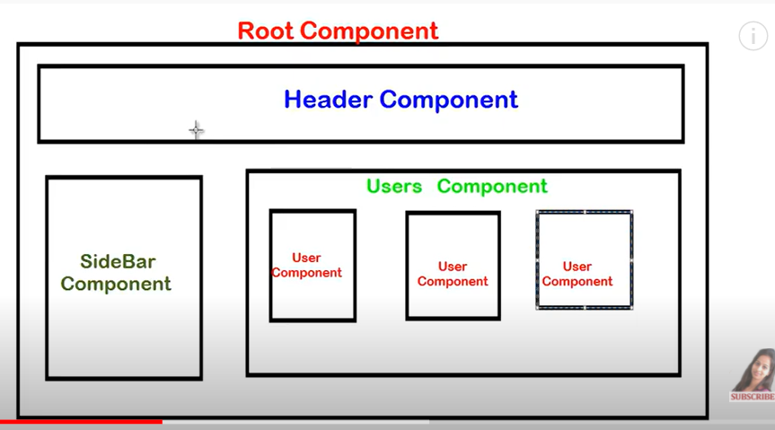

Create cpmponent separate and then add inside main folder.

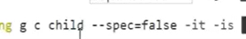after creation child component is added into root module.

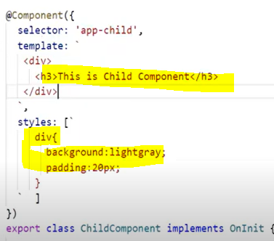

Now just add this inside main indexhtml page.

**Communicate from parent to child : -**

Passing data from parent component to child component we will use concept of input decorators.

In example we are passing username value from parent to child.we can do so by adding property binding syntax.whatever we have name given in property binding same name should be given to child component as well .

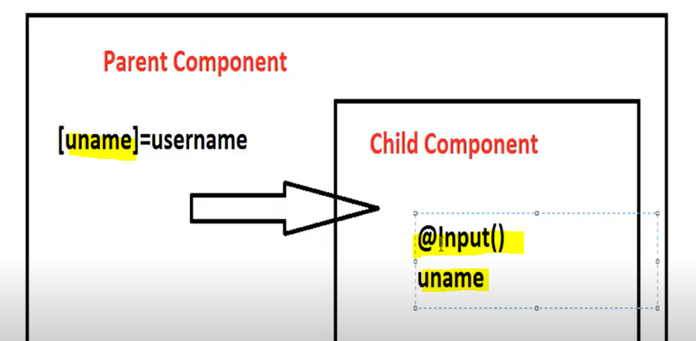

Now question arises how child will understand this value coming from parent component.we can do so with the help of **@Input** decorator.

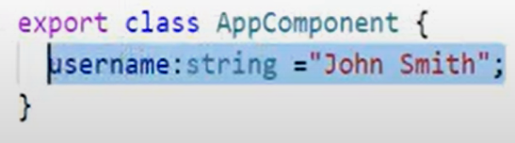

Above variable created in parent. Then doing property binding with the help of root component index page.



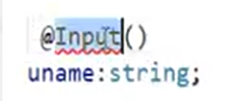

Import input as well : it is inside angular core .



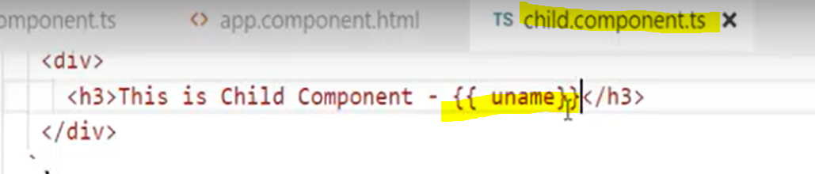

Added uname to the html part of child so that we can show values as well.

**Communication from child to parent component : use @Output decorator child to parent is basically an event based communication.Now child is publisher and parent is subscriber.**

**Inside child component :**

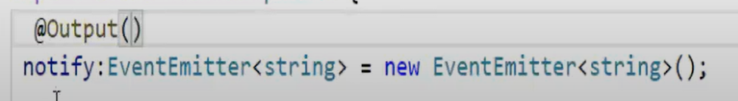

**We will import output as well.**

**Child component inline HTML changes**

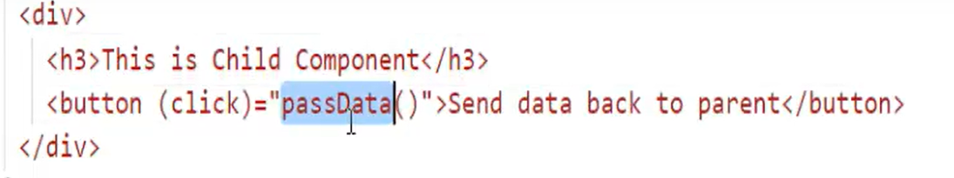

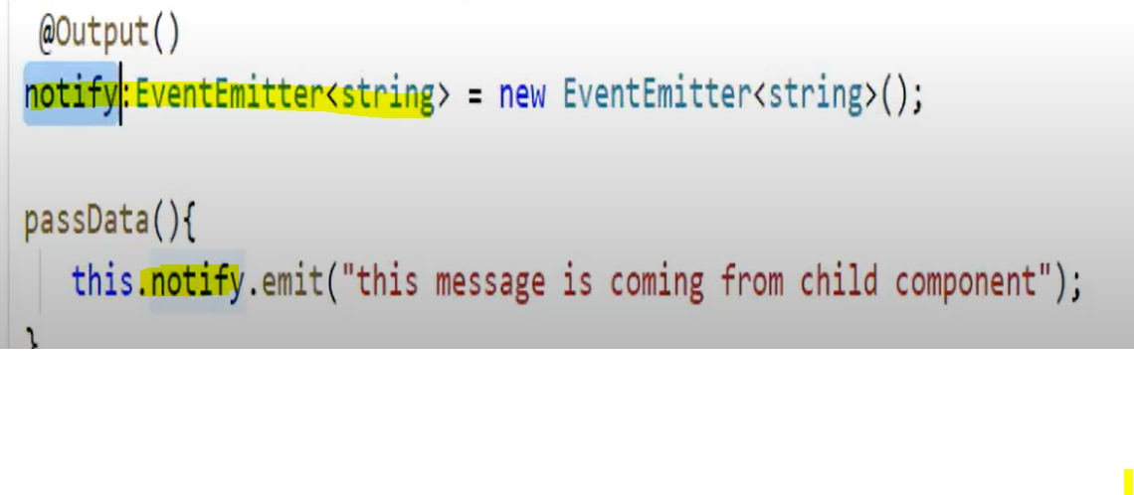

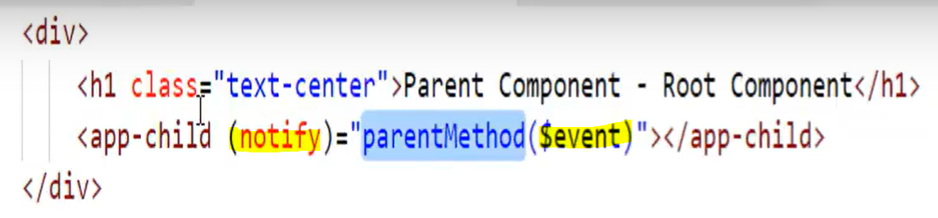

**Here inside parent component where we have definded chaild component we are calling notify and calling parentMethod(). We can trace the notify value using $event.**

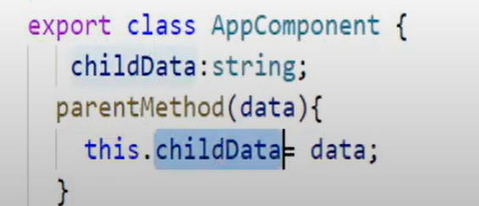

**Parent class.me ye defined kiya ab wire kar denge parent k HTML se.**

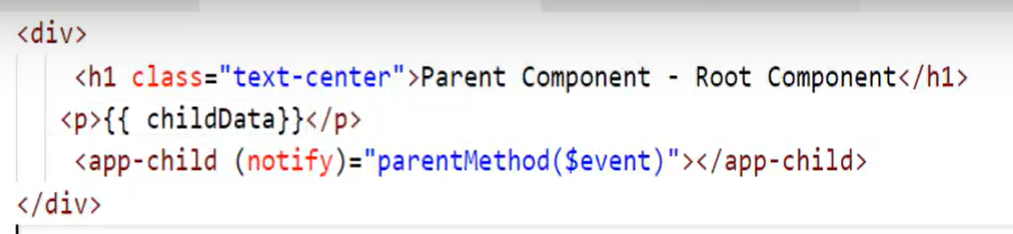

**Pipes : - previous versions of angular there was filters in angular upper versions it is called as pipes.**

**Transforms data before display to users.**

**Builtin Pipes**

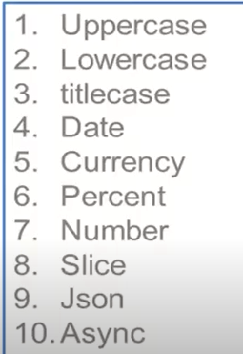

**Async pipe use to handle asynchronous data.**

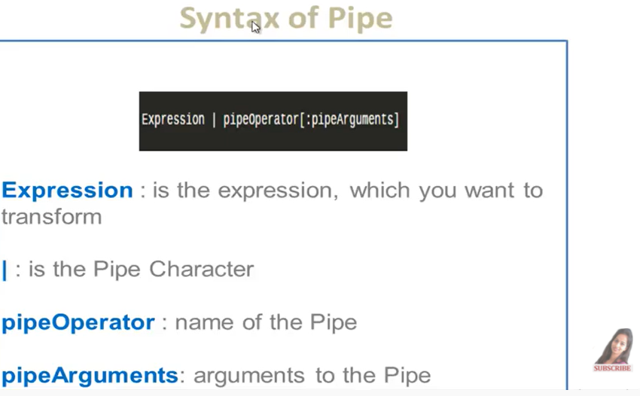

**We can also do chaining in pipes as well .**

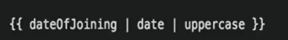 **Output of date pipe will work as input for uppercase.**

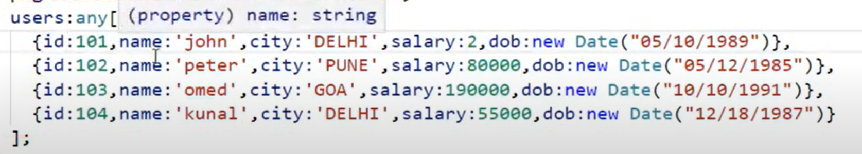

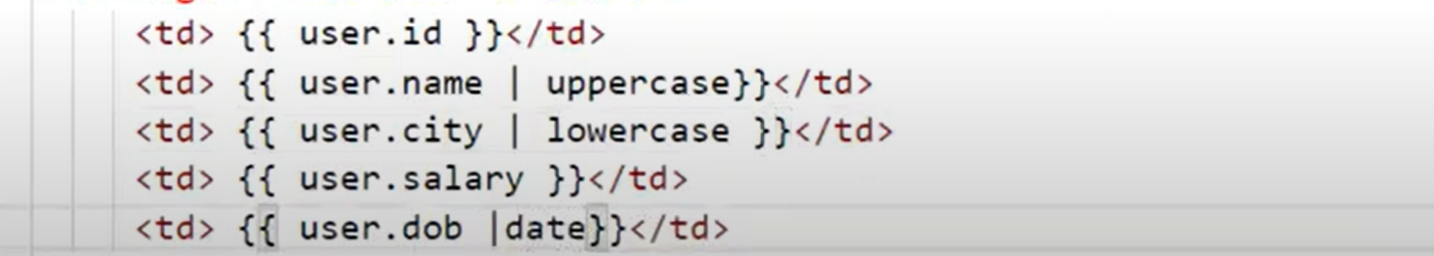

**With arguments :**





**Default is symbol but if you want code then another argument send**





**Mens minimum disgit before and after decimal is 3**

**JSON pipe is basically used for debugging.**

**{{arrayName | json }}**

**HTML Pre tag gives formatted json string.**



**Customs Pipe :**

**Creating age pipe by ourself :**



**Insite pipeTS there is decorator @Pipe**

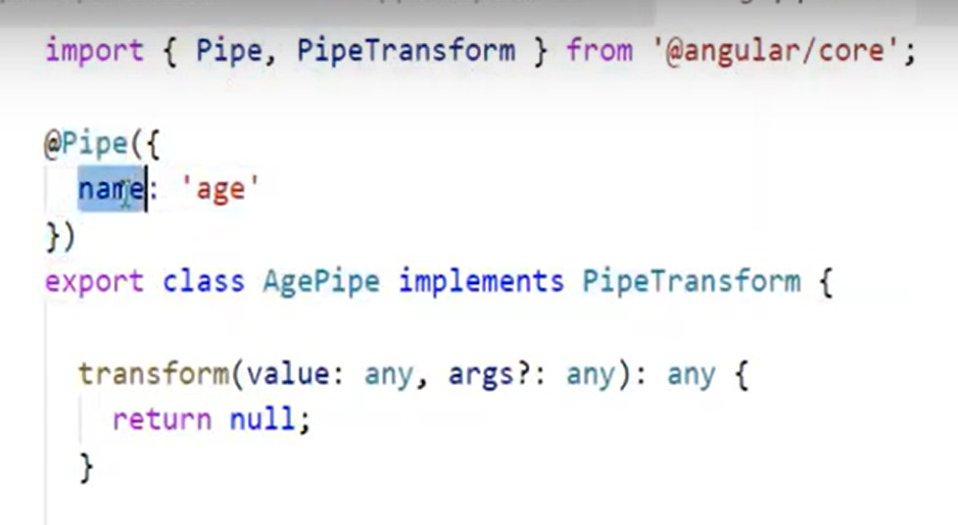

**For custom pipeline we need to implement pipetransform which has transform method to override.**

**Value gives data on which you are going to apply pipe. Args? Is optional if we want to send as paramerter like we have done for currency.**

**Calling age pipe from HTML**



**Logic for returning age**

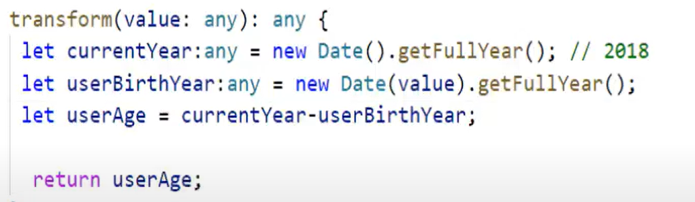

**Angular Serviece : chainig of data across the application required.**

**If we want to share user details across two different component then we can do so by many approach (using @Input we can get data from parent to child component second approach is to create same userdetails in each component so code replication will occur and also data will not be consistent) or we can also do it using services.**

**Service is centralized location in my application.**

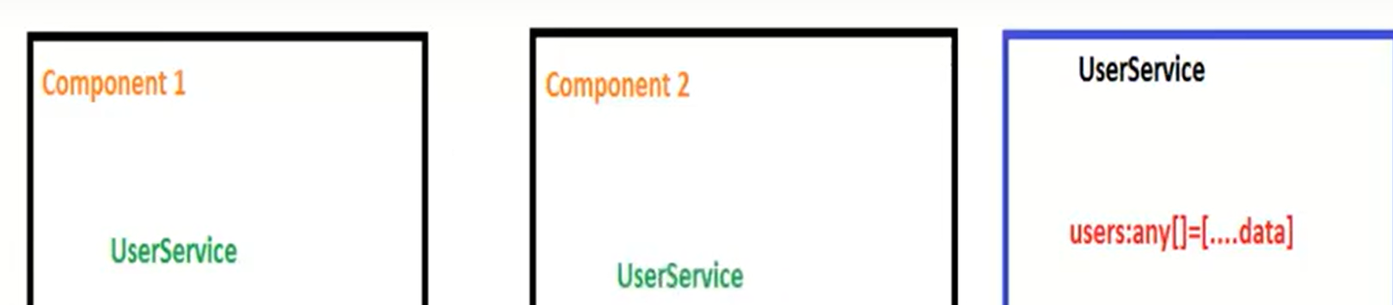

**Component is inject userservice to itself.**

**This data we are shifting main component to new service**

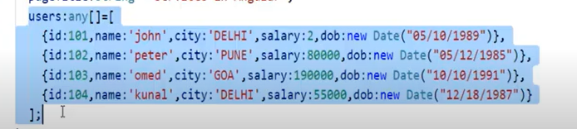

**How to create service :** 

**Service class have @Injectable decorators.We can inject service in any component.**

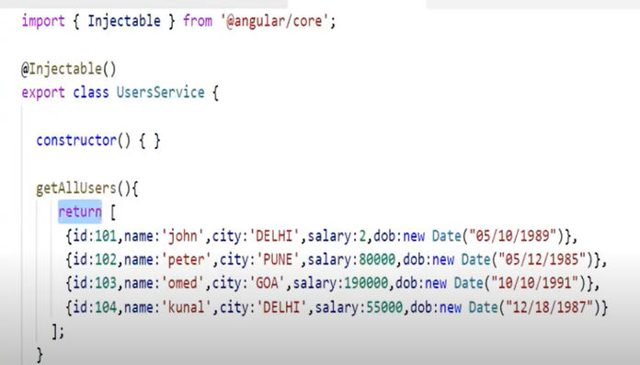

**After this our next step is to register service.All services in angular must be defined in providers of root module.ts file**



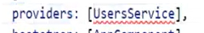

**Now we need to inject reference of service in component.we can do so by defineing servie in constructor of component;**

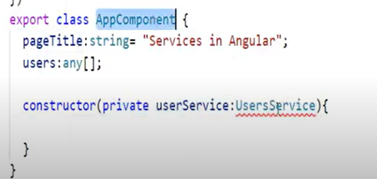

**In angular Constructor is used for dependency injection.**

**NGONINIT is lifecycle hook of angular component : every hook is coming form some interface so we need to implement functions of that interface as well.It is used to do initialization kind of thing.**

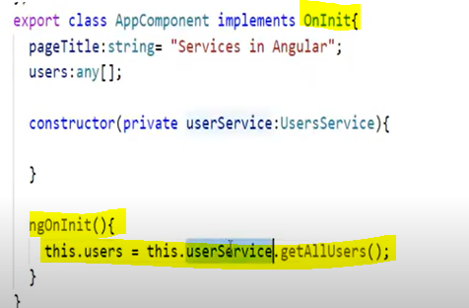

**HTTP Service : -**

**Step 1 : Enable HTTP Service : We will add in main module.**

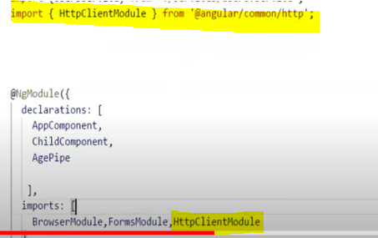

**Step 2 : Inject HttpClient in service we have created we can do same as parameters to constructor**

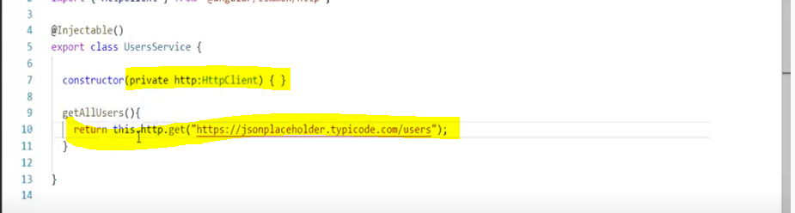

**In angular HTTP or async call returns observable in response wiz lazy in nature we need to subscribe it first.**

**Now inside Componant**

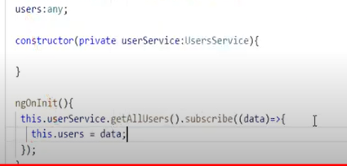

**Error Handling in Angular : for observable we can use catch operator to catch the error.**

**We will catch the error inside component section.**

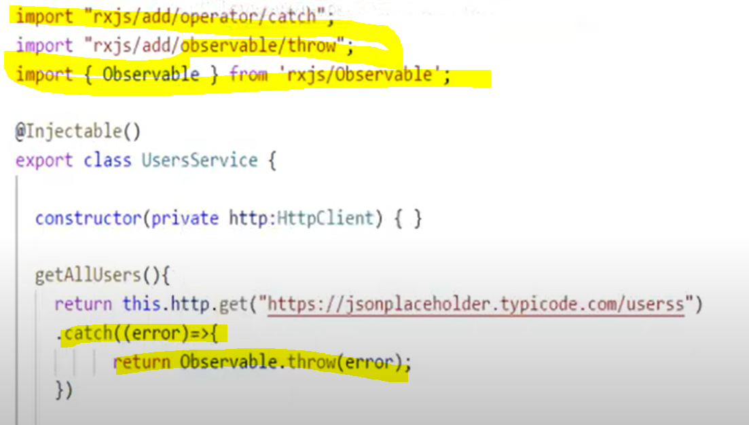

**Now ngoninit of component will also get changed .**

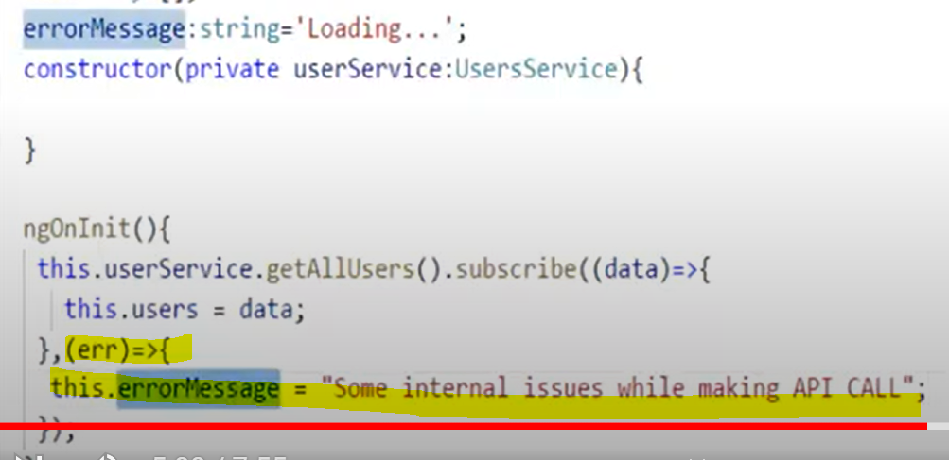

**Now we will change in component HTML file to display results and we are done.**

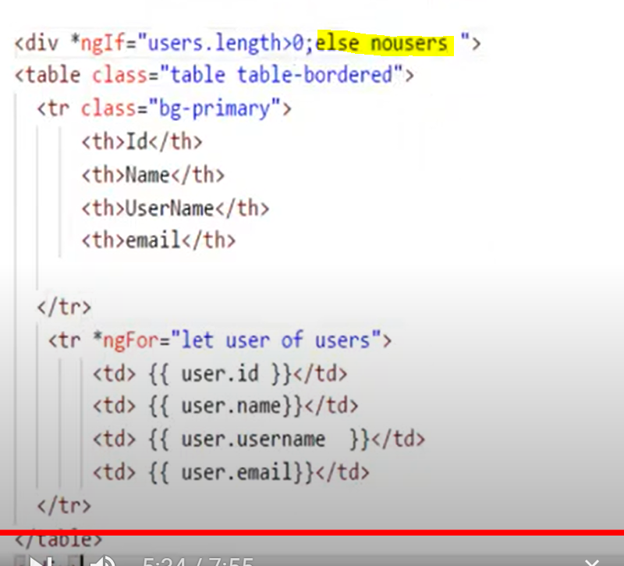

**Wrap error in ng Template**

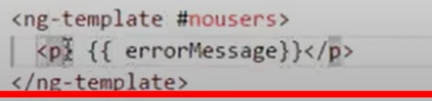

**Angular Routing : Navigating from one component to another by user evets like click**

**Create different component using CLI Command**

**Step One :**

**Create menu inside html of main comopnant and configure router**

**App.module.ts me hum add karenge router ko.**

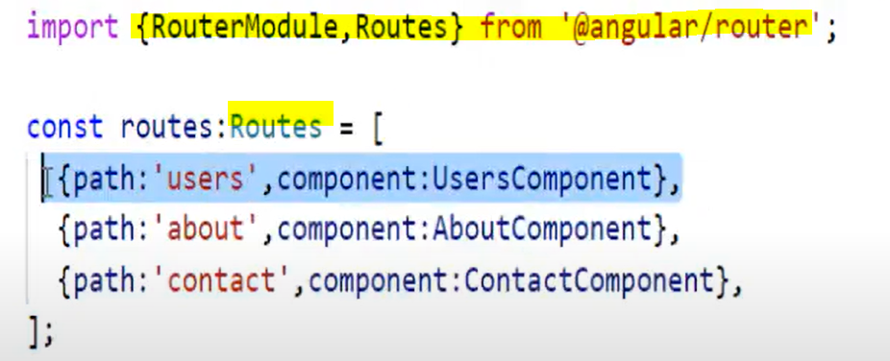

**Now Import it in imports array as well**

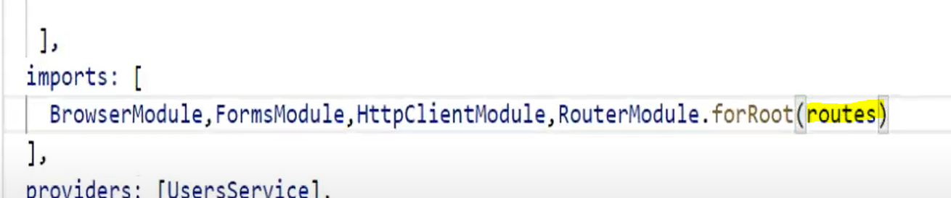

**Yellow highlighted is variable of type Routes wiz defined above**

**Router-outlet directive : With the help of this wee can say that here we want to load user component.**

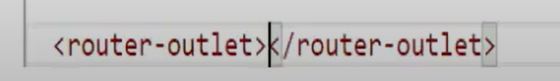

**Defined inside main comopanet HTML**

**For default path we can leave path value as blank and we should provide pathmatch as well otherwise it will not work.**

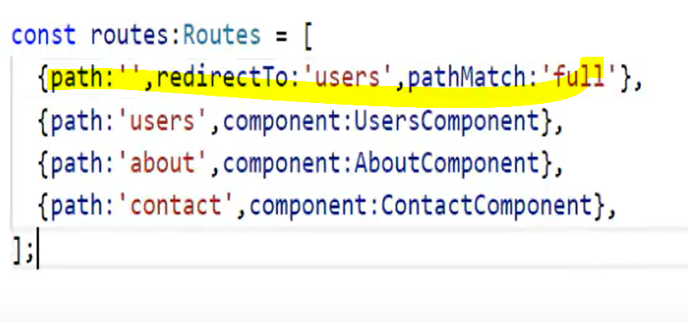

**We can use match all route (can be done using ** ) to catch is user have defined some url wiz not mentioned then we can handle that as well .**

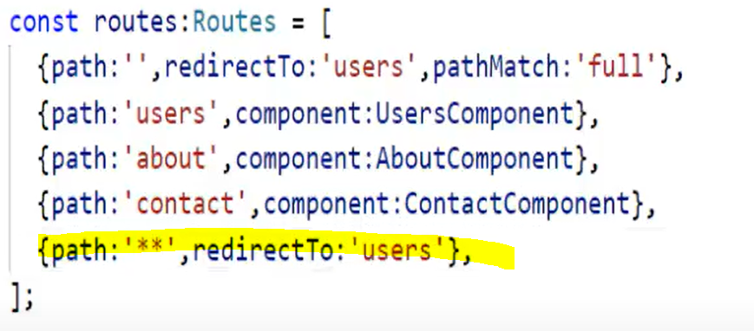

**Step 3 : Navigation Linking .**



**Done.**

**Router Parameters : in this way we can send data dynamically.**

|  |  |
| --- | --- |
|  |  |

**HTML me id ko link me convert kar k navigable banao.we have made routerlink array and passed ass parameter.**

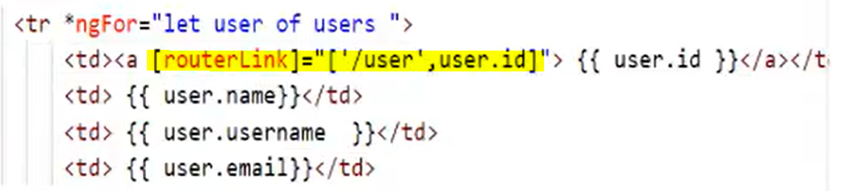

**creates one more componant to show only that particular user information.**

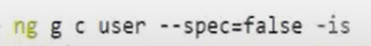

**Now router links are available now receive router link variable values from URL to user componant.With the help of activated route we can get data from URL.**

**Import this and get this in to parameter constructor**

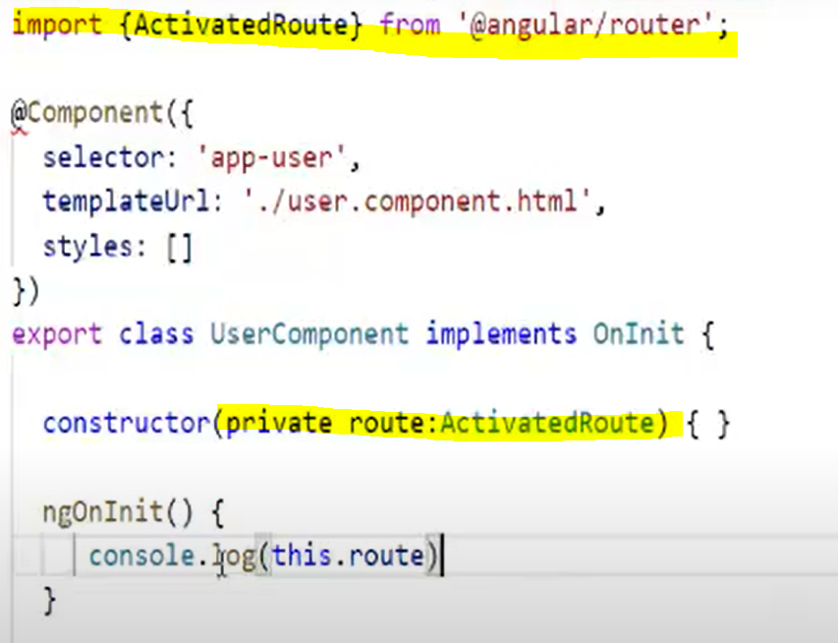**this.route have very big object us me se humko id nikalna hai so we can use**



**This will give you iD.**

**Now is id ko variable me le lo and service call kar k get user details se data nikal k page k HTML me dikha do. But ab ID wise data chaiye particular user ka to ek function bana lo jo id k base par data return kar de .**

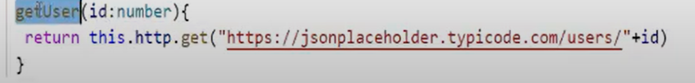

**This method gets called from componant**

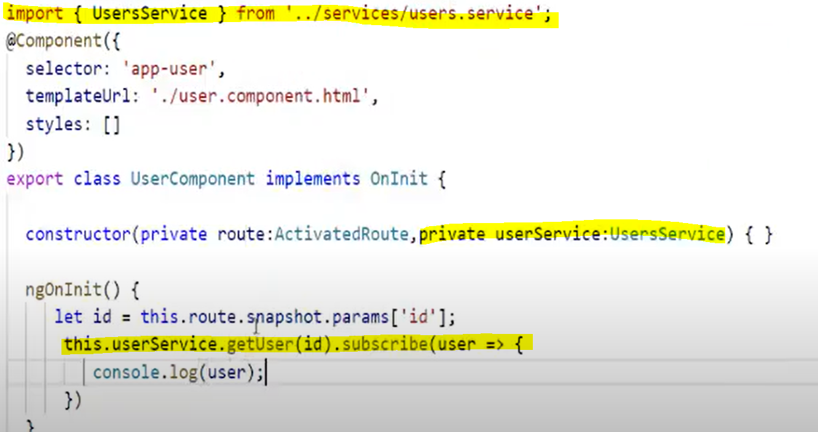

**Subscribe kiya hai because observable hai.**

**Inside HTML file we can do this.**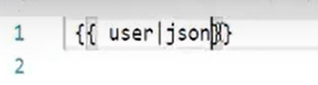

**Nested Routers : Routes within other routes.**

**We want to show either address details of user or company details of user so we can say that we will create two component one with company and with address using command**

**Ng g c company, Ng g c address**

**Add children in previous route and import componant.**

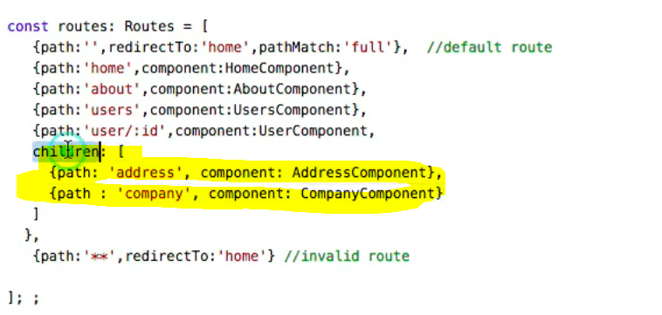

**Now inside user componnat html we will add navifation with address and company**

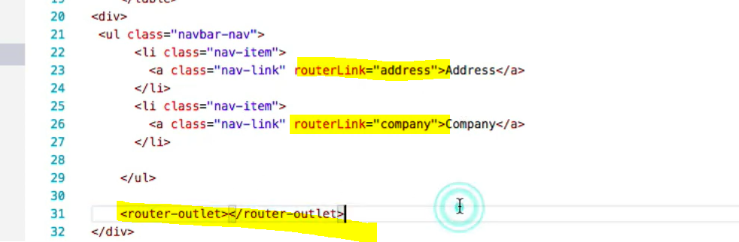

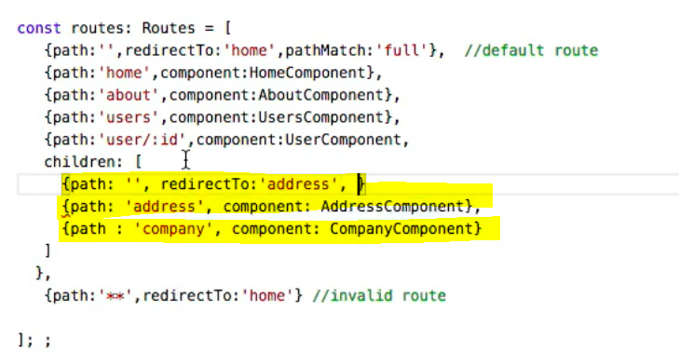 **default value hogi to address par jaega pahle wale me value kuch ni aati.**

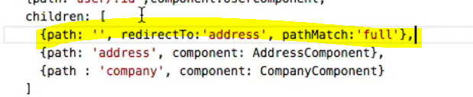

**Named Router outlet : if router outlet has name then called router outlet.**

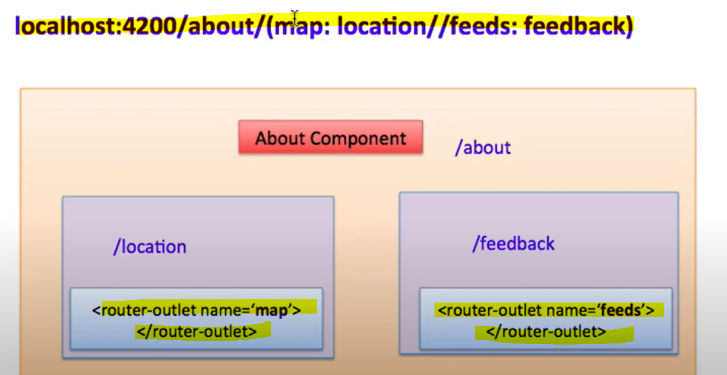

**Created two componant with name location and feedback**

**Inside about html we have done this**

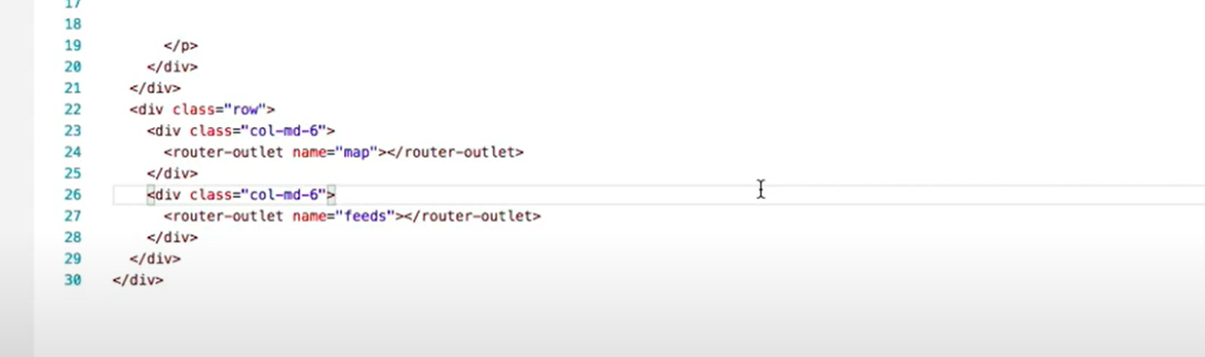

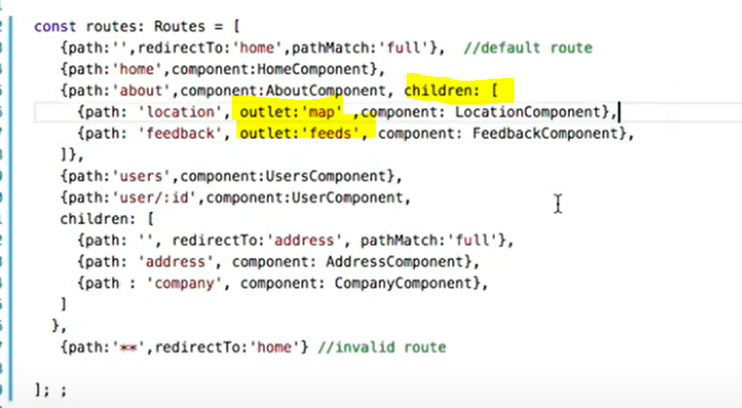

**In this way we can add named routers.**

**Protection of route with the help of guard :**

**Can Activate Guard :**

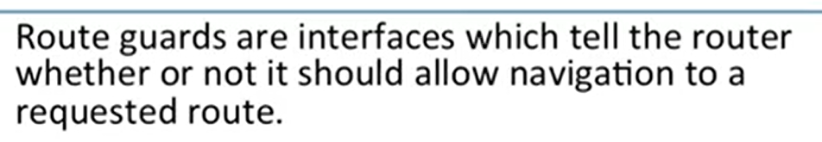

**Guards can return either Boolean observable<boolean> or promise<boolean>.**

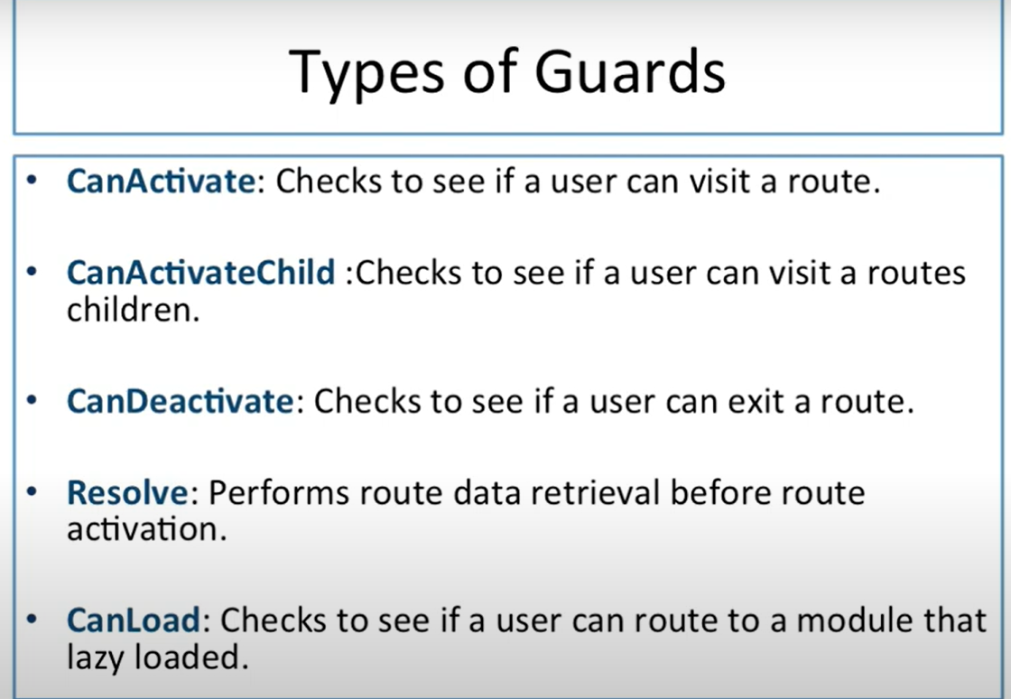

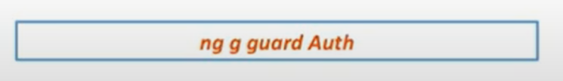

**Aim is to block all the users route which are not authenticated.**

**To create guard in angular.**

**create service to check weather user is authenticated or not.**

**Inside the providers we need to register our routes inside root module.**

**Guard is implemented like services and all services provided in provider.**



**Inside Approuting Module**

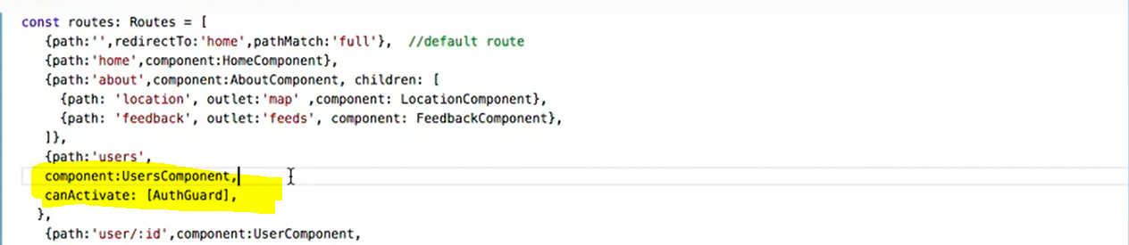

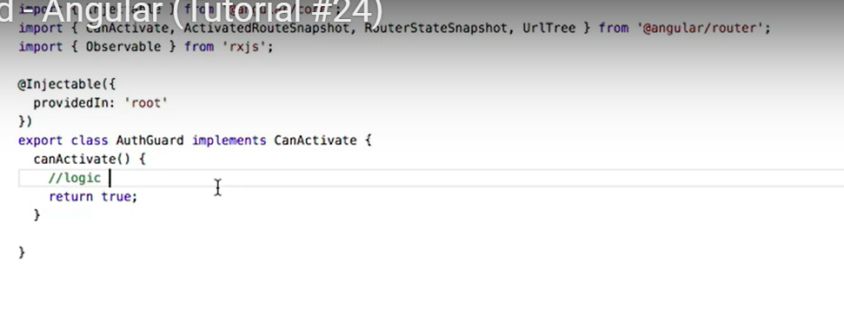

**Now if user returns false then user can not go to user page because we have disabled.Inside auth service we are making fn is user loggedin and returning true now this function we can call in authguard by authservice in constructor parameter and the we can call isuserloggedin() function and return value.**

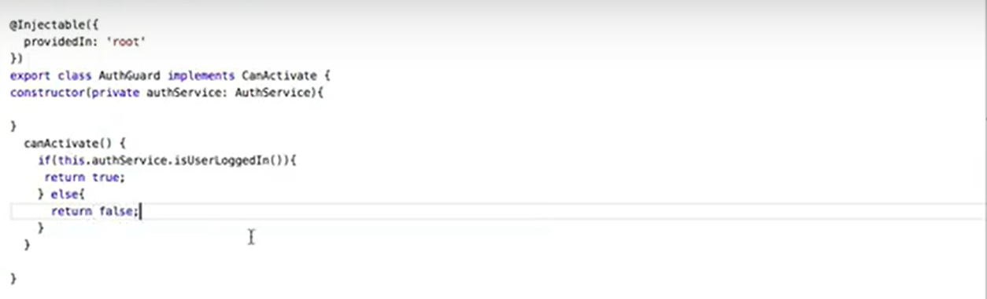

**canActivateChildRoute : in this way we can create canActivateChild guard**



**Inject this guard in providers of parent module.ts** 

Now we will implement this guard on to route.

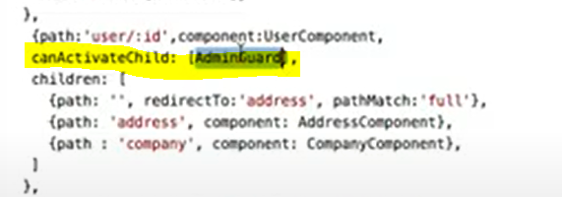

**Address and company will directed only if adminGuard will return true. In this way accessibility of parent user/id will also get restricted so we nee d to resolve this issue.**

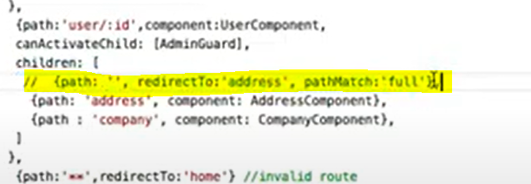

**After commenting yellow line now we can get user/id page**

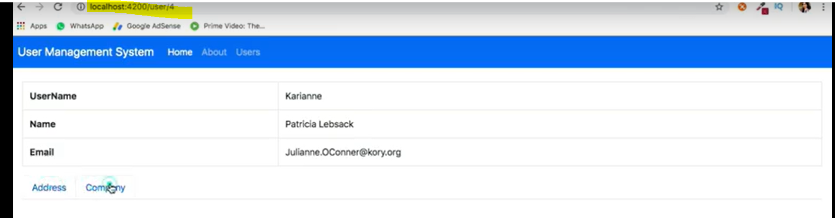

**Now we will implement canActuvate guard to authorize weather user is authorized person or not.**

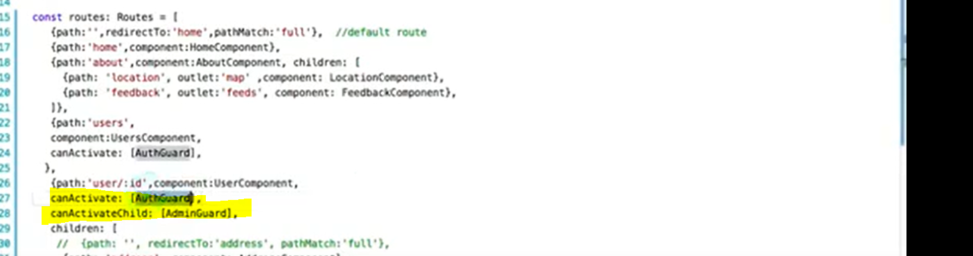

**canDeactivateRouteGuard : called when we are navigate away from route.**

**We have created one form and now we are mapping form to new componant.and their HTML file.**

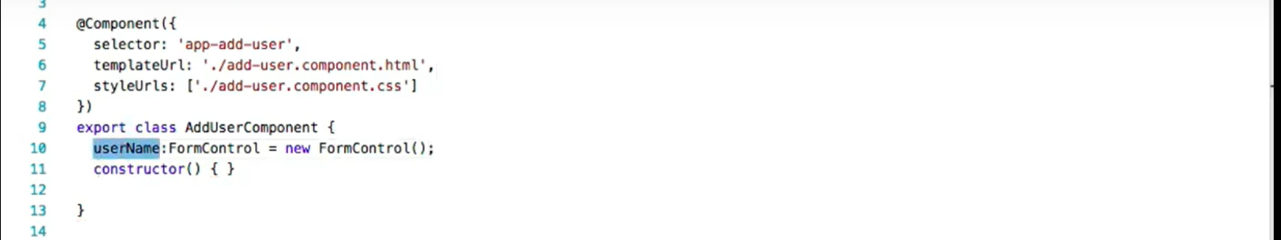

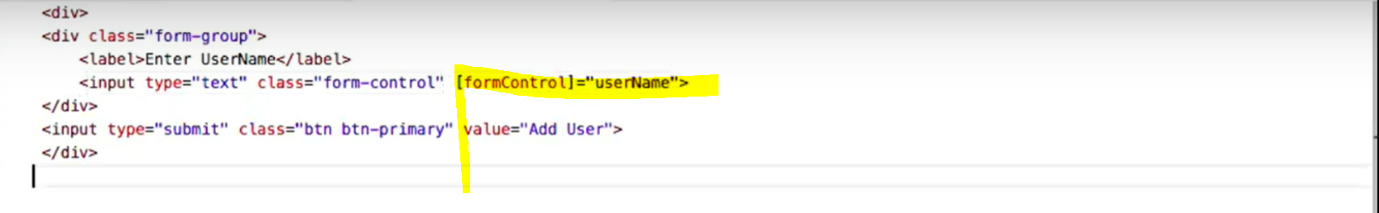

**Created deactivate guard**



**Register this guard in module.ts providers**



**Now Implement guard on route :**

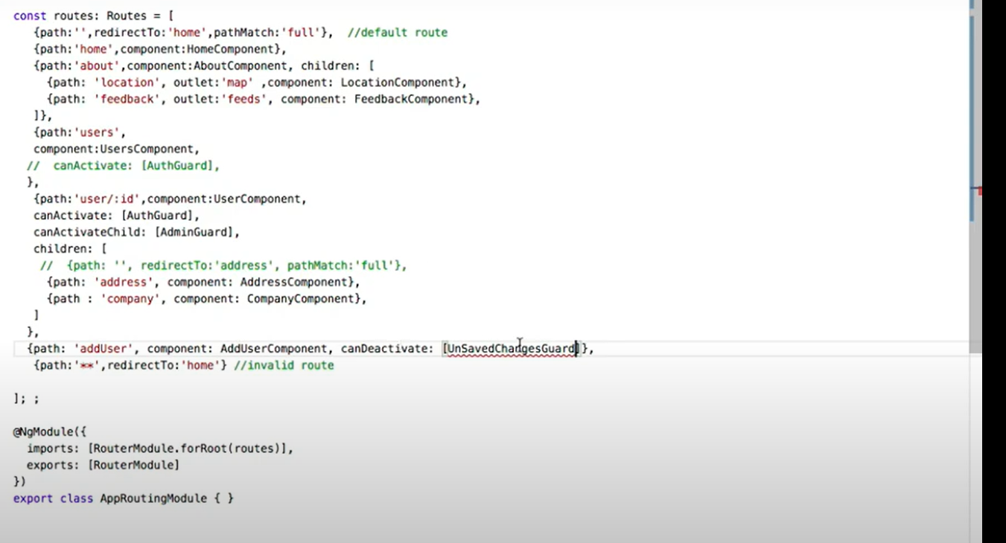

**Now write logic inside guard.**

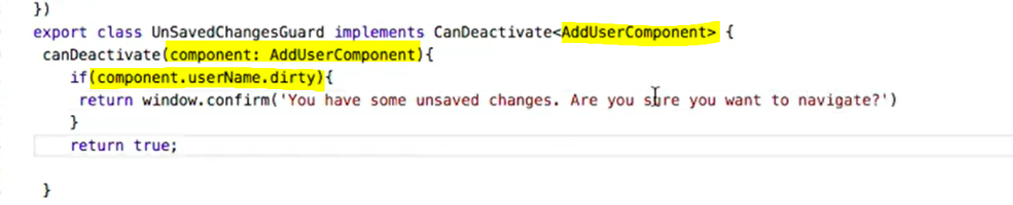

**Dirty gives true if any change in input box and givers false if if no changes.**

**Since we are using AddUserComponant so we can say that this guard is not reusable.**

**So we will write in such a way that we can reuse this.we have created interface for this and based on that we have modified our code.**

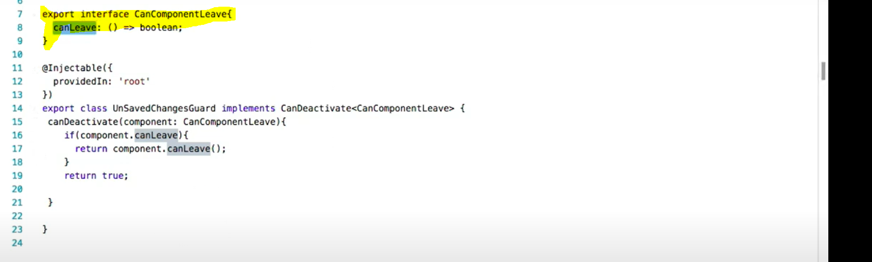

**Now we will implement CanComponantLeave inside add user componant and override method.**

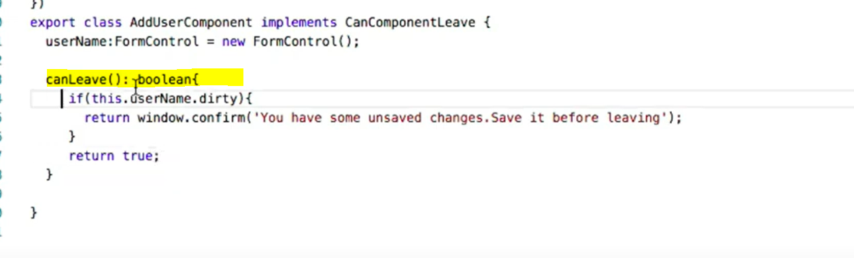

**Resolve Route Guard : certain data should be available before activating the route.**

**Create Routeguard :**

**We are modifying logic so we are calling Userservice here**

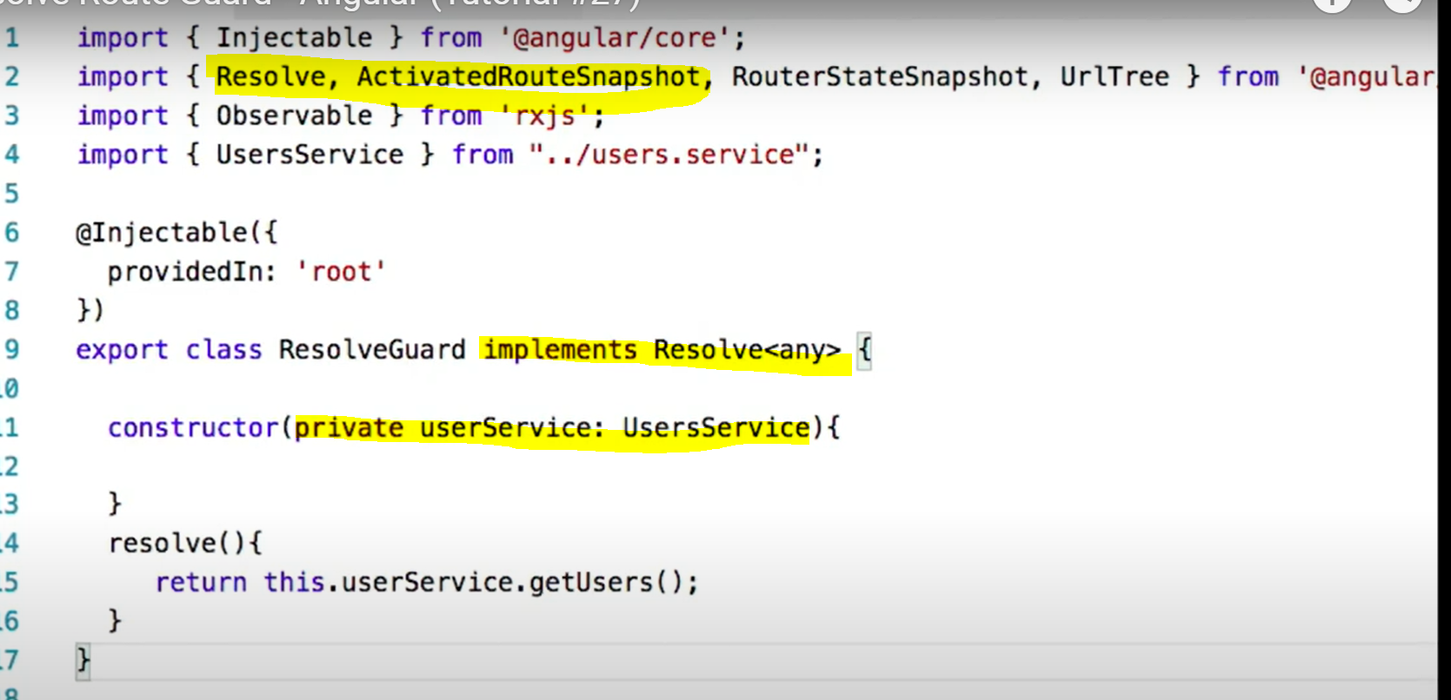

**Register guard in module.ts file.**

**To implement resolve guard we need use keyword resolve in routes**

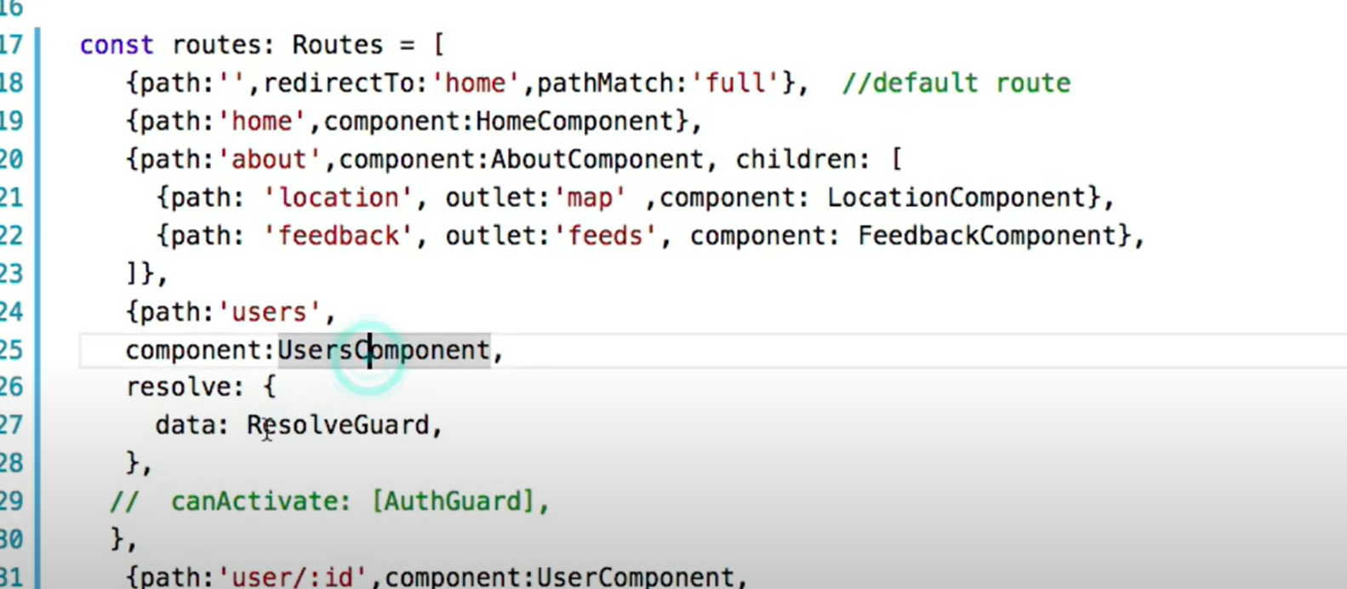

**Changes making inside componant :**

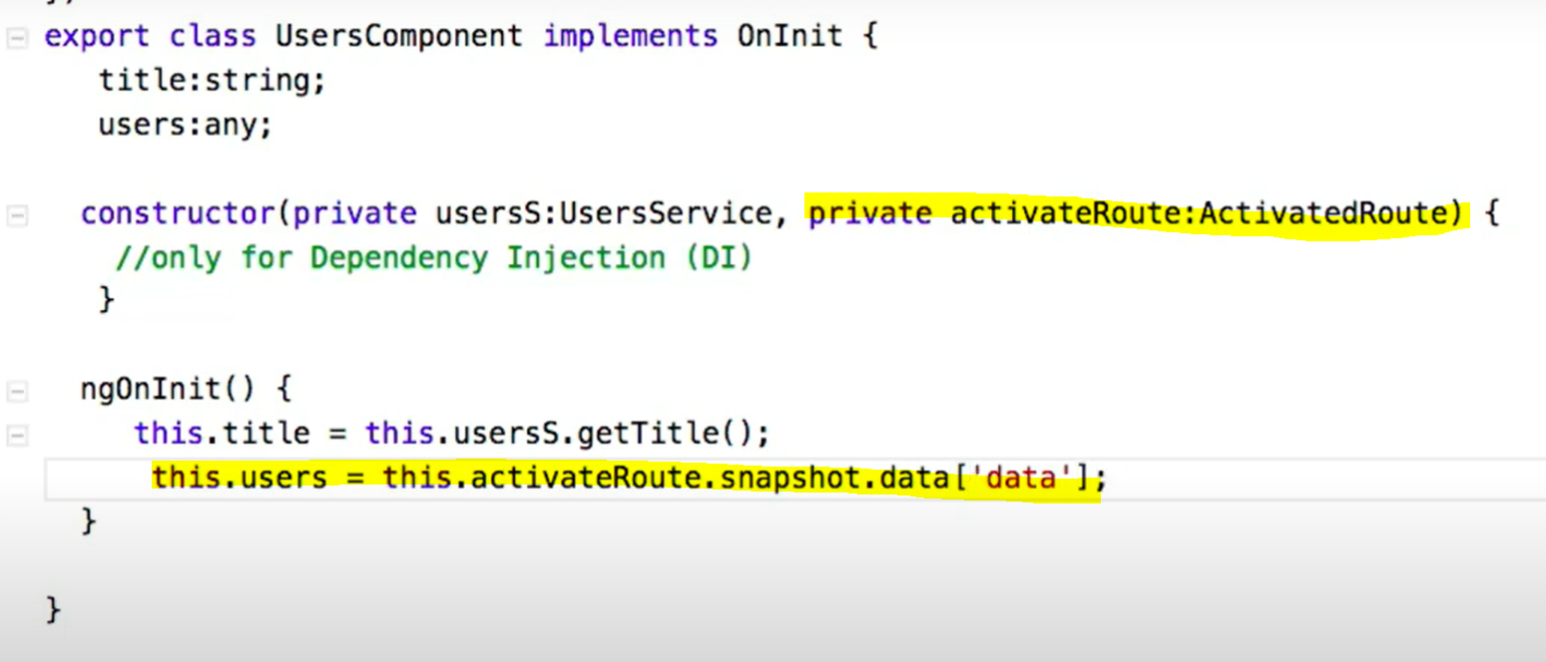

**Featured Module : can help us achieve below mentioned points. It can break big module into smaller module.**

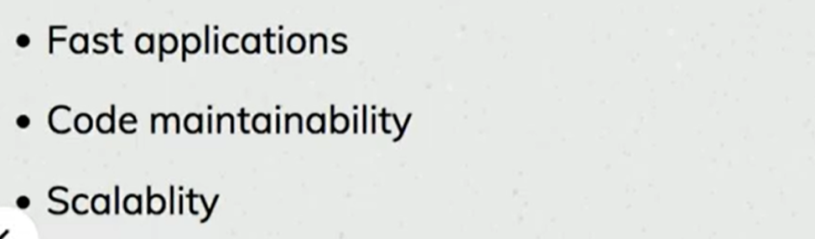

**Putting all components inside one module is not good for large scale application so we can put sub modules inside parent module and we can import those modules inside parent and in sub module we will have their corresponding components.**

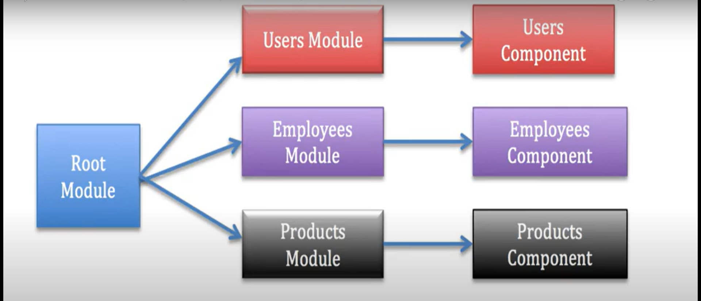

**CLI Command to generate Module :**



**Feature module will import common module as well and root module will import browser module.**

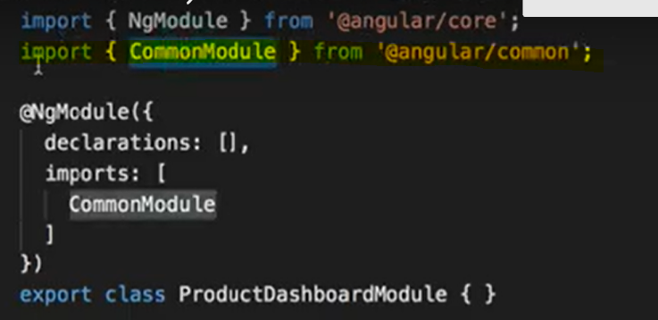

**Creating componant inside featured module**



**Inside declaration of featuremodule there should be entry of componant .**

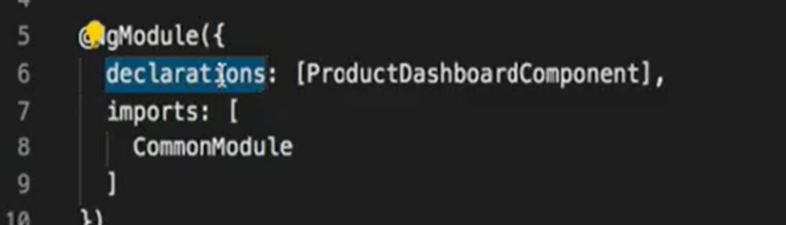

**Now merge Module to parent module.**

**We willimport module in parent module and then we will do the same in import array of main module .then done**

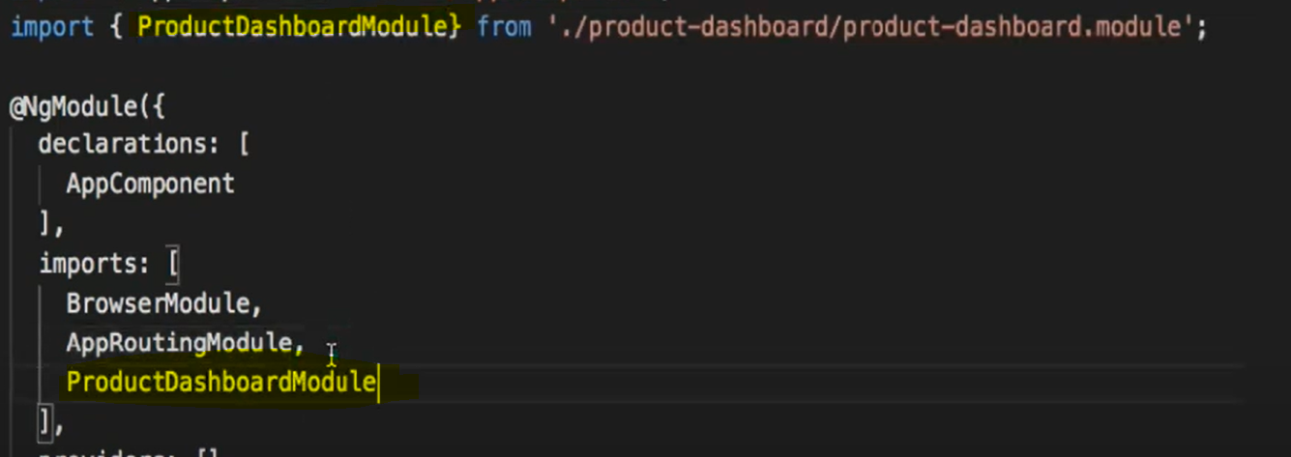

**Unless we will introduce export componenet will not introduce to parent componant**

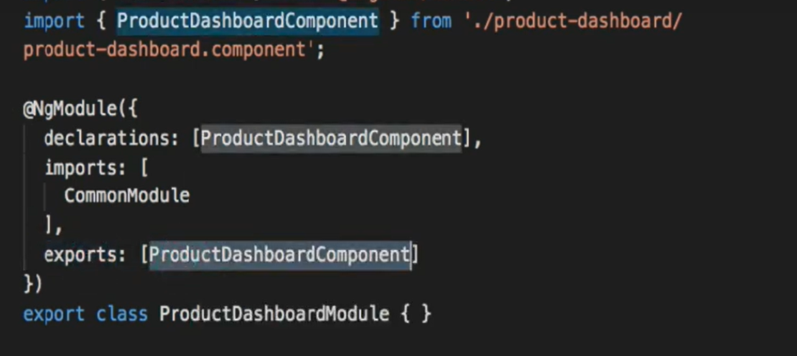

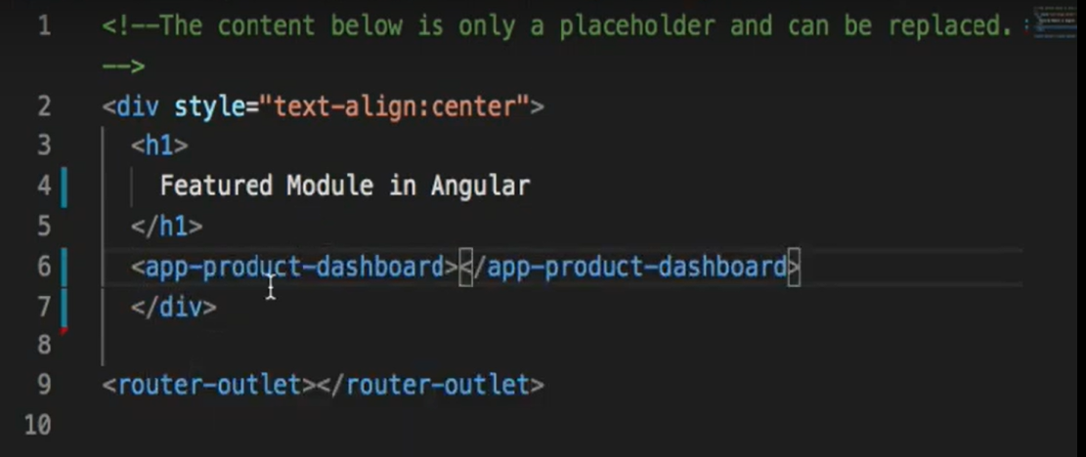

**Inside parent application we are showing module**

**Angular Lazy Loading :------- Download Augury : You can see complete router tree.**

**Created 4 modules and then calling their components .**

**By defining inside routes we can call components.**

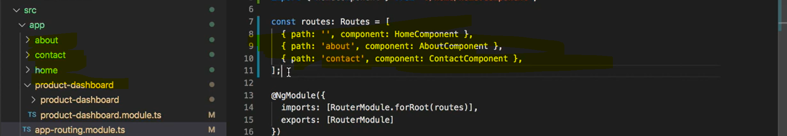

**Angular handeles lazyloading with the help of feature module.**

**Now we will load our feature module with the help of routing we will remove feature module imports and tages from main module otherwise it will load eagerly .**

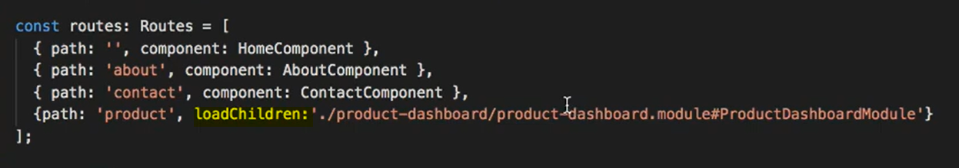

**We have defined in route.**

**Now feature module k liye b ek route create karenge.**

|  |  |
| --- | --- |
| **Previously we had export as shown in pic** | **Here we have removed export and added route variable and imported it into imports**  **Forchild used in feature module and parent will have forroot** |
|  |  |
|  |  |

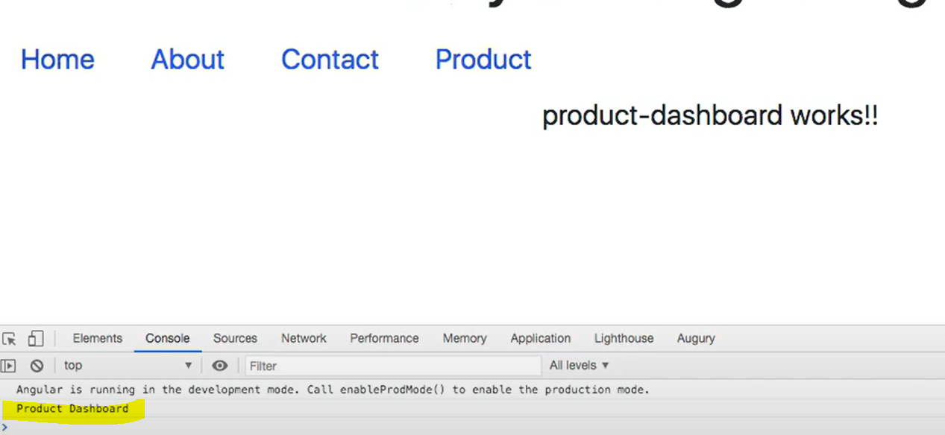

**Module is getting loaded only after click on product tab**

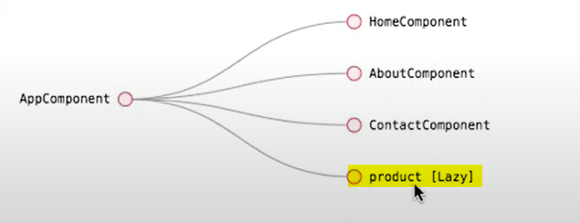

**Augry showing we are doing it lazy**

|  |  |
| --- | --- |
| **Promises** | **Observable** |
| **Perform Async operation** | **Perform Async operation** |
| **Native in js no need to import** | **Part if rxjs (Manages Async data) Need to Import first** |
| **Whenever you want to return something from promise we use resolve method.** | **installing rxjs** |
|  |  |
| **We can create consumer that can listen to promise.** |  |
|  |  |
| Eagar | lazy |
| Return single value | Return multiple value |
|  | Behave like array |

**Even if we don’s call promise it will work as soon as we have defined but not the case for observable.**

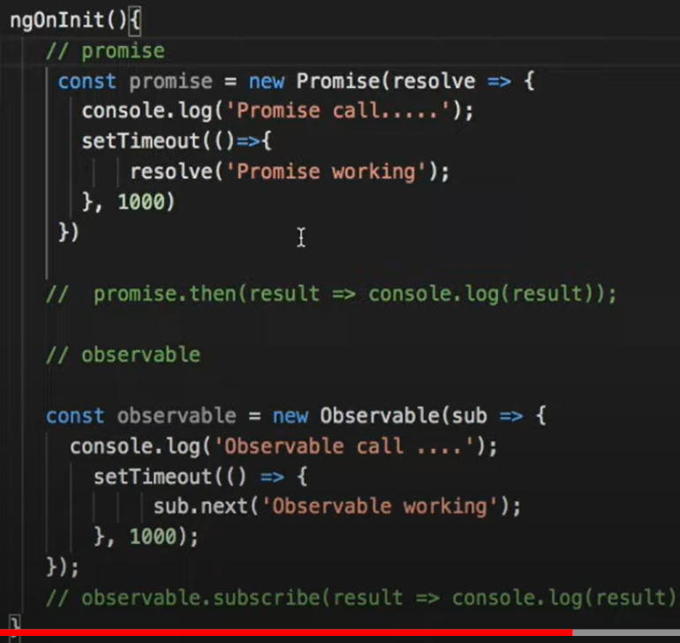

**Result will be promise call**

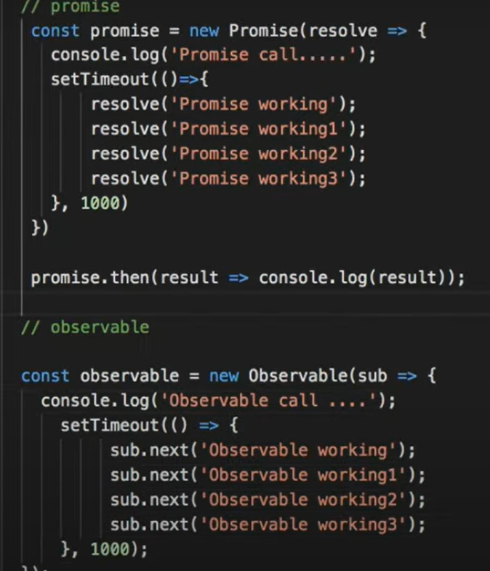

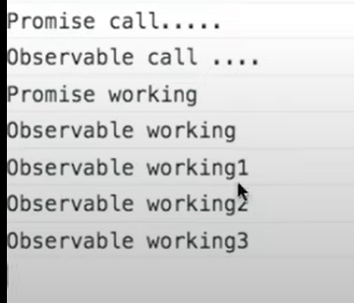

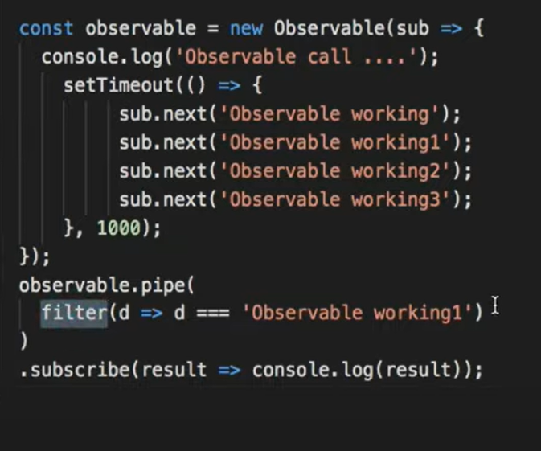

**Op is observable working 1.Observable will not work until we have subscriber.**

**we can should unsubscribe observable once created will always be there and cause memory leak.**

**We can use ngOnDestroy(){**

**} inside we will unsubscribe observable.**

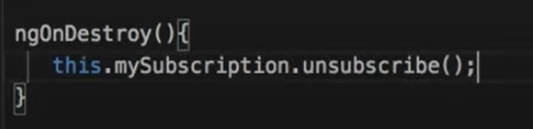

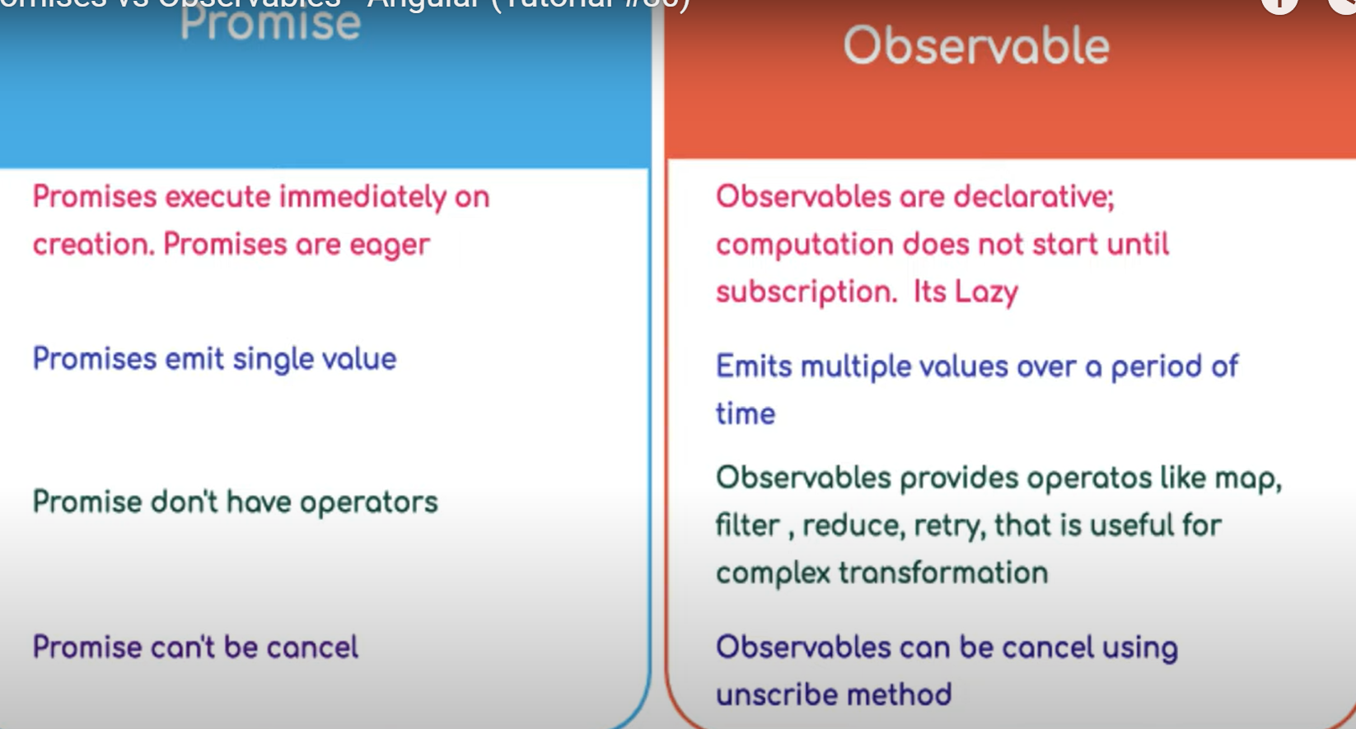

**RXJS Subject : and observable are same but one difference is subjects are multicast and observables are unicast.**



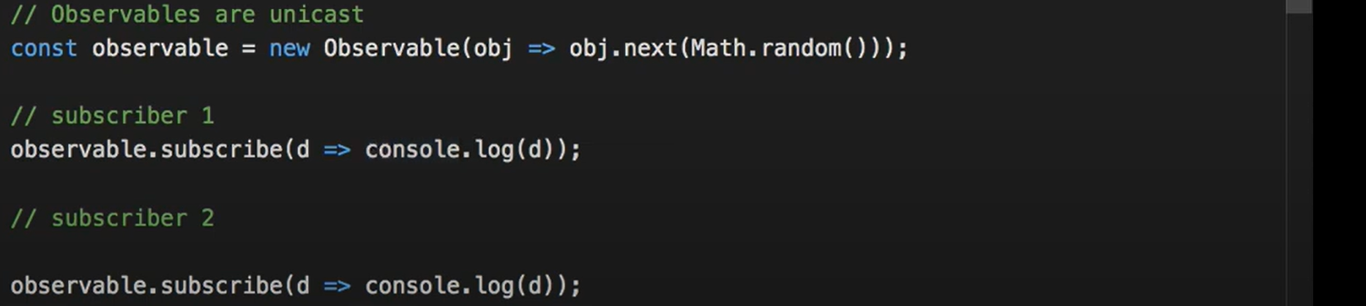

**Result :**

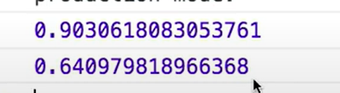

**So we can say that new subscriber comes new value created so it is unicast.**



**Observable are one to one and subjects are one to many like radio.**

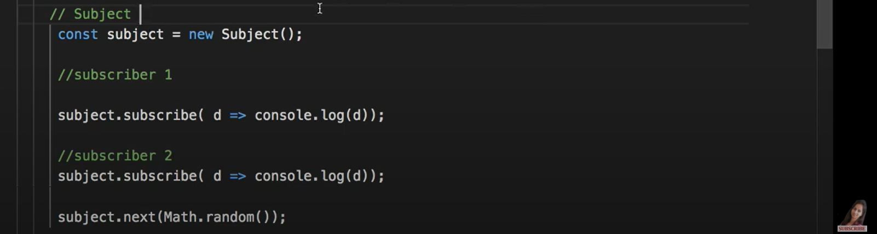

**Ajax call returns observable so below code will hit URL two times wiz not good**

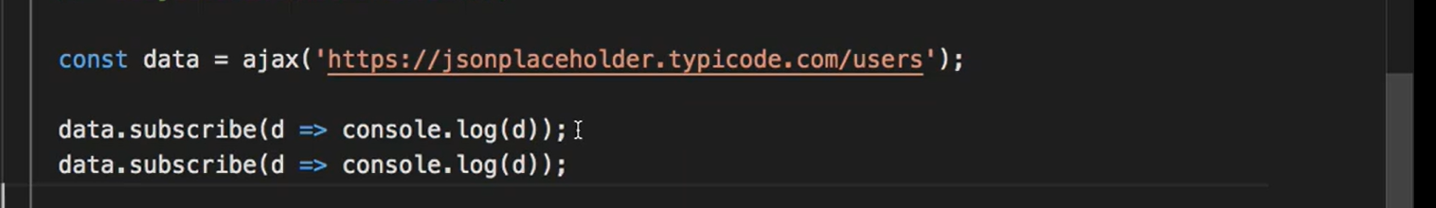

**In below code subject is considered as data consumer.**

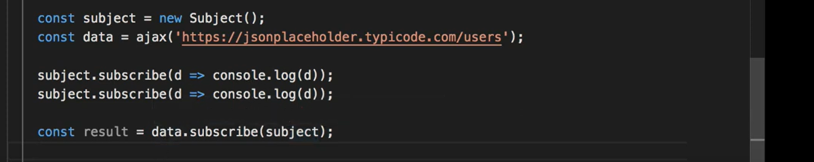

**Behaviour Subject : knowing at any time what is balance in my account is behaviour while in subject company emits then subscriber (Employee) get to know about salary.**



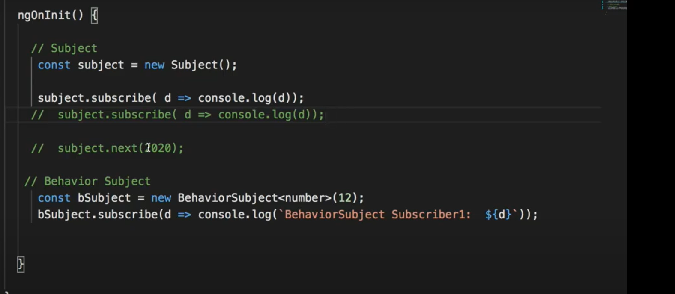

**Subscriber will not notify any value until we will emit value through next fn. While in behaviour subject it’s not like that.**

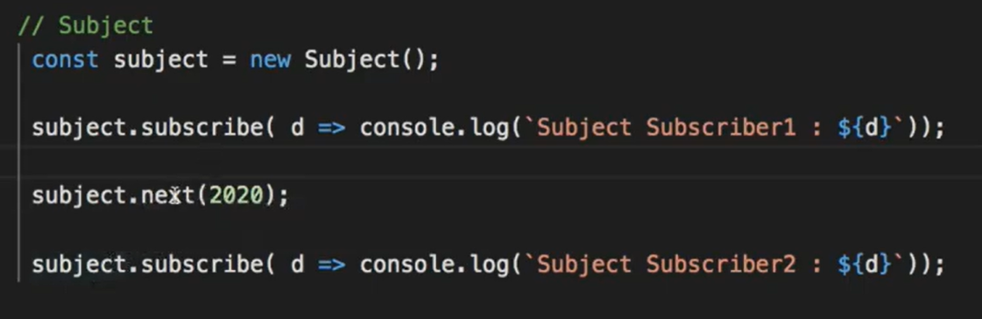

**Above case me 1 wala print hoga but 2 wala nahi q k next ni kiya hai humne**

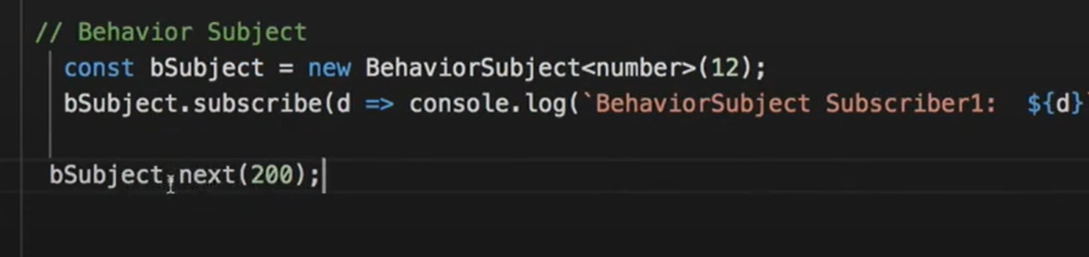

**1st will print 12 and then 200**

**If we ant to share data from parent to child and from child to parent we can use input or output. But what happens if componant doesnot have parent child relationship then service concept comes inside service we can use Subject.**

**Implementation**

**Create service name notification.**

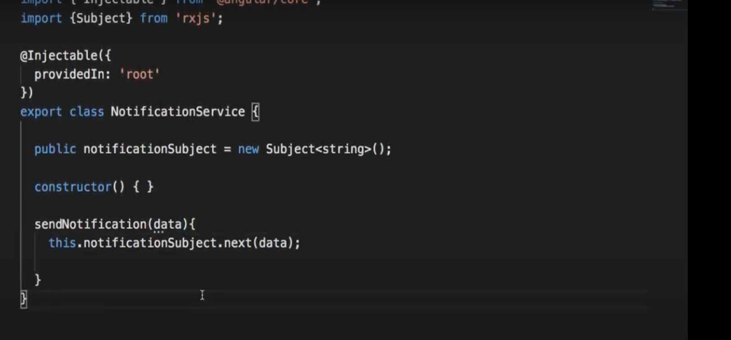

**Now register service in module.Componant will be subscriber to subscribe service.**

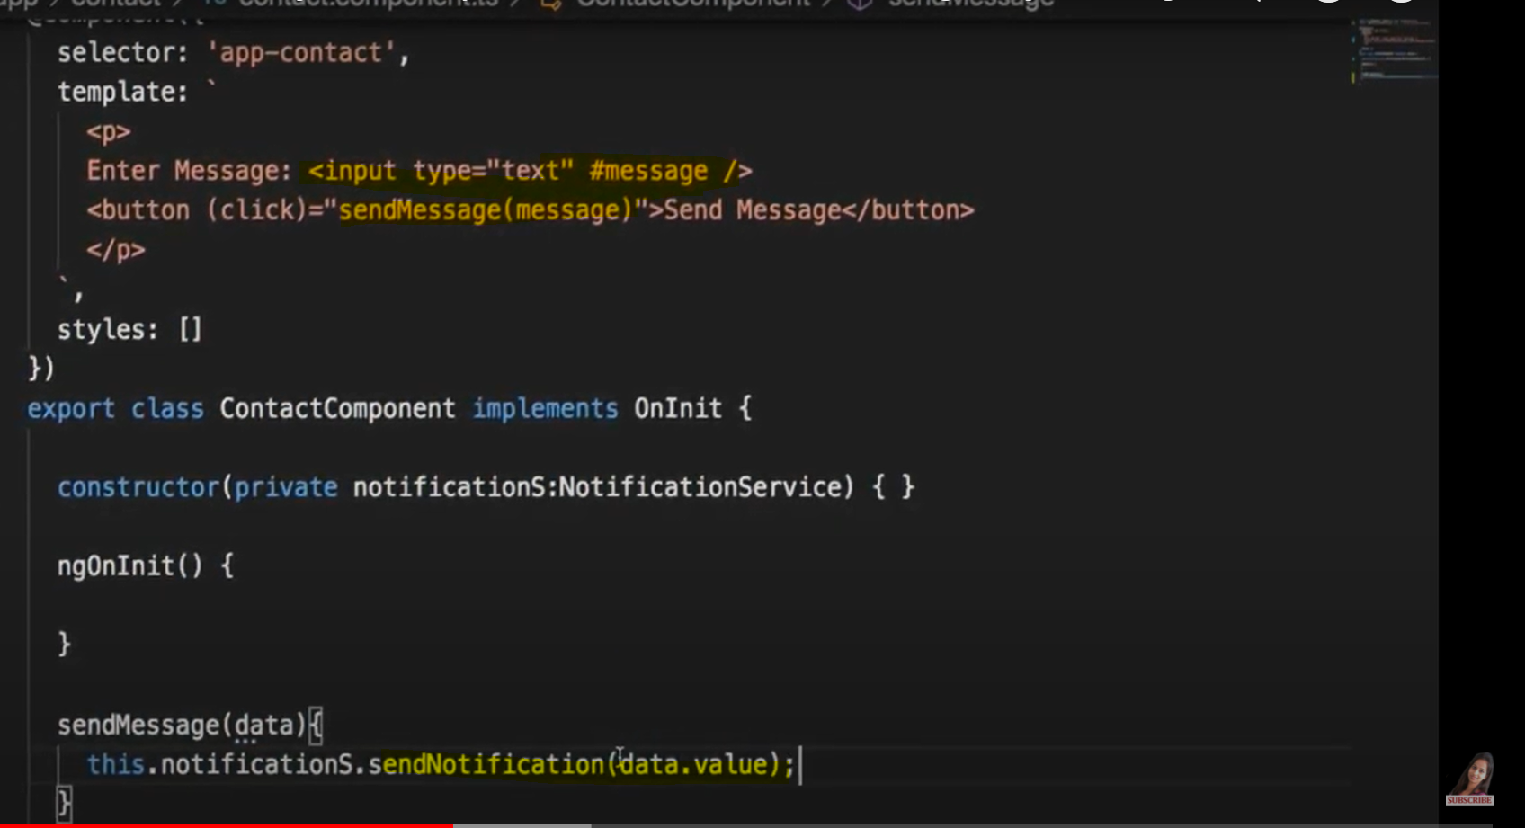

**Created one new componant to show values entered by user componant name is NoticeBoard.**

**Maine HTML me tag add kar do taa k hum log value show kar sake ab componant me subscribe kar denge value.**

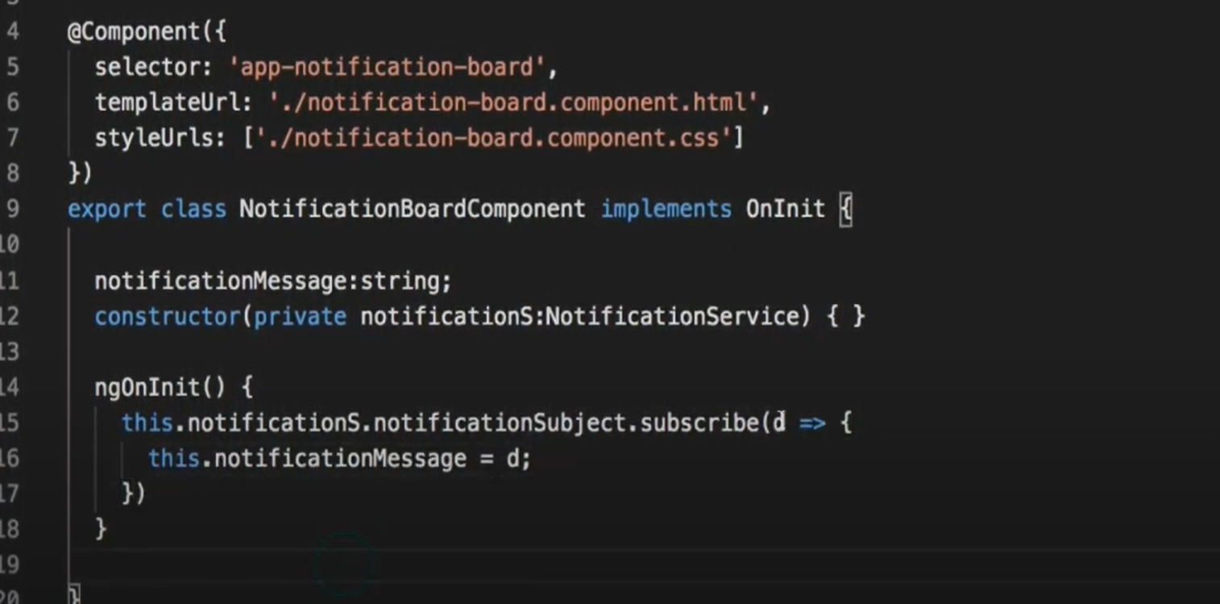

**If we want any default value to show then instead of subject we will take behaviour subject.**



**Replay Subject :**

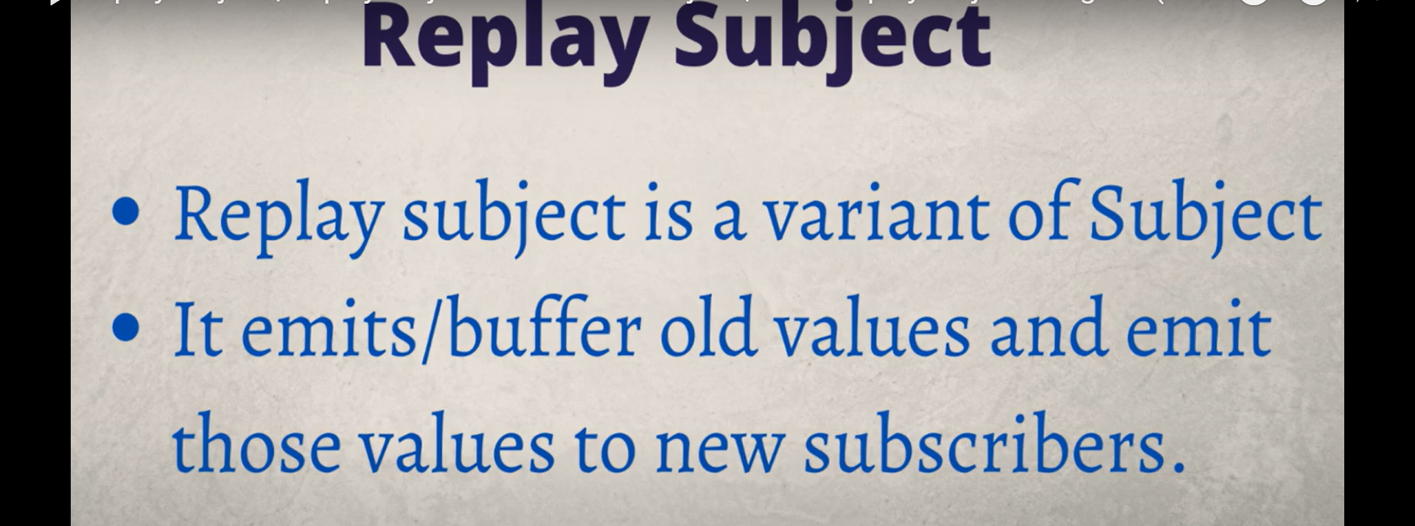

**No initial values have this**

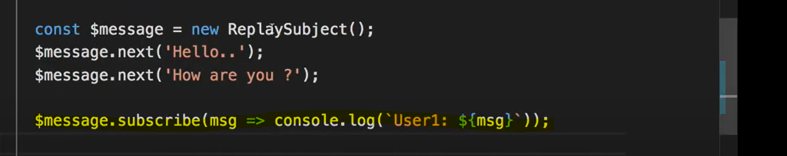

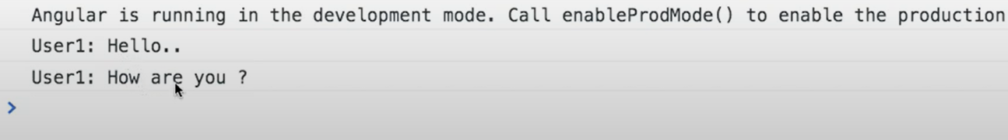

**So we can say that even for new subscriber it has old values.**

**If I want only last two value or lat 3 value to subscriber we can also do that : last 2 value will print .**

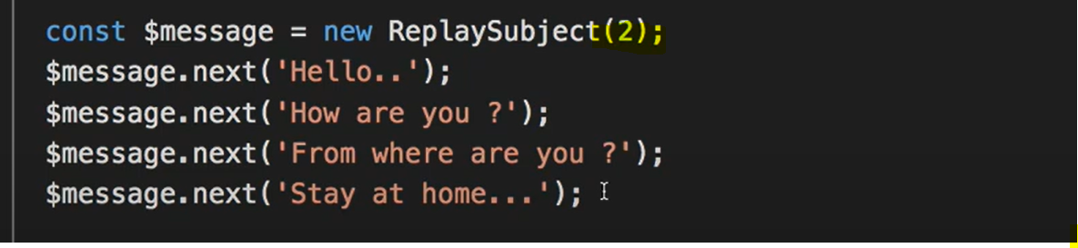

**Async Subject :**



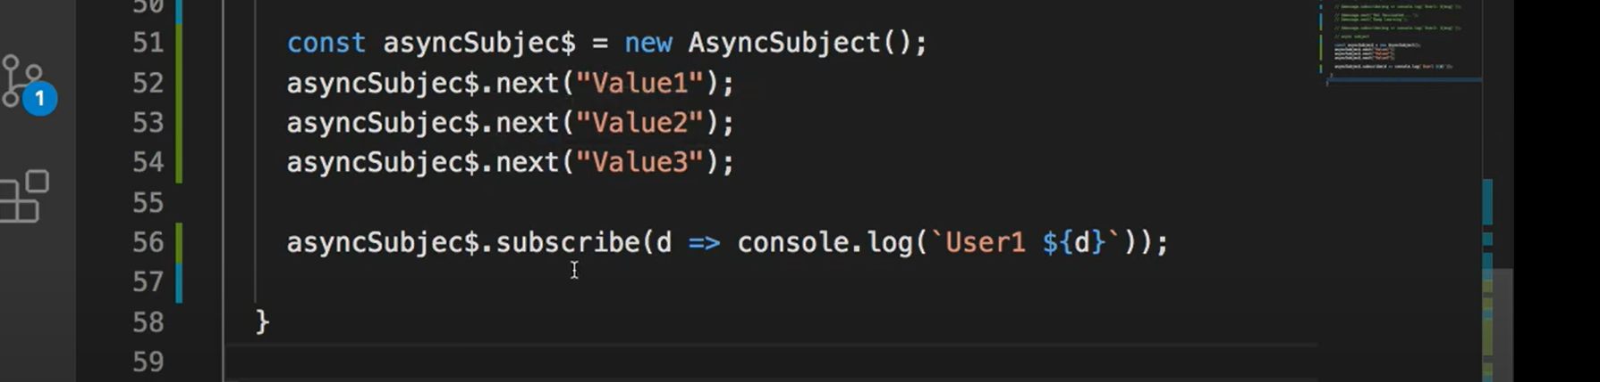

**This will not show any thing on console because we have not called complete.**

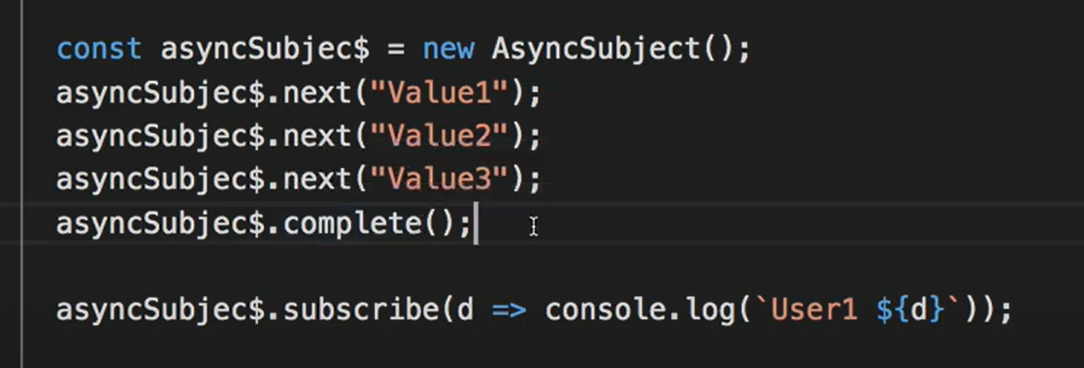

**Values 3 will print .**

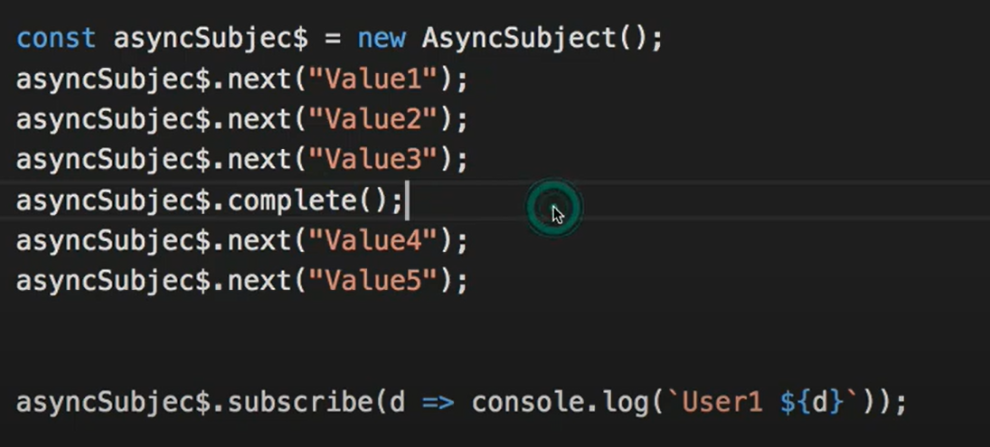

**4 and 5 will get ignored because it is called after complete.**

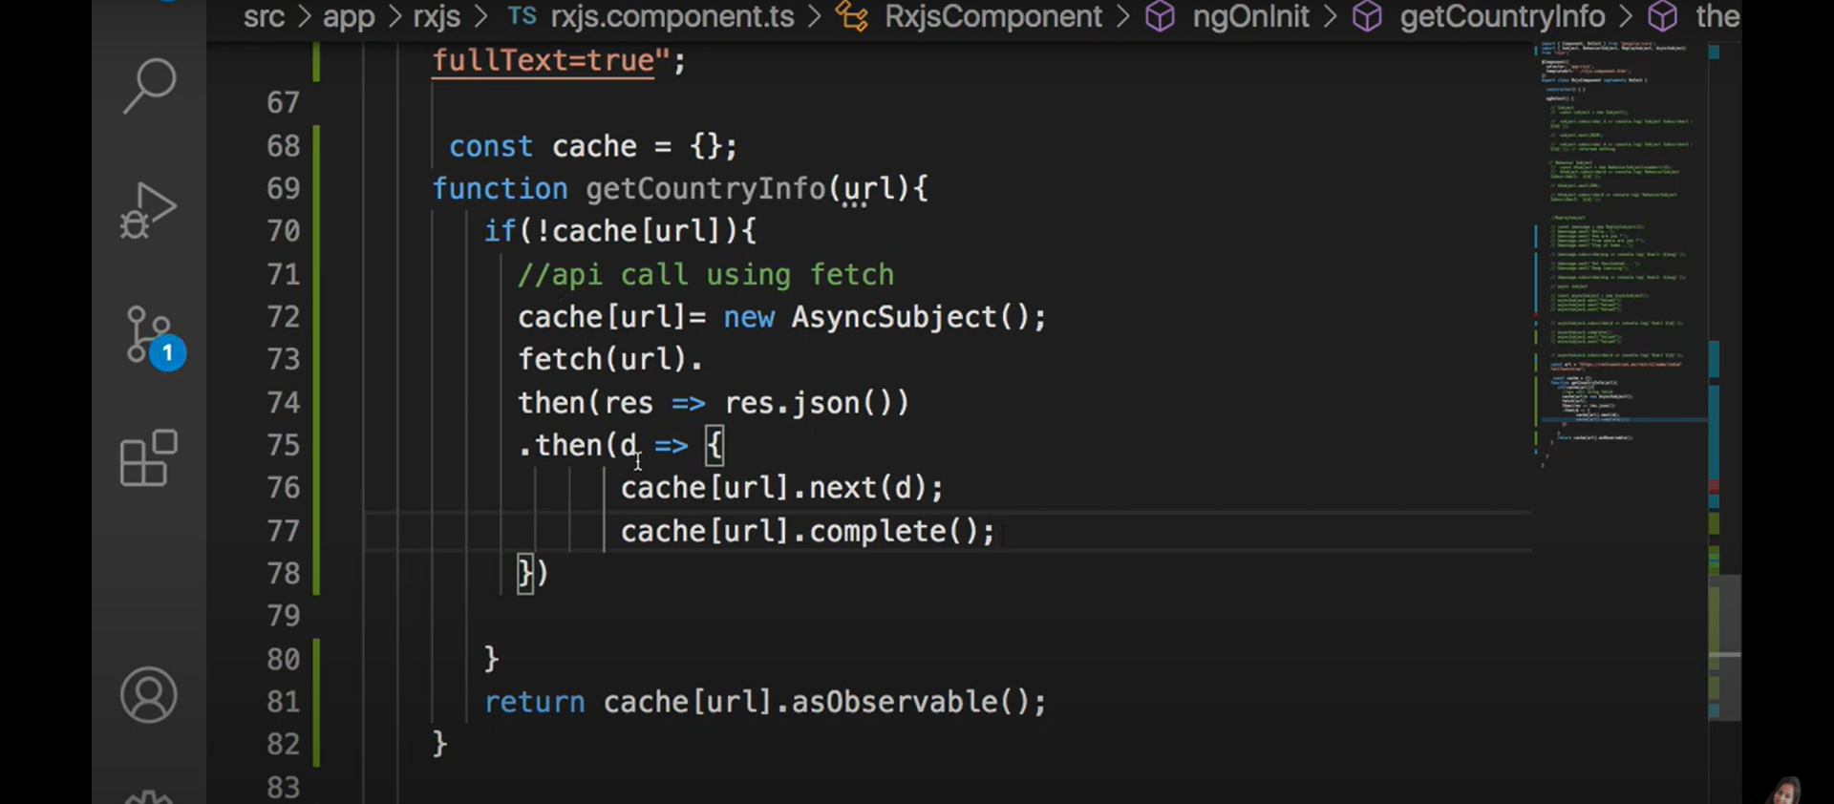

**Getting country information from URL .**

**In this way we can get data .**



**@ViewChild : pahle get element by id kar k hum manipulate karte the angular me @ViewChild kar k kar dsakte hai.**

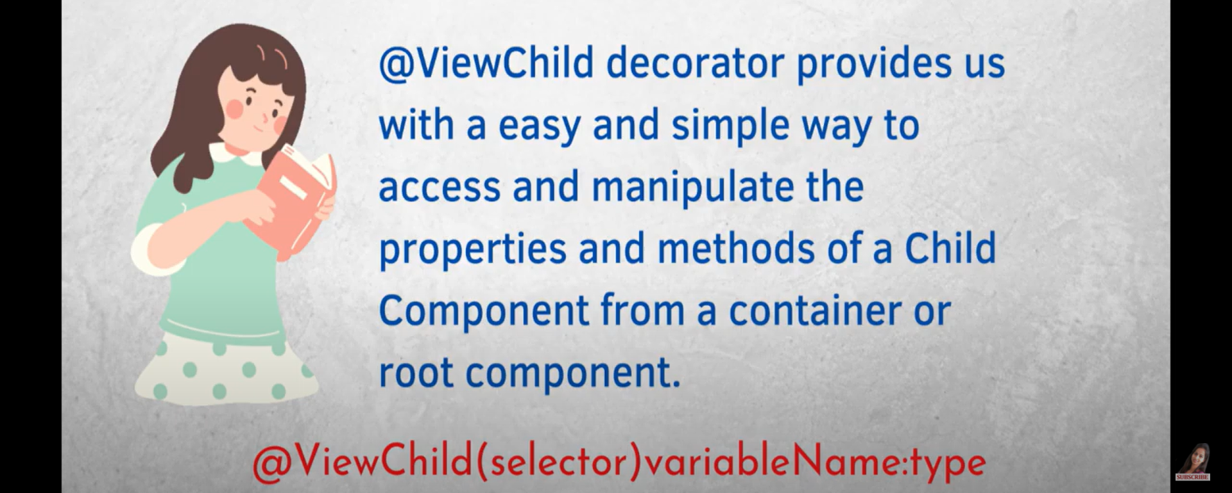

**Syntax in old HTML and js and now in angular.**

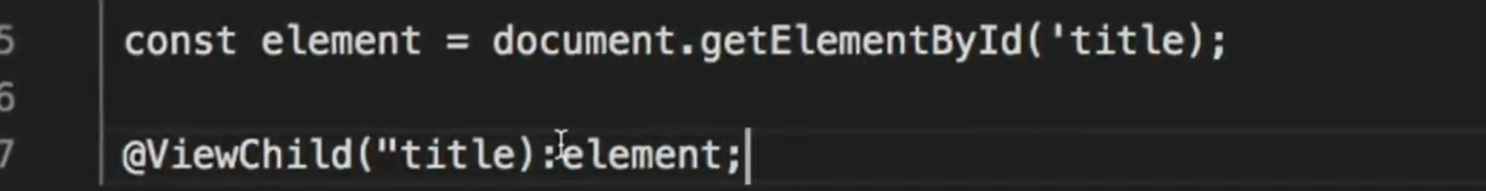

**HTML changes : to pick value in componant**



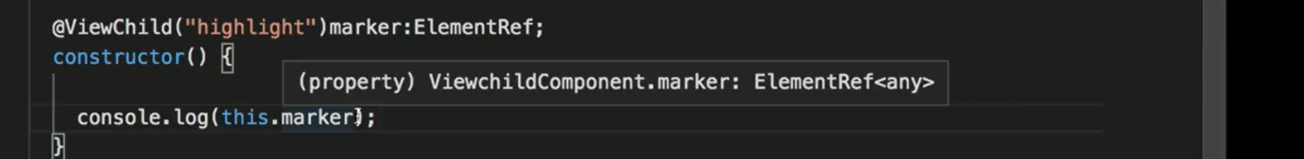

**Now console output will be undefined as we are using view child before initializing it.**

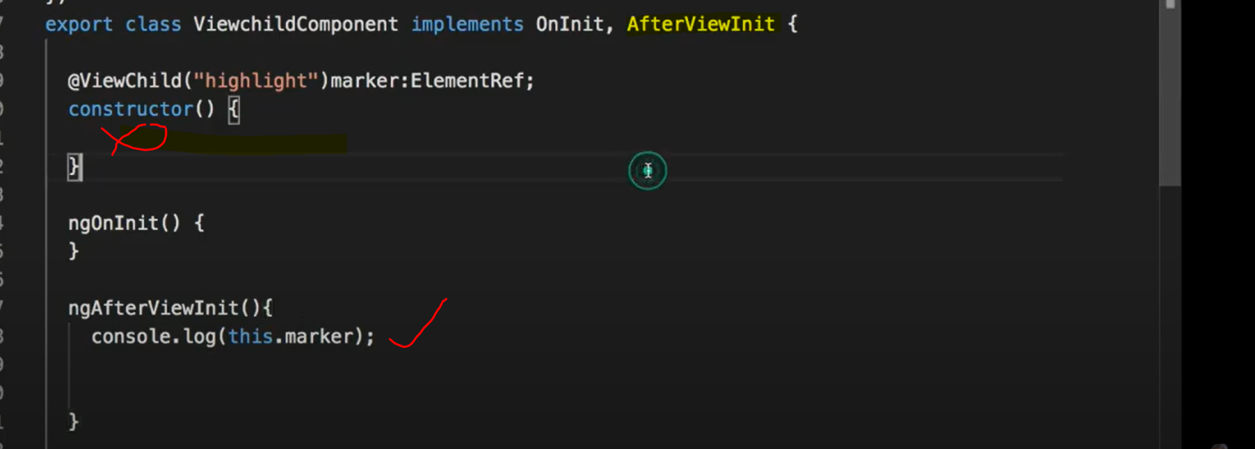

**Now we will see value in console**

**It will apply on first element only if having same #heighlight with two p tag then value will be applied only one 1st child.**

**Because viewchild only returns 1st child.**

**Viewchildren se humko mil jaega 2nd wala b**

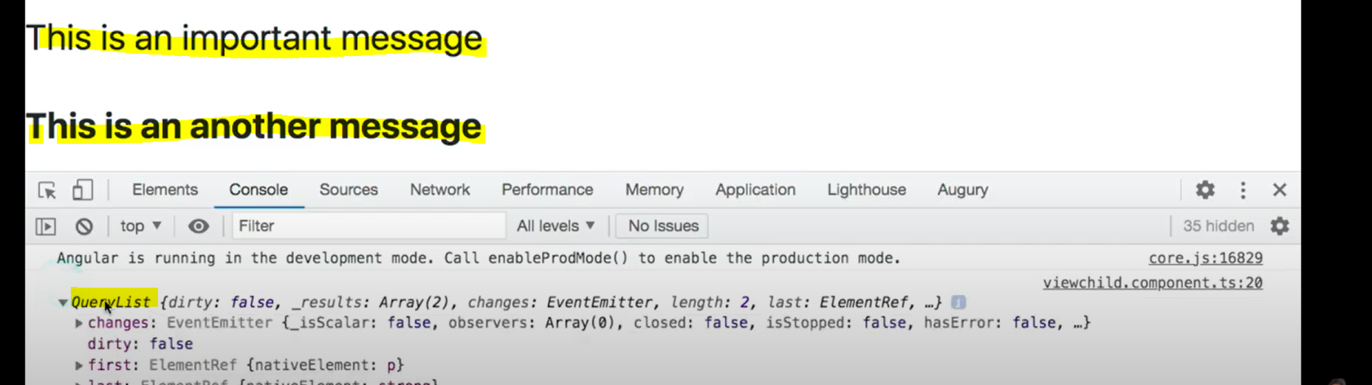

**Now it’s returning list instead of single element.**

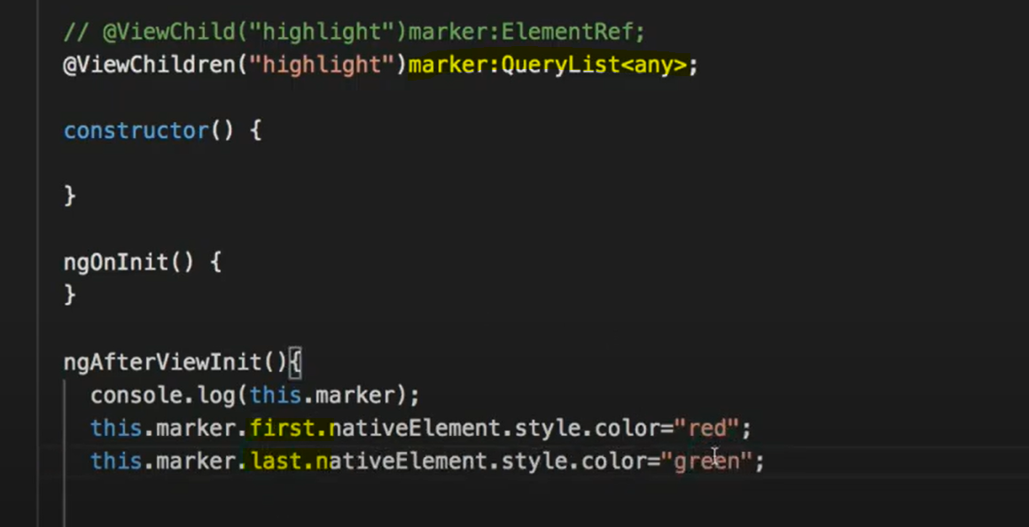

**We can also use @viewchild or @viewChildren if we want to access child componant into parent componant .**

**Created new component for showing demo of above statement.**



**Now added the selector in viewchild template(WIZ HTML).**

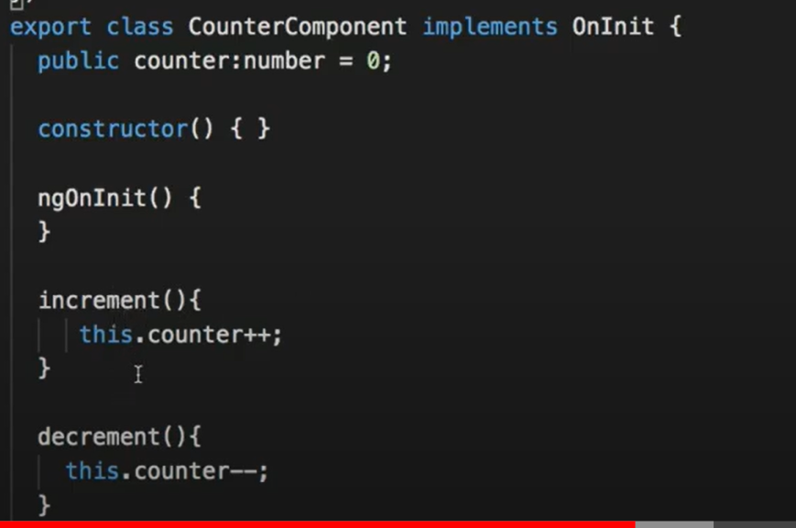

**I want to call increment or decrement from parent file not from same so we will do that in following way.**

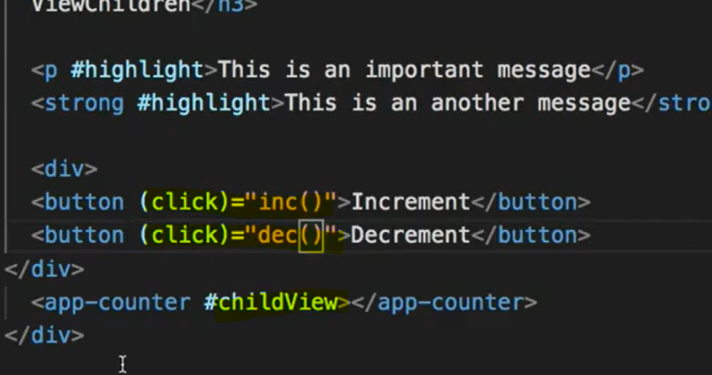

**With this selector we will use in parent componant.**

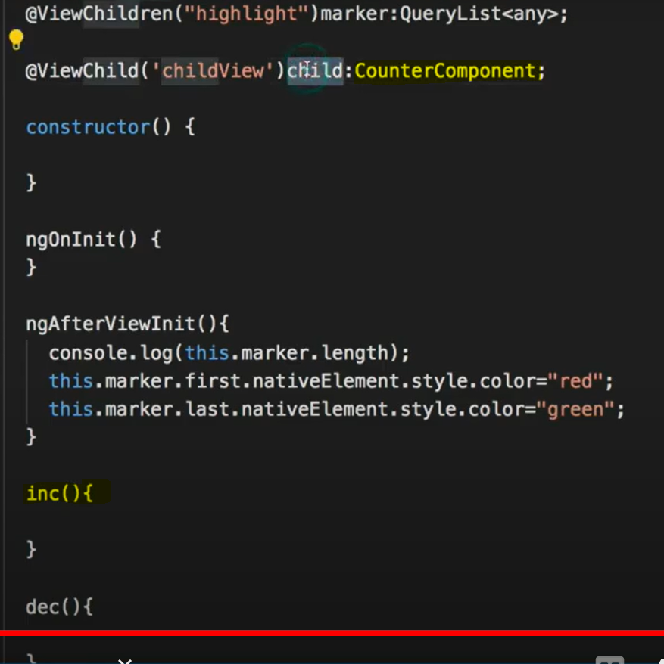

**Variable is of type componant .**

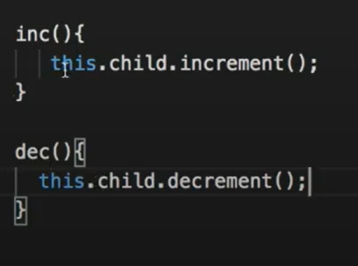

**Implemented function in parent componant now need to show value in parent template HTML.**

**Content Projection : -**

**We are having one component wiz having list of product and now we need to pass that value in child component so we can do so by @Input or @Output decorator.**

**And we are defining it inside parent component Template like this.**



**Salesproduct is list of product items defined inside parent componant.**

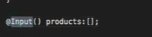 **with the help of this in child componant we can get data and we can bind this variable to child component template and show results.**

**We have again defined select in same parent HTML file and now result will look like this**

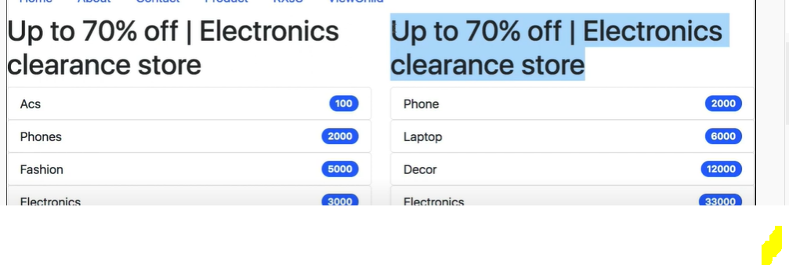

**But as you can see we have resued componant but there is one problem we wand different heading how do we do that ?**

**Contetnt projection will help us in sending HTML as well along with the list.**

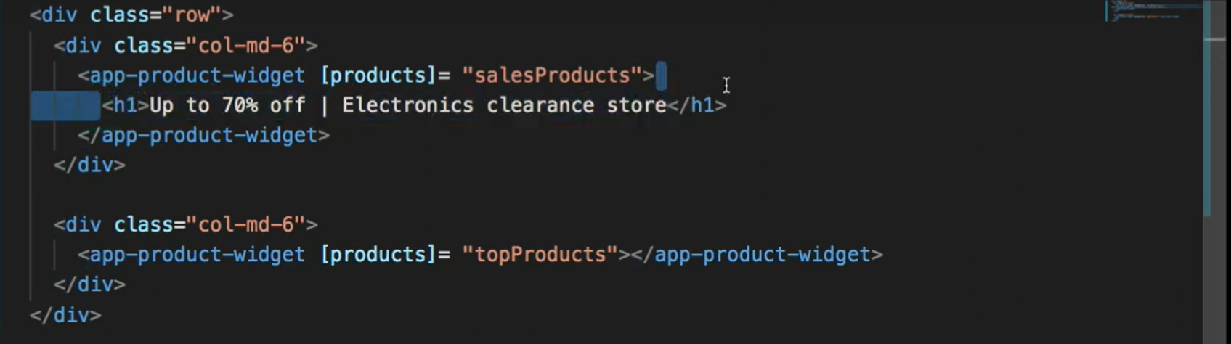

**I have passsd HTML but there will be problem both section will not show hwading because of we are not telling where we want to project**

**Now have putted ng-content now we can say that it will show different heading.**

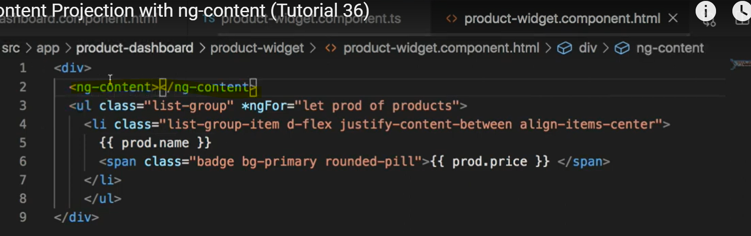

**Now another requirement in which in child componant we have provided link to visit ideally what will happen is both widgents should have different link but actually it will have same link for both the widgets so we can say that we can control through content- Projection**

**Inside children we can define multiple ng-content and we can do so**

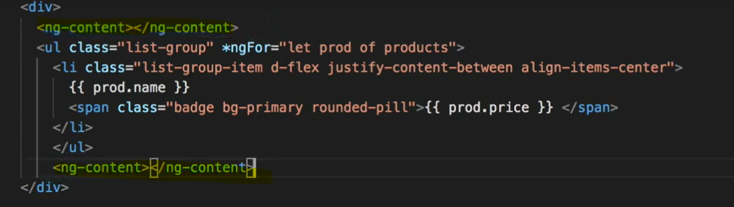

**Now both the link and heading will come bottom so now the requiremrnt is multiple ng-contetnt at different location that can be also doen in below way.**

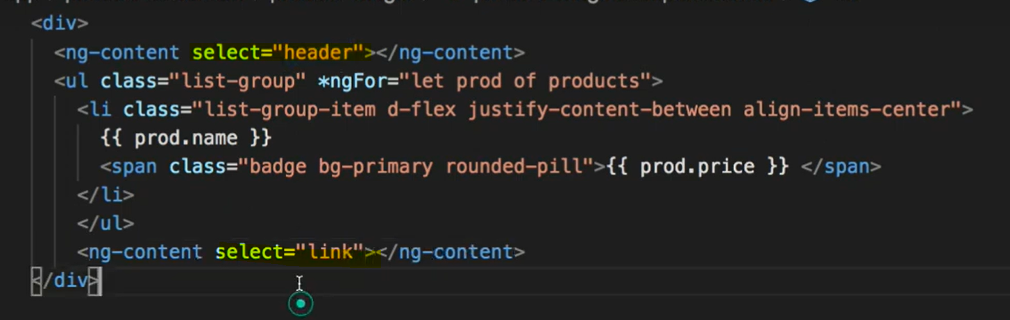

**This header and link we will define in parent class as well.these are calss selector.**

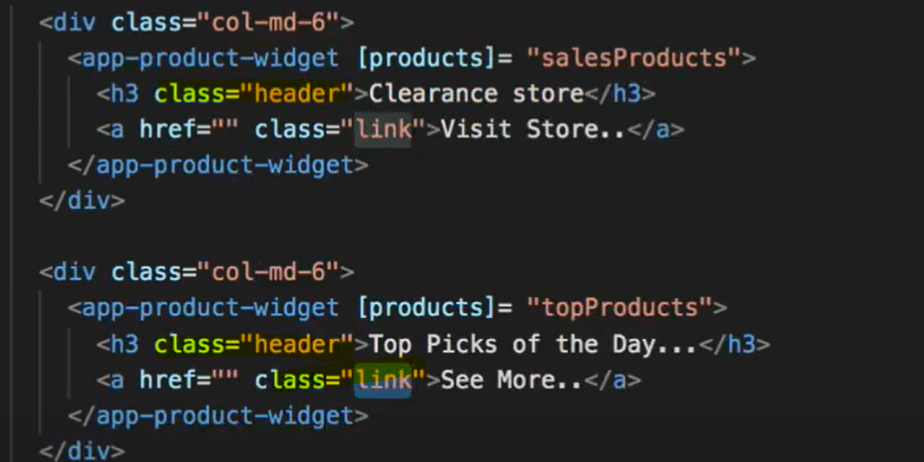

**Http Interceptors :**

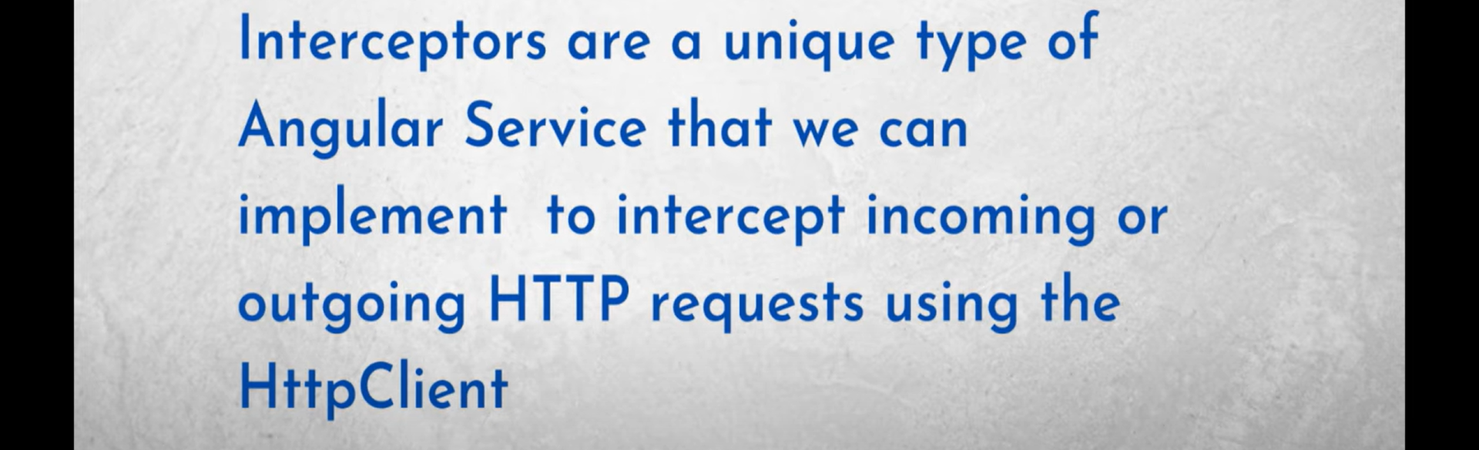

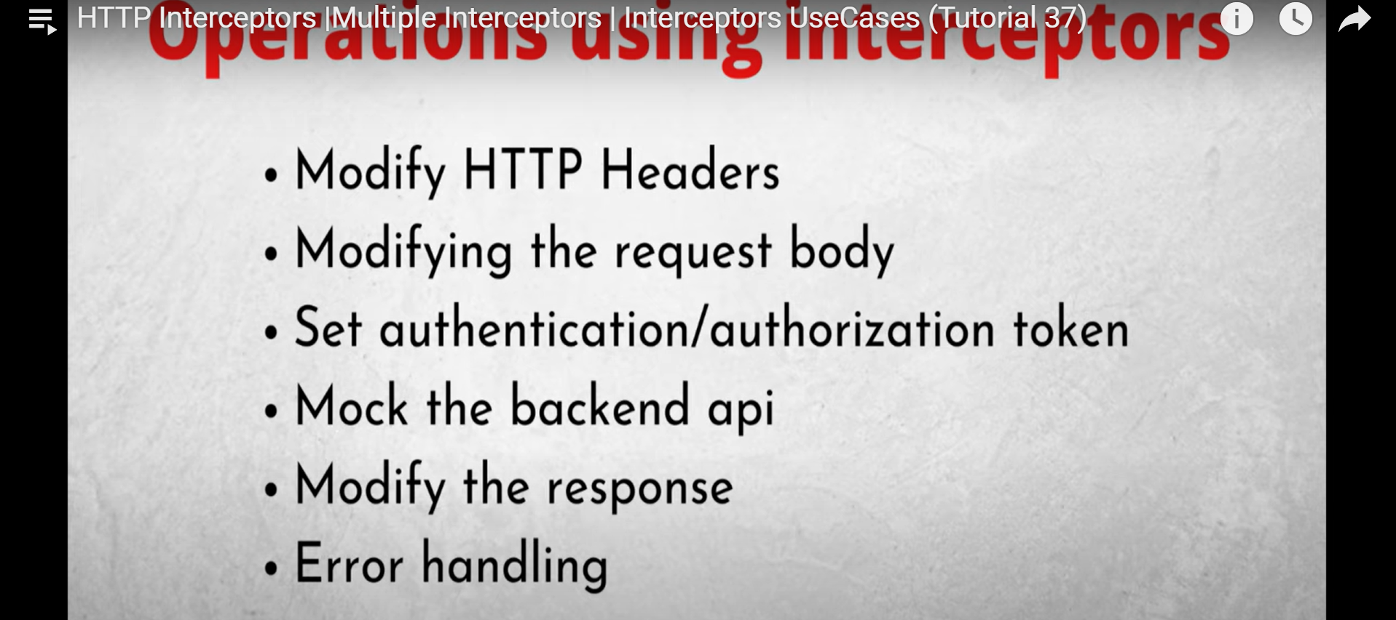

**We can create interceptor using below mentioned command but angular CLI version should be >=9**

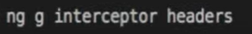

**HttpHandlers : has handle method that returns desigred http events observables.**

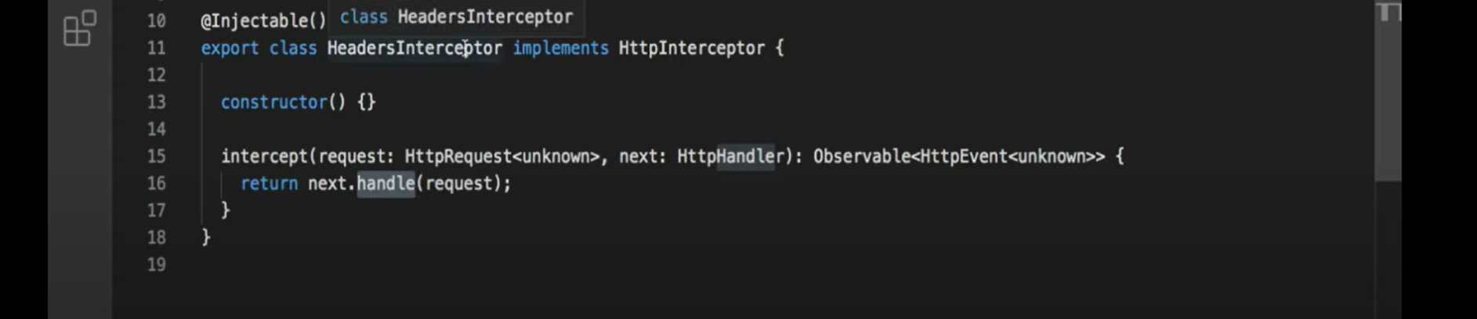

**Got to app module ts file and inside providers mention this interceptor.**

**Multi = true means tells angular that httpinterceptor is token for multi provider that injects array of value rather than single value.**

**HTTPRequest is immutable class so to make any change we need to colne the object and then we will work.**

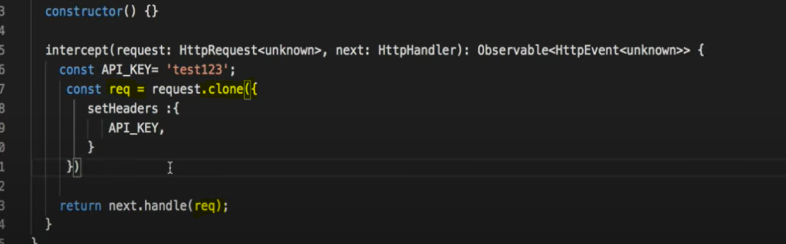

**Multiple Interceptors : Interceptors are called in the order in which they are provided.**

**Created another interceptor name logging and now we will check total time taken from request to response.**

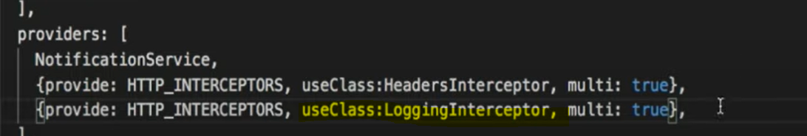

**Map is RXJS operator so please Import it 1st.**

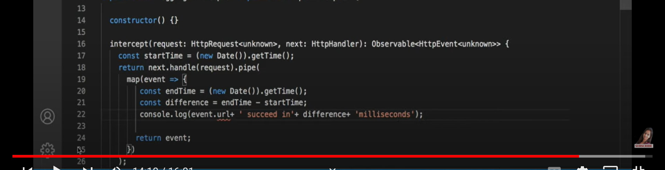

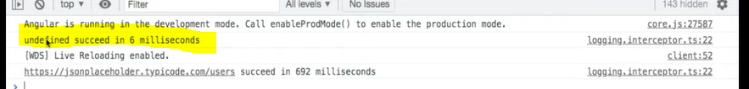

**We are getting undefined as we have not checked for type of event here it is preflight so we need to put check in code.**

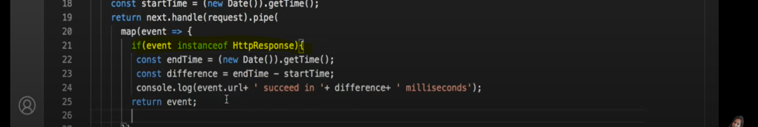

**Two types of forms there :**

1. **Template driven form tdf**
2. **Reactive forms MDF (Model Driven Form)**

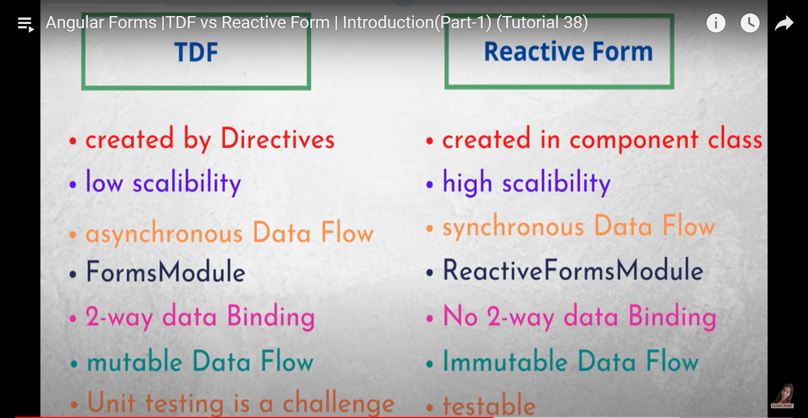

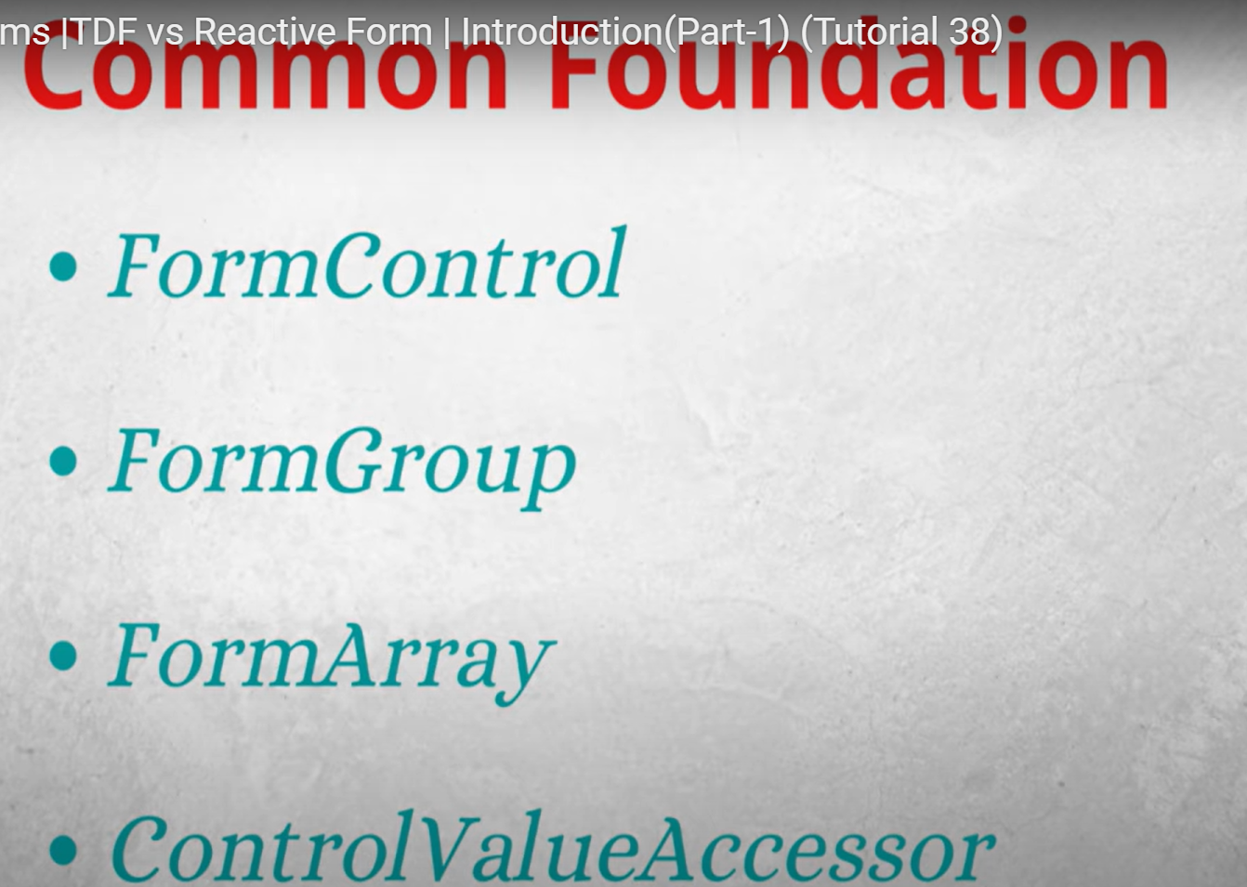

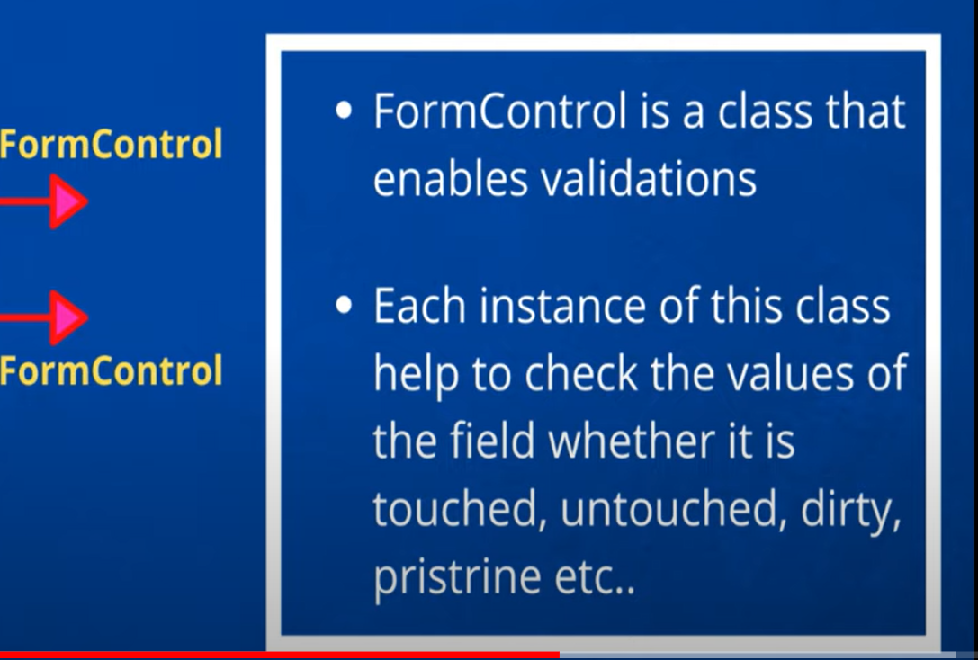

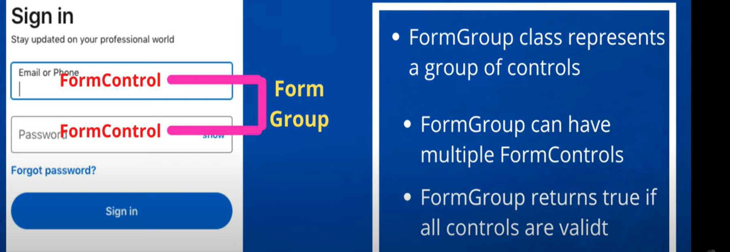

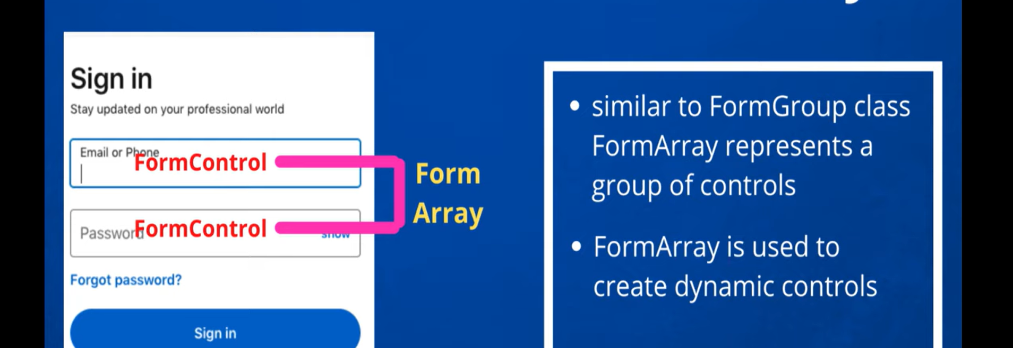



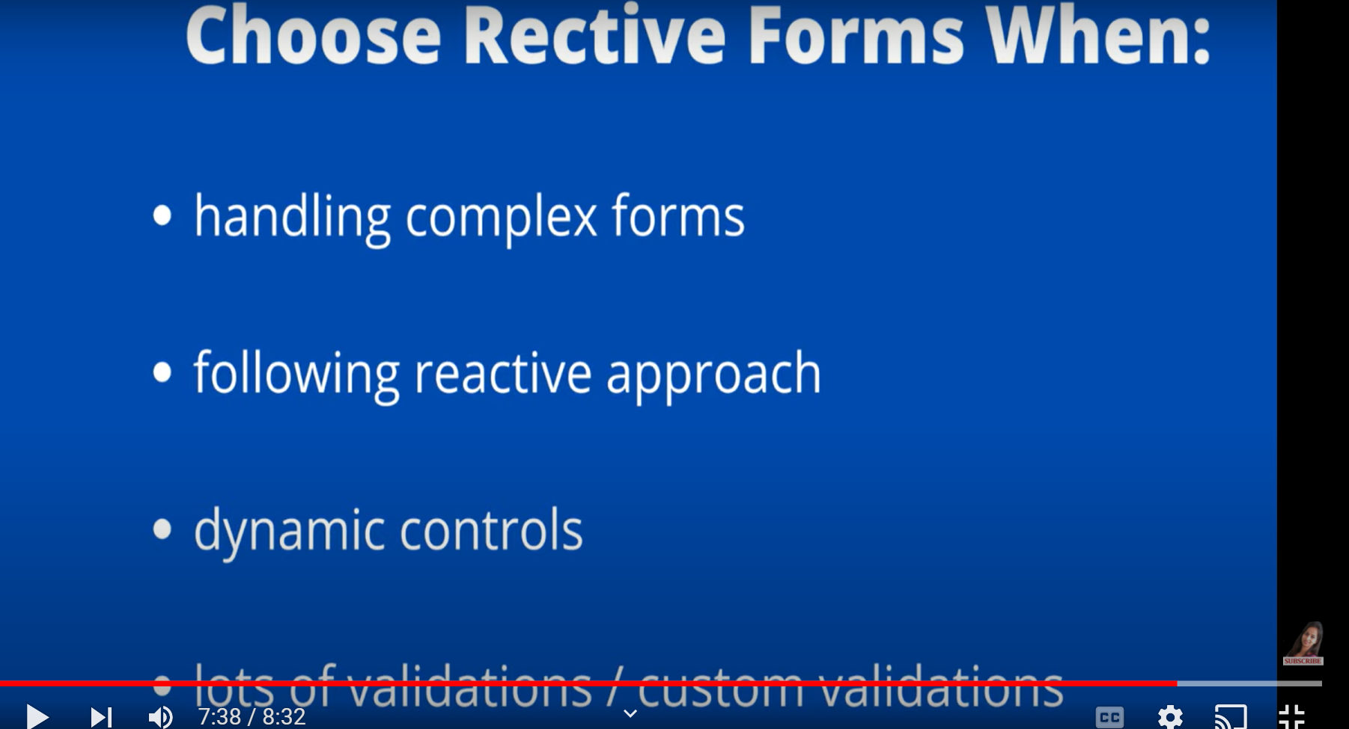

**Template Driven Angular Form :**

**Import form module.**

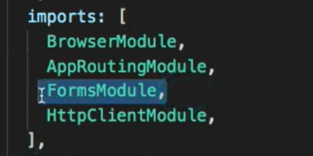 **ng form makes angular template driven form works.**

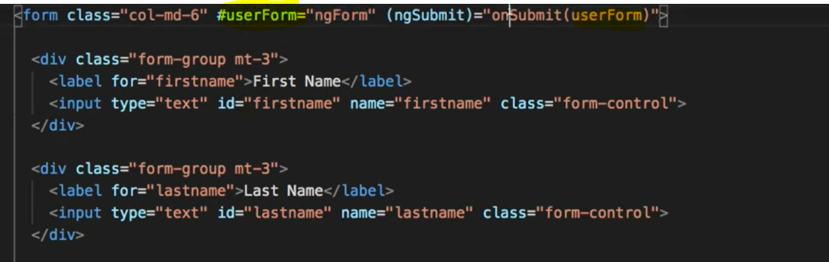

**Now we will define userform inside componant.**

**Defined inside component**

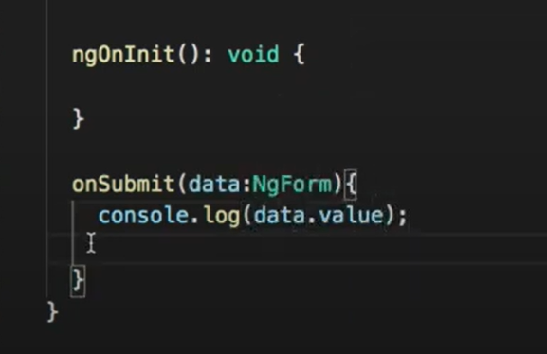 **but if we will test and check in console we will get empty object .**

**Inside input box if I will define ngmodel then and only hen log will print the value we have pressed in input box.**

**In this way we can check form status :**

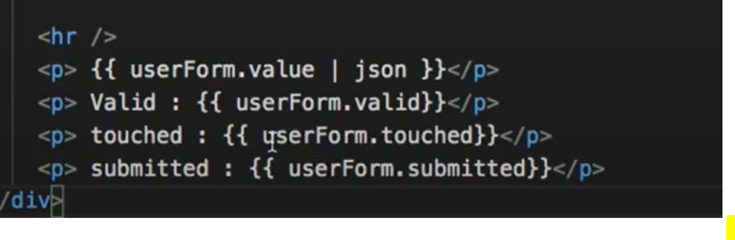

**We can use NgmodelGroup if we want to send nested data**

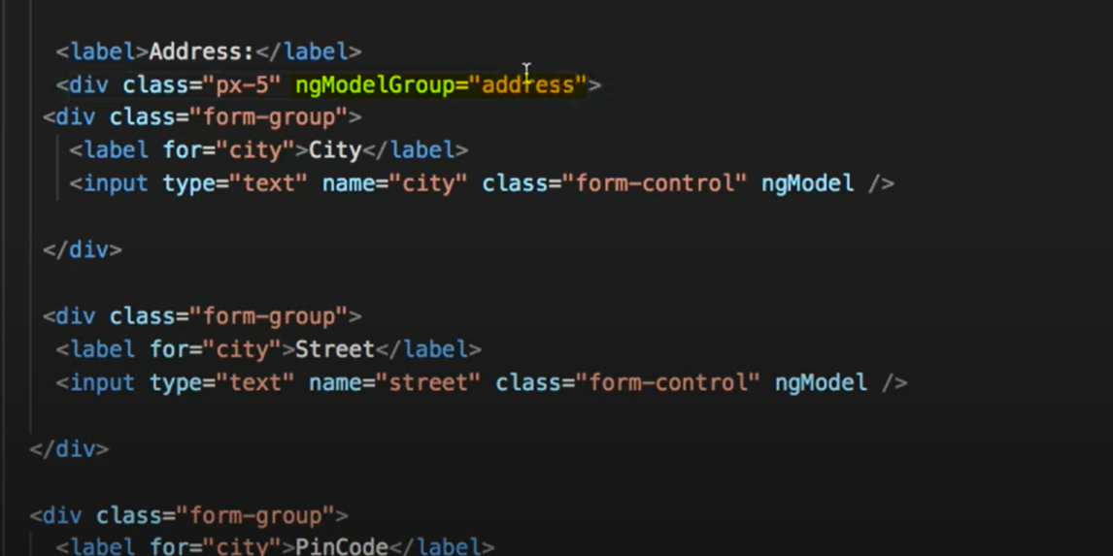

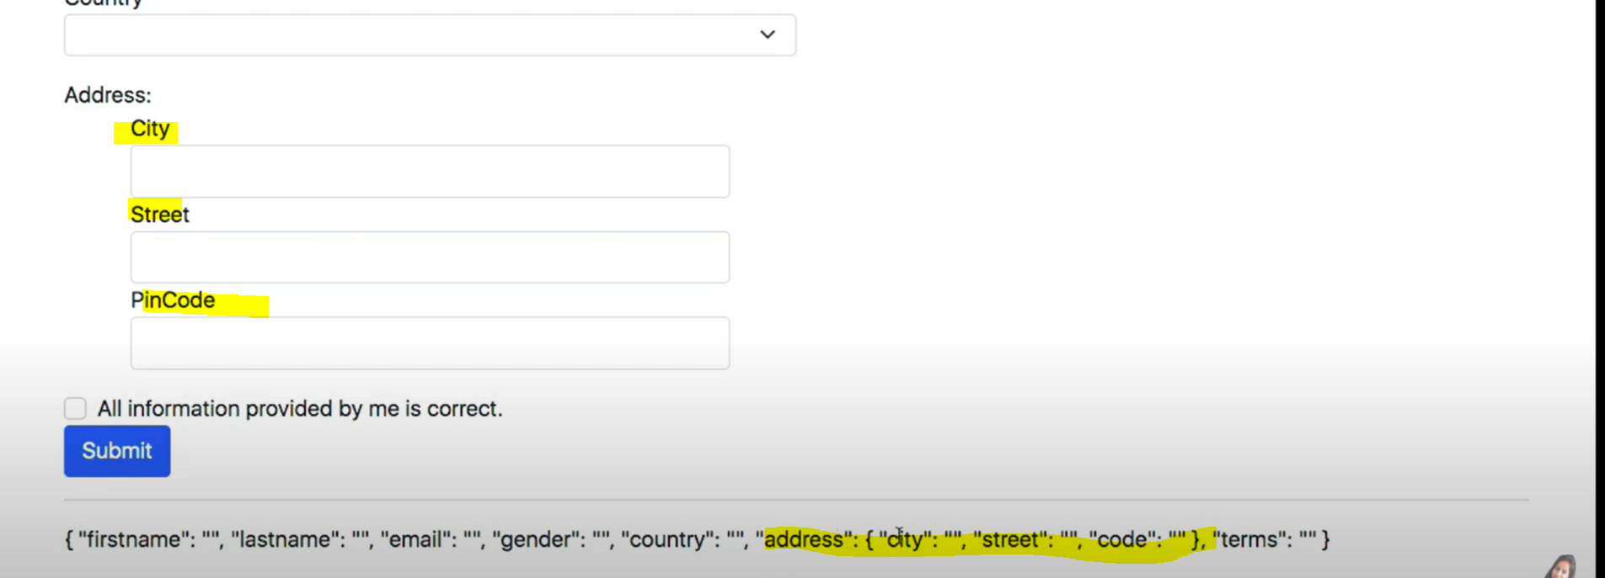

**Resetting values in form :in reset form variable we need to send template form reference variable**



**Inside componant.**

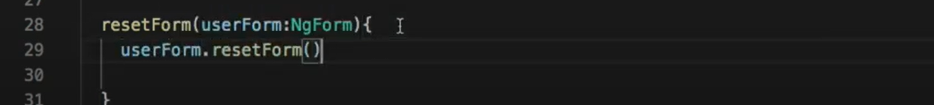

**If we want post reset some value to be in default value then**

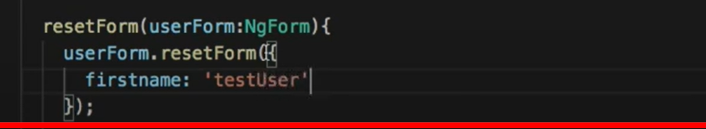

**If nested values there then we can put values like this**

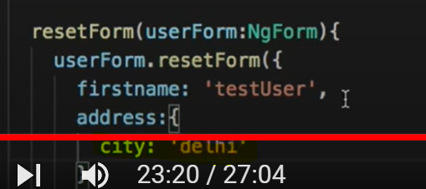

**Default value that to be present in form when page loads.**

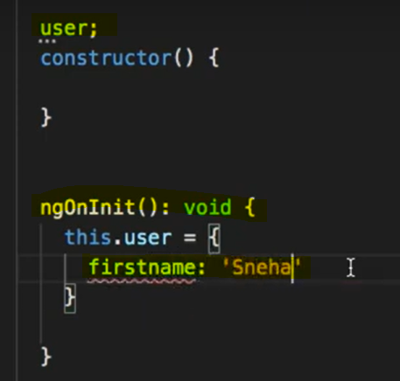 and bind this user to form input tag using ngmodel



**Validations in template driven form.**

**@Contentchild :**

**If I want to access h3 inside another component.**

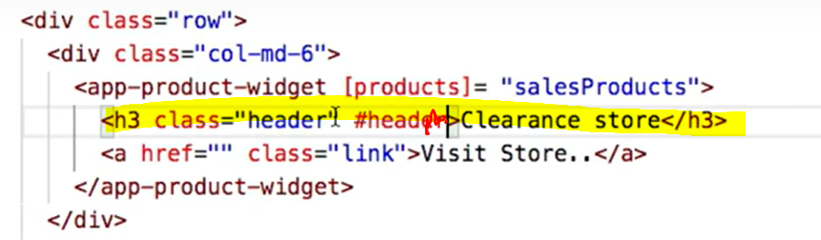

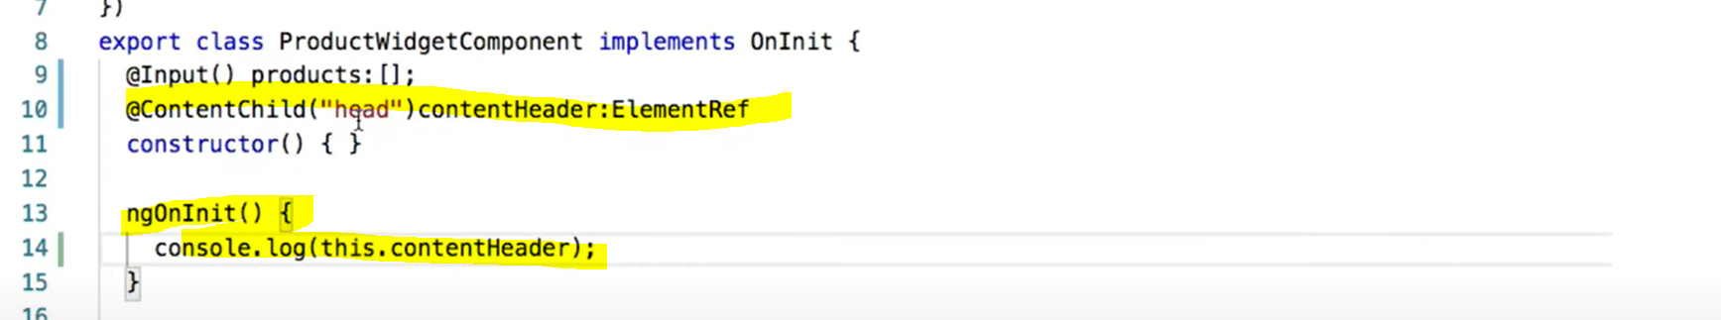**it will not work we need to call this ngAfterInit() inside that if we console it will give us value.**

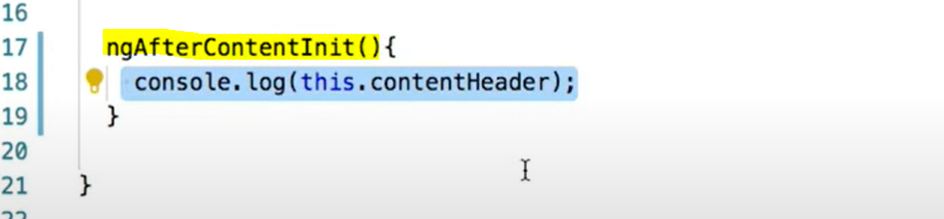

**@Componentchildren :**

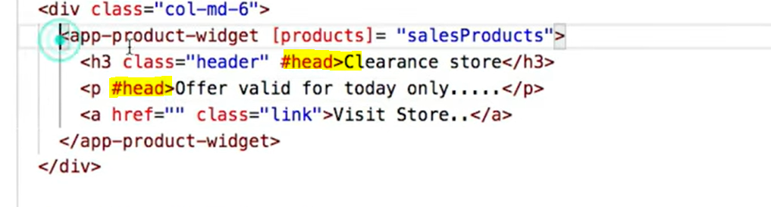

**Two tag having same selector. Content child will work on only 1st element to with the help of children we can apply for both the tags.**

**It will return query list which we can manupulte as per our need.**

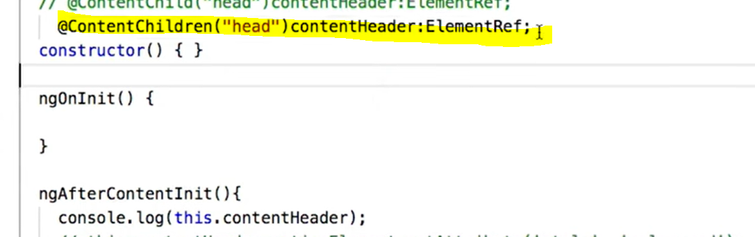

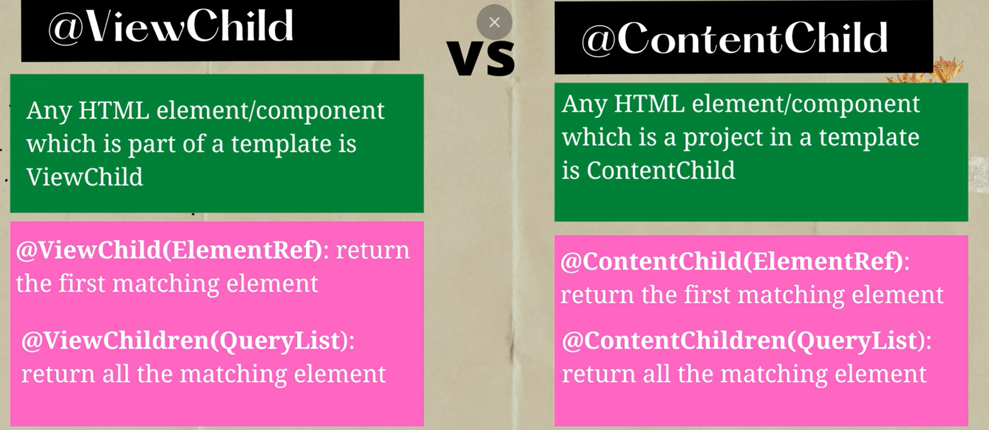

**Life Cycle Hooks :**



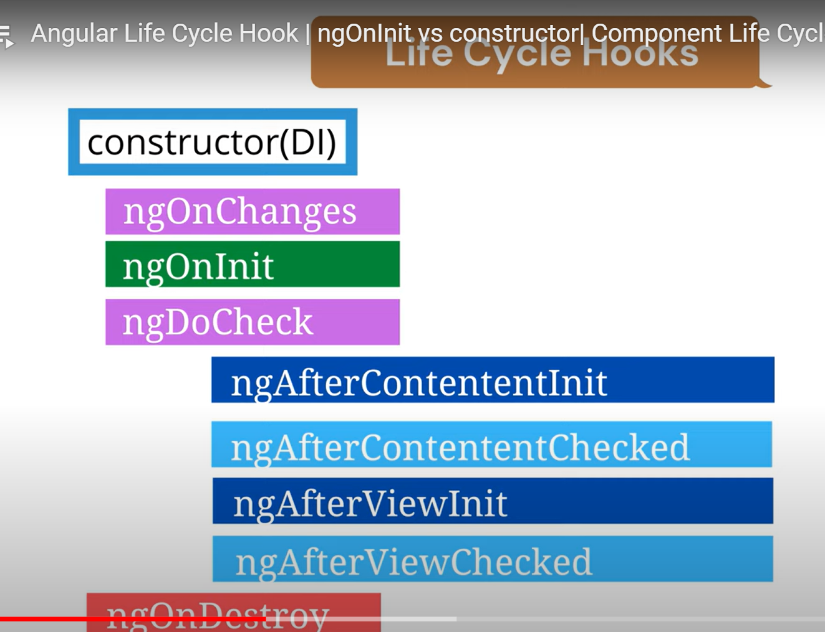

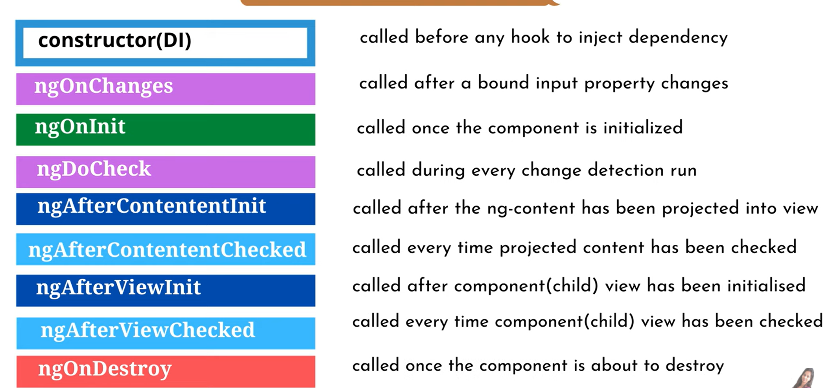

**In angular constructor is used for dependency injection.**

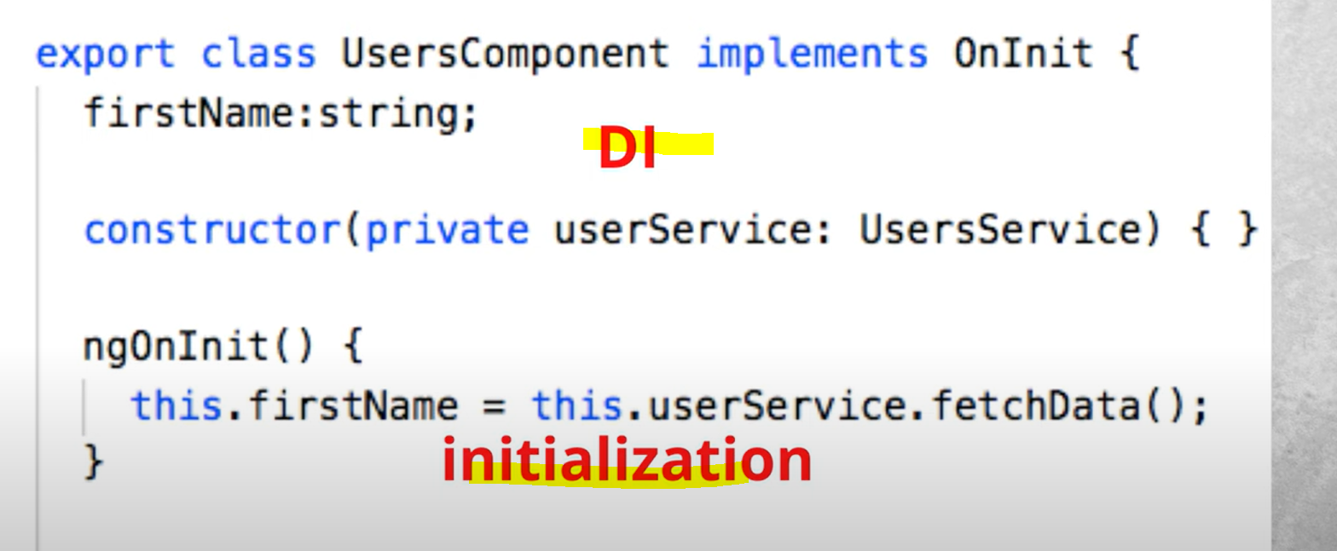

**Ngononit (); should used to handle nay initial logic that need to execute only once.Binding is not done at constructor function so only class and variables are accessible only.**



**It can work with only some input tag.**

**Pahle input tag banao onchange par function call karo parent component me data lo and usko selector(child wala) [] usme bind karo and @Input tag k jariye child componant me le lo to kya hoga ngOnchange child me work karega.**

**Created one form**

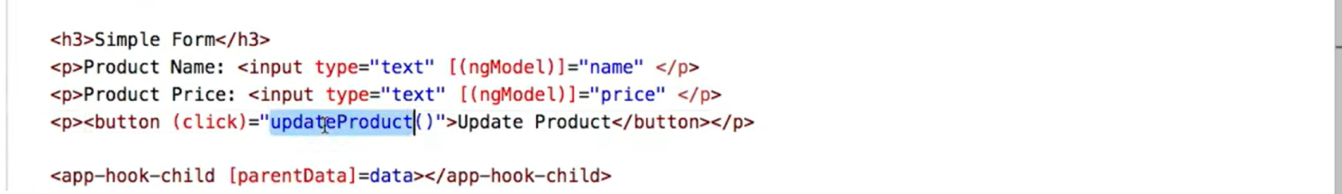

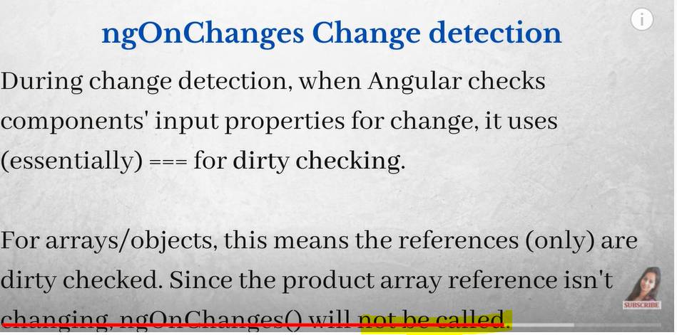

**If we are having array of object so on changing value their reference will not change so ngonchange will not detect change to detect change we can do the same in two ways one is create new refeence of object and then we can assign values or we can check ngdocheck**

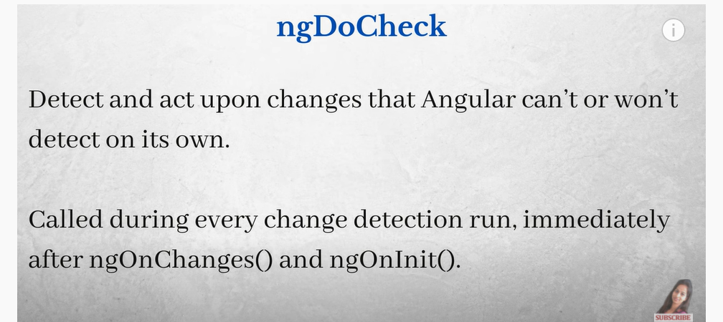

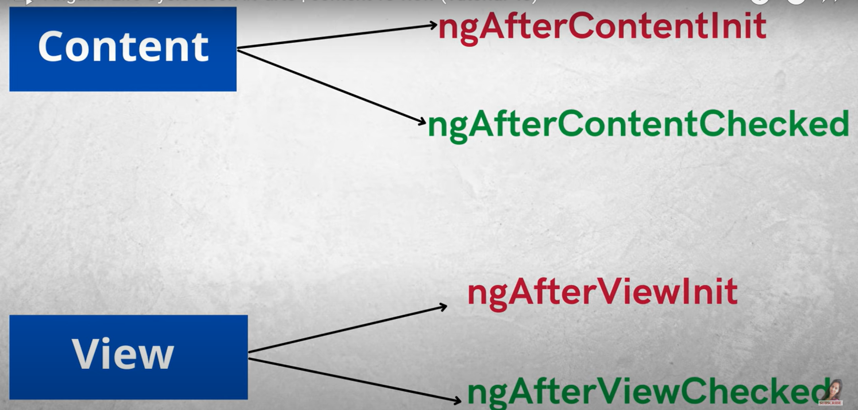

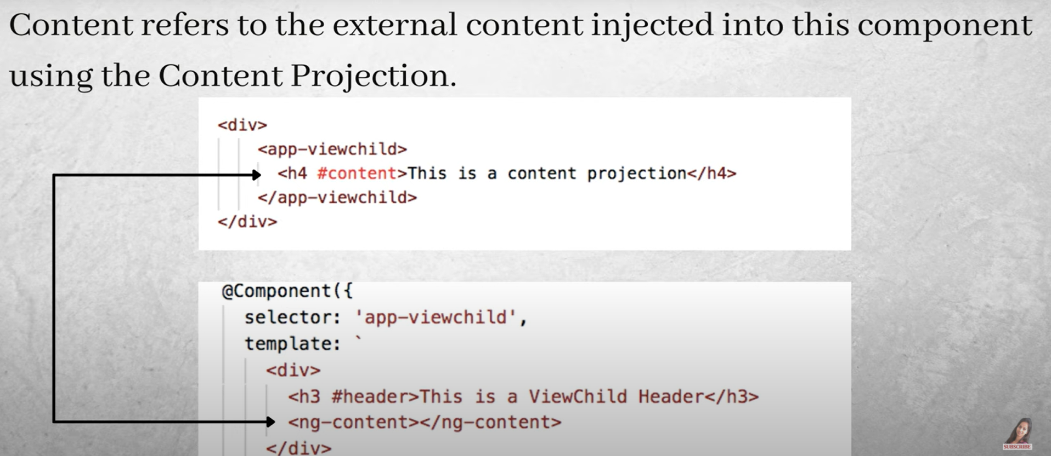

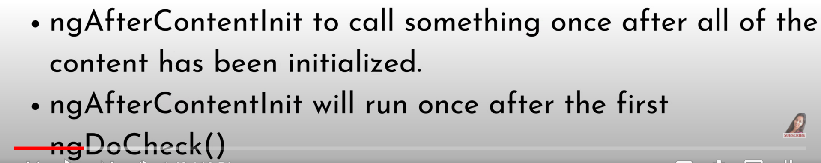

**If we want to make any changes in external content injected we can use ngAfterContentInit() and it will get called only once while ngAftercontentDocheck will called for each time there is change**

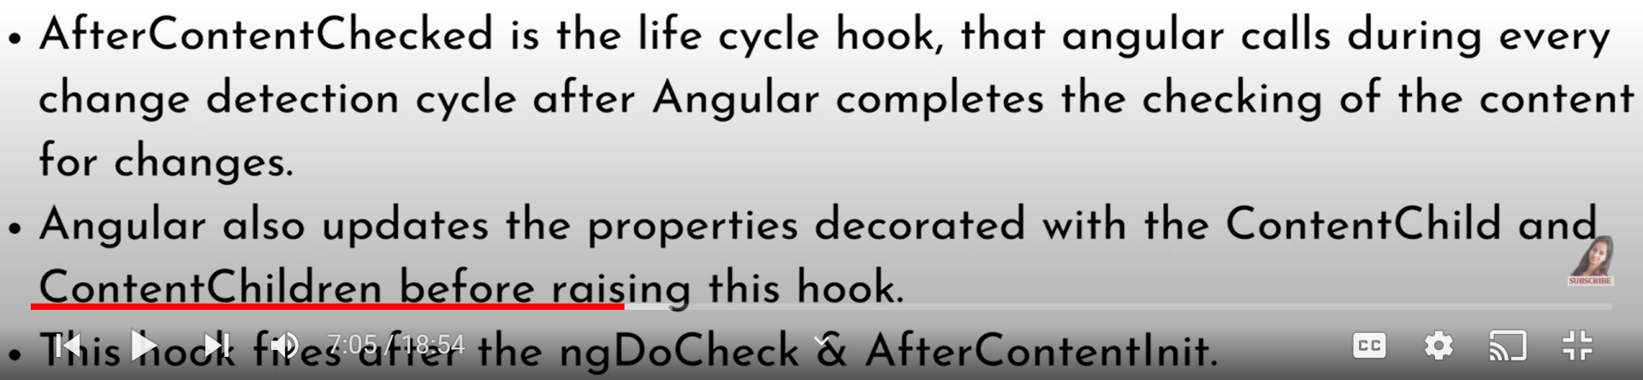

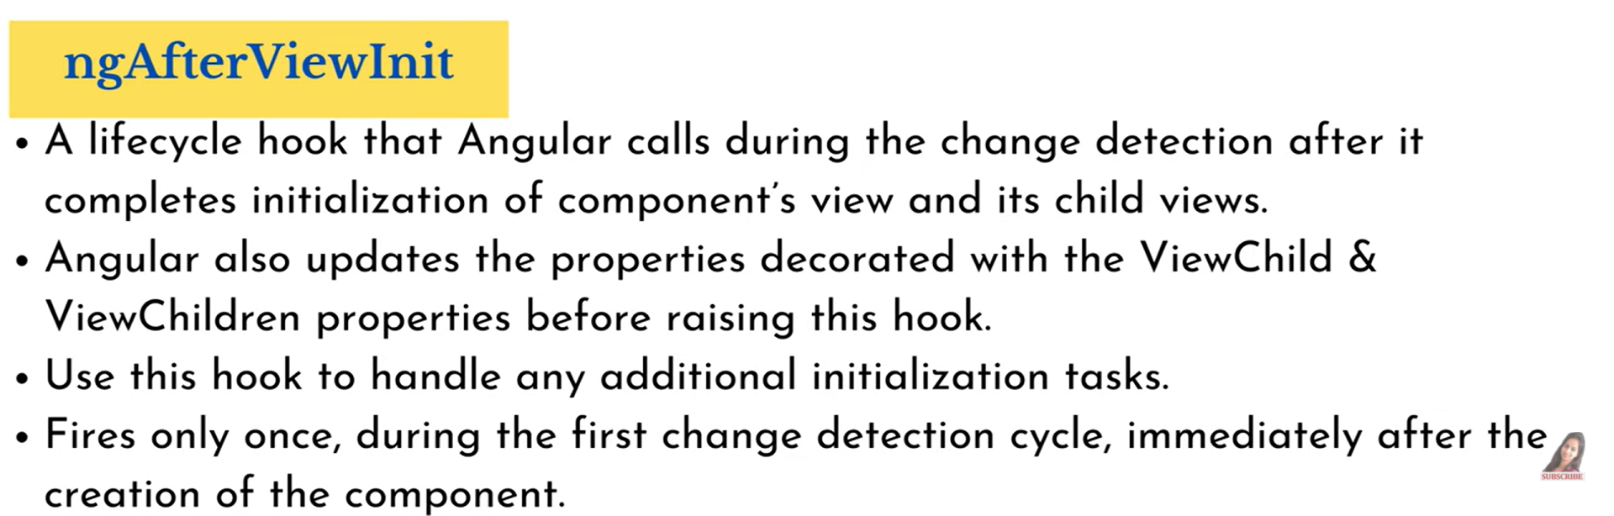

**Ng onDestroy :**

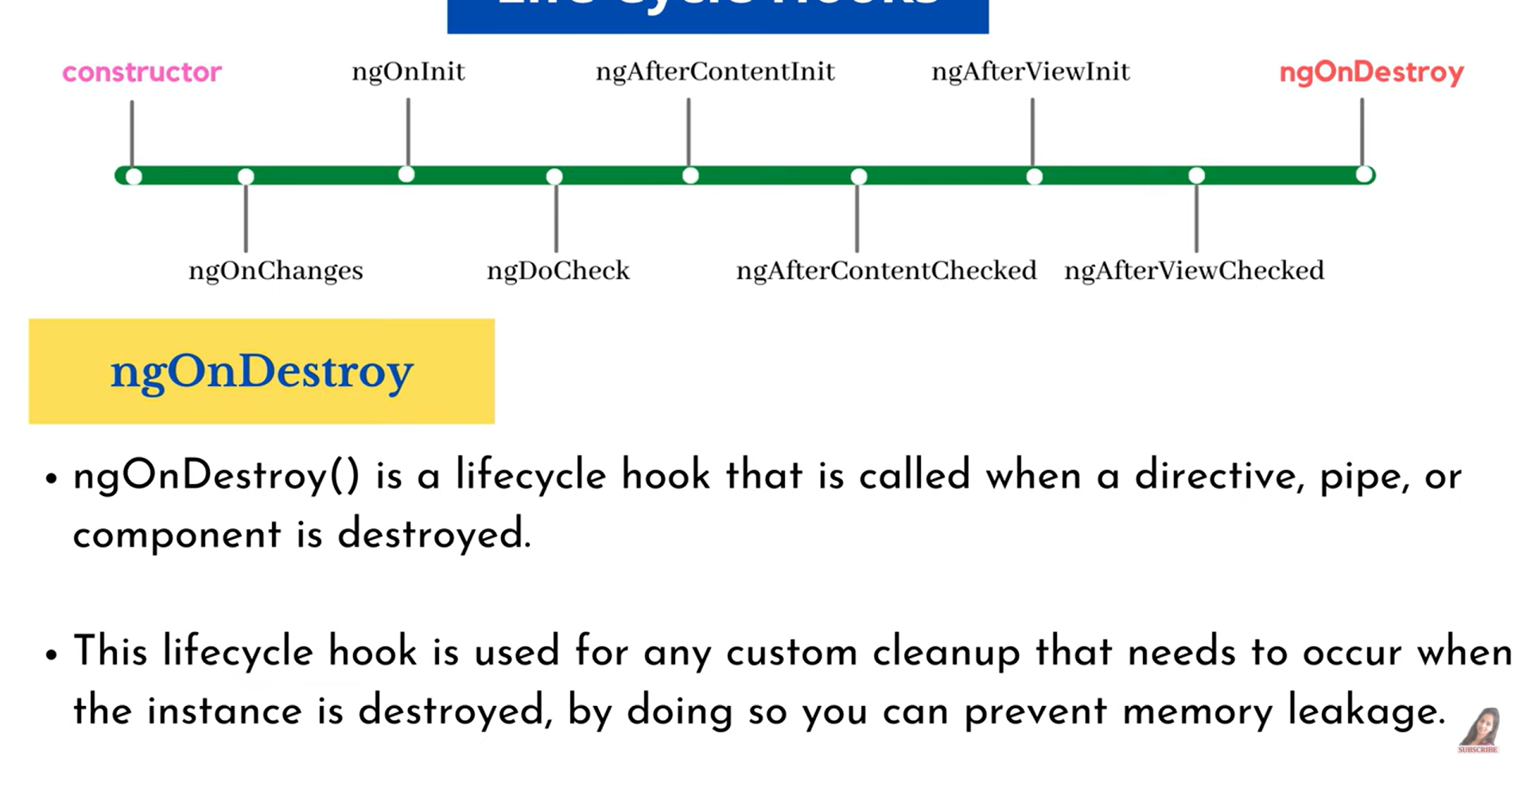

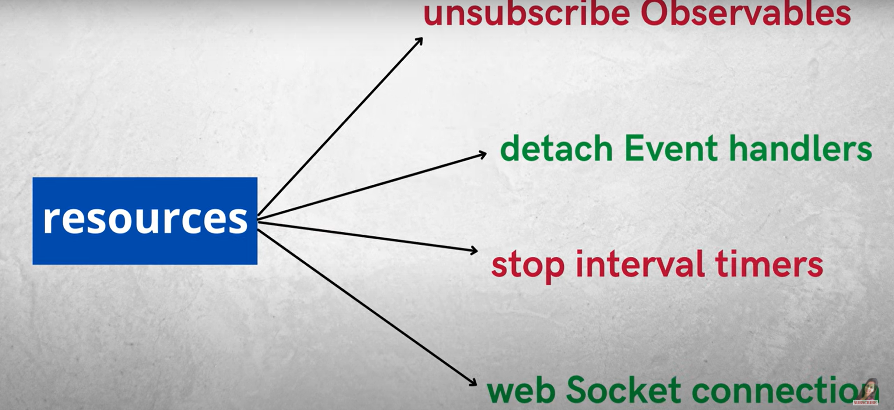

**https://dev.to/axlblaze/angular-file-explanation-5fp7**

**app.module.ts:-**

This is also a typescript file which includes all the dependencies for the website.

## karma.config.js:-

This file specifies the config file for the Karma Test Runner,Karma has been developed by the AngularJS team which can run tests for both AngularJS and Angular 2+

## polyfills.ts:-

This file is a set of code that can be used to provide compatibility support for older browsers.

## tsconfig.json:-

This is a typescript compiler configuration file.

## tsconfig.app.json:-

This is used to override the tsconfig.json file with app specific configurations.

## tsconfig.spec.json:-

This overrides the tsconfig.json file with app specific unit test configurations.